Article
Sewage Sludge in Agricultural Lands: The Legislative Framework in EU-28

Dimitrios Koumoulidis ,*, Ioannis Varvaris ¹, Zambella Pittaki ² and Diofantos Hadjimitsis ^{1,3}

Citation: Koumoulidis, D.; Varvaris,
I.; Pittaki, Z.; Hadjimitsis, D. Sewage
Sludge in Agricultural Lands: The Legislative Framework in EU-28. Sustainability 2024, 16, 10946. https:// doi.org/10.3390/su162410946
Academic Editor: Antonio Boggia
Received: 17 October 2024
Revised: 3 December 2024
Accepted: 10 December 2024
Published: 13 December 2024

Copyright: © 2024 by the authors. Licensee MDPI, Basel, Switzerland. This article is an open access article distributed under the terms and conditions of the Creative Commons Attribution (CC BY) license (https:// creativecommons.org/licenses/by/
4.0/).
- Eratosthenes Centre of Excellence, 3012 Limassol, Cyprus; ioannis.varvaris@eratosthenes.org.cy (I.V.); d.hadjimitsis@cut.ac.cy (D.H.)
- World Agroforestry Centre, Nairobi P.O. Box 30677-00100, Kenya; z.pittaki@cifor-icraf.org
- Department of Civil Engineering and Geomatics, Faculty of Engineering and Technology, Cyprus University of Technology, 3036 Limassol, Cyprus
* Correspondence: dimitrios.koumoulidis@eratosthenes.org.cy
Abstract: Incorporating sewage sludge (SS) into soils presents a cost-effective and environmentally friendly option compared to conventional farming practices. However, SS could be perceived as a double-edged sword, as it may contain a broad spectrum of contaminants, such as heavy metals (HMs), microplastics (MPs), Pharmaceuticals in the Environment (PIE), and personal care products
(PSPs), raising concerns for soil health, water resources, food safety, and human health. Council Directive 86/278/EEC, which regulates SS application in agriculture, specifies limits for six HMs but has not undergone substantive revisions since its inception in 1986, until the release of the updated working document SWD-2023-{final 158}. This study critically examines the legislative landscape across the European Union (EU) Member States (MSs), identifying heterogeneity in implementation, regulatory gaps, and the absence of thresholds for emerging contaminants. The results reveal significant disparities in the permissible concentrations of HMs across MSs and in comparison to international guidelines established by the Food and Agriculture Organization (FAO) and the World Health Organization (WHO). Furthermore, the absence of regulatory measures for MPs, PIE, and other common soil pollutants underscores critical deficiencies in the current framework. These inconsistencies contribute to varying levels of soil health across the EU and highlight the need for a harmonized approach. The findings of this study highlight the imperative for a comprehensive overhaul of the EU legislative framework governing SS application. As evidenced, the establishment of harmonized contaminant thresholds, rigorous monitoring protocols, and regulatory provisions for emergent pollutants is essential for addressing the identified regulatory gaps, enhancing legislative coherence, and promoting sustainable agricultural practices aligned with the EU’s environmental and public health objectives.
Keywords: sewage sludge; heavy metals; 86/278/EEC; soil health; SWD-2023; R statistical analysis

The exponential growth in the population and rapid urbanization have led to the generation of significant volumes of semisolid waste residues [6]. The widespread acceptance of utilizing these residues in agriculture, referred to as SS application, highlights its effectiveness as a commonly practiced approach [6,7]. Applying SS to soil offers a viable solution for meeting the demand for renewable nutrient sources while mitigating the negative impact of chemical fertilizers. The presence of organic constituents within SS can improve soil properties and fertility by acting as a soil conditioner. This can result in enhancements such as the increased water-holding capacity, improved porosity, reduced bulk density, and enhanced stability of soil aggregates [8]. SS applications have also boosted crop yield and improved plant characteristics. For instance, the application of significant amounts of dried SS to soils (ranging from 10% to 40%) has demonstrated an enhanced yield of biomass in Brassica juncea L. [9]. A study by Eid et al. (2021) demonstrated that applying SS positively influenced tomato plants’ growth compared to those cultivated in non-amended soils. Various SS application rates (10, 20, 30, and 40 gr/kg) significantly increased shoot and root lengths and leaf area compared to the control group. All SS doses demonstrated a notable improvement in OM percentage and electrical conductivity (EC), with a minor decrease in pH values observed compared to soils that did not receive treatment. Notably, a 30 gr/kg SS application resulted in a significant increase of 48.5% in soil OM and 93.5% in EC relative to the non-amended soil. This specific dose led to a remarkable increase of 158% in nitrogen (N) levels and 51.5% in potassium (K) levels compared to the control soil [6]. Research by Mohamed et al. demonstrated that SS also had beneficial effects on the morphological and eco-physiological parameters of sunflower (Helianthus annuus L.) seedlings as well as soil chemical characteristics in Meknès-Saïs, Morocco [10].
While the significance and effectiveness of SS for soil application in agriculture are undeniably evident, it is imperative to exercise caution and implement stringent guidelines in this practice [6]. As an unavoidable byproduct resulting from the operation of municipal wastewater treatment plants, the sustainability of using SS in agriculture has been a matter of contention, primarily due to its potential adverse effects on human and environmental health [11]. In the EU, the application of SS as an agricultural amendment is subject to compliance with the quality requirements stipulated in the Council Directive (86/278/EEC) (EUR-Lex, https://eur-lex.europa.eu/legal-content/EN/TXT/?uri=celex:31986L0278, accessed on 16 October 2024), which regulates the utilization of SS in agriculture. All EU MSs are required to monitor sludge applications to prevent the accumulation of HMs in the soil from exceeding specified limits. Having been in effect since 1986, the directive has remained unchanged, without experiencing significant revisions. However, heading towards a revised version of the directive, the working document SWD-2023-final {158} was officially disclosed in May 2023. This was initiated and developed under the auspices of the EU Green Deal, the Updated Bio-Economy Strategy, and the EU Circular Economy Action Plans adopted in 2015 and 2020. Noteworthy is that the use of SS, compost, and other organic waste as organic soil amendments is a fundamental strategy to comply with Landfill Directive 2018/850 and with the ‘end of waste’ policy in Europe.
Regarding the pollutants identified in SS, HMs tend to accumulate in SS, where they are dissolved, precipitated, coprecipitated with metal oxides, absorbed, or assimilated with biological residues [12]. HMs are divided into two groups. The first one, including cadmium, lead, and mercury, is characterized by a high toxicity to humans and animals but lower toxicity for the growth and development of plants. In excess, the metals of the second group, i.e., copper, zinc, and nickel, are more toxic to plants than to animal and human organisms [13]. The translocation of HMs into the food chain accounts for 90% of human contact, with the remaining 10% resulting from inhalation and dermal exposure [14].
Besides the presence of HMs, which seem well studied, the presence of MPs in soils has become increasingly evident in recent years [15]. MPs pose significant challenges to soil health, disrupt the balance of ecosystems, and can have implications for food safety, as they can be easily transported to plants [16,17]. Those contaminants are ubiquitously found in various ecosystems, such as soil, rivers, wetlands, marine waters, and mountains, due to continuous discharge by human activities and inadequate management [18]. Large volumes of MPs are predominately conveyed from land-based environments through freshwater pathways, ultimately culminating in their deposition in marine waters, a phenomenon known as ecoline [19]. MPs consist of an array of polymer types. As a result, polymer identification has emerged as a vital strategy, given that different polymers demand tailored techniques for their separation and quantification [20,21]. Although much less is known about MP pollution in terrestrial ecosystems [19], between 360 and 1980 tons of MPs in the EU could reach municipal wastewater treatment plants annually [22]. The European Green Deal has developed a zero pollution vision for 2050 and a subsequent Zero Pollution Action Plan (ZPAP) [23]. The ZPAP will address emerging pollutants such as MPs and micropollutants, including PIE. However, pollution from such contaminants is not regulated, and the last updated working document (SWD-2023)-{final 158} does not yet consider MPs, despite the risk that SS land applications could create a pathway for MPs to enter and accumulate in agricultural soils.
Considering SS’s complexity, extent, and multi-level involvement in various environmental and social parameters, implementing and updating the relevant directives and legislation is imperative and of immediate priority. One of this article’s objectives is to review the applicable legislation within the European framework and at the MS national level. Additionally, this article seeks to examine and document the relevant legislative frameworks, particularly their limitations, control and environmental protection procedures, and regulations designed to ensure pollution-free European soil. Finally, this study aims to characterize and explore the updated SWD-2023-final {158} working document, highlighting its deficiencies and gaps and outlining potential enhancements and suggestions for future improvement.

2. Materials and Methods
This systematic review of the applicable legislation was developed in two stages.
The first referred to SS socio-economic and environmental impacts on the primary agriculture sector by searching international databases, including Web of Science (Clarivate, Web of Science, https://www.webofscience.com/wos/woscc/basic-search, accessed on
16 October 2024), Google Scholar (Google Scholar, https://scholar.google.com/, accessed on 16 October 2024), and Scopus (Scopus, https://www.scopus.com/search/form.uri? display=basic&zone=header&origin=searchbasic#basic, accessed on 16 October 2024). The second stage included the SS legislative frameworks by searching each EU MS’s official national ministerial (responsible for SS laws and regulations) web pages and Eurostat. The software used for bibliographic management was Zotero for Windows (v6.0.36) (Zotero, https://www.zotero.org/, accessed on 16 October 2024) for duplication searches. The primary keywords selected for the database search were SS, soil health, and HMs policies. These were linked with other words such as EU legislation, food safety, MPs, compost, incineration, bioenergy, contamination, antibiotics, and sludge treatment.
Approximately 600 research papers addressing the first stage of this methodology were considered eligible. These were assessed by evaluating the title, abstract, and relevant data to remove irrelevant studies. Following an assessment of the data’s quality, methodology, and relevance to this current study, 63 research papers were deemed suitable for this review. All research papers were from 2014 to 2024 to obtain the most up-to-date data, innovations, and trends on the subject examined.
The methodology’s second part included a statistical analysis conducted using R (version 4.2; R Foundation for Statistical Computing) [24]. Data manipulation and visualization were performed with packages such as dplyr and ggplot2, respectively. Summary statistics, including means and standard deviations, were calculated for pollutant concentrations, with visualizations highlighting regional variations. All maps’ visualization, editing, and preparation were performed using the free and open-source Qgis software (version 3.43) (Qgis.org blog, https://blog.qgis.org/2023/11/05/qgis-3-34-prizren-is-released/, accessed on 16 October 2024).

3. Results

3.1. Council Directive 86/278/EEC
The 86/278/EEC Directive establishes thresholds for hazardous surface water and soil substances that receive sludge applications. However, since its inception in 1986, the directive has remained unchanged, resulting in its obsolescence. The Council Directive has banned untreated SS and introduced specific regulations for the sampling and examining of SS and soil to prevent adverse consequences [25]. It stipulates the necessity for maintaining thorough documentation concerning (i) the quantities of SS generated, (ii) the quantities utilized in agriculture, (iii) the composition and characteristics of the SS, (iv) the treatment processes involved, and (v) the locations and guidelines of SS application (FAOLEX, Database, https://www.fao.org/faolex/results/details/en/c/LEX-FAOC019147/, accessed on 16 October 2024). As an illustration, per Article 8 of the directive, if soil pH levels dip below 6, it is crucial to consider the amplified mobility and availability of HMs to the crops when utilizing SS.
The regulation outlined in Regulation (EU) 2019/1009 directly confronts the issue of
SS composting. It establishes strict restrictions on the amount of SS allowed in fertilizing products across the EU. Consequently, fertilizing products that incorporate composts and digested materials sourced from SS will be prohibited from being commercially available in the EU market with the CE marking beyond July 2022.
Additionally, the FAO’s report on wastewater treatment and its utilization in agriculture offers further insights in addition to the regulations set forth by the EU. Specifically, in Section 6 (Agricultural Use of SS), point 6.2 (Sludge Application) [26], the authors present the maximum allowable concentrations of potentially toxic elements (PTEs) in the soil after the application of SS [27]. This document outlines the maximum permissible concentrations of potentially toxic elements in the soil following the application of SS and specifies the maximum-addition annual rates.
The report ‘Developing Human Health-Related Chemical Guidelines for Reclaimed
Water and SS Applications in Agriculture’, produced by Chang et al. for the WHO, presents a detailed analysis of the maximum allowable concentrations of pollutants in the receiving soils. Notably, this report presents threshold values for specific elements, including silver (Ag), boron (B), beryllium (Be), titanium (Ti), and vanadium (V), which were not part of the FAO document and Council Directive [28]. Table 1 illustrates the permissible concentrations of toxic pollutants and the differences observed between the WHO, FAO, and Council Directive.
Table 1. Maximum permissible toxic pollutant concentrations from WHO, FAO, and the 86/278/EEC Directive (source [25]).
 | WHO—World Health  Organization | FAO—Food and Agriculture Organization | 86/278/EEC Directive
Heavy Metal Limits | Maximum Permissible Pollutant  Concentrations in the  Receiving Soils  (mg/kg⁻¹) | Maximum Permissible  Concentration of Potentially  Toxic Elements in Soils  (mg/kg⁻¹ Dry Solids) | Limit Values for  Concentrations of HMs in Soils  (mg/kg⁻¹ Dry Matter of Soil)
Arsenic (As) | 8 | 50 | -
Cadmium (Cd) | 4 | 3.5 | 1–3
Chromium (Cr) | - | 400 (prov.) | -
Copper (Cu) | - | 80 | 50–140
Fluoride (F) | 635 | 500 | -
Lead (Pb) | 84 | 300 | 50–300
Mercury (Hg) | 7 | 1 | 1–1.5
Molybdenum (Mo) | 0.6 | 4 | -
Nickel (Ni) | 107 | 50 | 30–75
Zinc (Zn) | - | 200 | 150–300
Table 1. Cont.
WHO—World Health FAO—Food and Agriculture 86/278/EEC
Organization Organization Directive
Heavy Metal Limits | Maximum Permissible Pollutant Maximum Permissible Limit Values for  Concentrations in the Concentration of Potentially Concentrations of HMs  Receiving Soils Toxic Elements in Soils in Soils  (mg/kg⁻¹) (mg/kg⁻¹ Dry Solids) (mg/kg⁻¹ Dry Matter of Soil)
Silver (Ag) | 3 - -
Boron (B) | 1.7 - -
Beryllium (Be) | 0.2 - -
Barium (Ba) | 302 - -
Selenium (Se) | 6 - -
Antimony (Sb) | 36 - -
Titanium (Ti) | 0.3 - -
Vanadium (V) | 47 - -
Concerns regarding potential environmental hazards stemming from obsolete EU legislation have prompted certain MSs to enact stricter regulations surpassing EU directives’ boundaries. Consequently, there has been an increase in the number of pollutants being monitored. The varying strategies employed by EU MSs in the agricultural application of SS contribute to differences in the permissible limits for these pollutants [29]. Table 2 lists the applicable legislations of all 28 MSs that define, delimit, and concern SS use processes.
Table 2. MS national legislation on SS.
EU-28 | National Legislation | Description
Austria | BGBl 1959/215  Waste Management Act (Abfallwirtschaftsgesetz)
Belgium | Royal Decree (Koninklijk Besluit 07.01.1998)  Flemish Regulation on Behalf of Waste Prevention and Waste Management (BWC/GC) | The Flanders region has adopted specific local legislation.
Bulgaria | - | No regulations
Croatia | RC Waste Management Strategy (NN 130/05)  Ordinance on management of sewage sludge when used in agriculture
Cyprus | K.∆.Π. 269/2005  K.∆.Π. 407/2002
Czech Republic | Waste Act No. 185/2001
Denmark | Fertilizer Act
Estonia | Regulation No. 29 (2019)  Waste Act (2004, as amended in 2014)  Water Act (2019, amended 2020) Reg. No. 24 (2017)
Finland | Decree of the Ministry of Agriculture and Forestry on  Fertilizer Products
France | NF U44-051/2006
Germany | Biowaste Ordinance (BioAbfV, 1998)  Fertilizer Ordinance (DüMV)  Fertilizer Application Ordinance  Sewage Sludge Ordinance (AbfKlärV)
Greece | K.Y.A. 80568/4225/91

Table 2. Cont.
EU-28 | National Legislation | Description
Hungary | 36/2006 (V. 18.) FVM
Ireland | Licensing of treatment plants, as agreed with EPA, stabilized biowaste
Italy | Genoa Decree (Legislative Decree 109/2018)  Decree n.109/2018, ‘Decreto Morandi’, art.41 DCI 27/07/84 | Several regions like Venetto  Lombardia have adopted specific local legislation.
Latvia | Regulation No. 365, 2002
Lithuania | Regulation on sewage sludge Category I (LAND 20/2005)
Luxembourg | Licensing for plants
Malta | Subsidiary legislation 549.09, 2002
The Netherlands | Fertilizer Decree (Ub)
Poland | Act on fertilizers and fertilization Journal of Laws No 119, item 765
Portugal | Decreto-Lei n. 276/2009
Romania | Government Decision no. 1157, 2008 Order no. 344/708/2004
Slovakia | Solid Waste Law 238/91  STN 46 5735 Industrial composts guidelines for agricultural use of sewage sludge, and sediments, 1997
Slovenia | Environmental Protection Act  Decree on waste (Official Gazette of RS, no. 37/15)  Decree on the emission of substances in the discharge of landfill effluent (Official Gazette of RS, no. 7/00, 41/04—ZVO-1 and 62/08)
Spain | Royal Decree 824/2005
Sweden | SPCR 152 Guideline values SNFS 1992:2  SPCR 120 Guideline values
The UK | Sewage sludge in agriculture: code of practice for England, Wales, and Northern Ireland, 2018
Other Countries
Russia | ГOCT P 17.4.3.07-2001-Oxpaнa пpиpoды. Πoчвы. Tpeбoвaния к cвoйcтвaм ocaдкoв cтoчныx вoд пpи иcпoльзoвaнии иx в  кaчecтвe yдoбpeний
Egypt | Law 93/1962  ECP 501/2005  Decree 171/2005—Egyptian Code of Practice for Reuse of Treated Wastewater in Agriculture.
Algeria | NF U 44-041 (1989)—Matières fertilisantes—Boues des ouvrages de traitement des eaux usées urbaines.
Jordan | Jordan Standards and Metrology Organization (2016): Sludge. Uses of biosolid and disposal [30]
As illustrated in Table 3, a dominant finding concerns the joint recognition and institutionalization of legislation by almost all MSs for seven HMs when SS is amended. Cadmium, nickel, lead, zinc, mercury, copper, and chromium are among them. During this study, Bulgaria was the only exception that had yet to enact relevant legislation. The next studied statutory HM that has been adapted and incorporated into the legislation of several MSs, such as Germany, France, the Netherlands, and Italy, is arsenic. Individual quantitative characteristics also identified by the review of MS legislation concern the state with the highest number of HMs incorporated into relevant legislation, locating Germany with 14 recognized HMs, Italy and the United Kingdom with 10, and France with 9. In contrast, the countries with the lowest number of HMs regulated are Poland, with 5, and Estonia, Spain, and Sweden, with 6. Qualitative characteristics include the finding that several Mediterranean MSs constitute the group with the smallest number of HMs that comply with their legislation. Greece, Croatia, Cyprus, Malta, and Portugal count 7 HMs, in contrast to the MSs of Central and Northern Europe, which include more than 8 in their legislation, such as the Netherlands, the United Kingdom, Germany, the Czech Republic, Lithuania, and Slovakia. Upon conducting a supplementary analysis, it becomes evident that a significant number of HMs are integrated into the national legislation of the Eastern Mediterranean Middle East and North African (EMMENA) region nations. This legislation enumerates permissible limits for 10 HMs, including molybdenum. The UK uniquely holds the position as the only MS in the EU-28 that has integrated this HM into its legal statutes. Table 3. Type of pollutants included in MS national legislation.
EU-28 | Cd | Pb | Cu | Type of Pollutants Included in MS National Legislation Framework  Ni Zn Hg Cr As Se Co Be Sb Th |  |  |  |  |  |  |  |  |  | V | Sn | Mo
Austria Belgium | √  √ | √  √ | √  √ | √  √ | √  √ | √  √ | √  √ | -  - | -  - | -  - | -  - | -  - | -  - | -  - | -  - | -  -
Bulgaria  Croatia  Cyprus  Czech Republic  Denmark  Estonia  Finland  France  Germany Greece  Hungary  Ireland  Italy  Latvia  Lithuania  Luxembourg  Malta  The Netherlands  Poland  Portugal  Romania  Slovakia  Slovenia Spain  Sweden  The UK | √-  √  √  √  √  √  √  √  √  √  √  √  √  √  √  √  √  √  √  √  √  √  √ √  √ | √-  √  √  √  √  √  √  √  √  √  √  √  √  √  √  √  √  √  √  √  √  √  √ √  √ | √-  √  √  √  √  √  √  √  √  √  √  √  √  √  √  √  √  √-  √  √  √  √ √  √ | √-  √  √  √  √  √  √  √  √  √  √  √  √  √  √  √  √  √  √  √  √  √  √ √  √ | √-  √  √  √  √  √  √  √  √  √-  √  √  √  √  √  √  √-  √  √  √  √ √  √ | √-  √  √  √  √  √  √  √  √  √  √  √  √  √  √  √  √  √  √  √  √  √  √-  √ | √-  √  √  -  √-  √  √  √-  √  √  √  √  √  √  √  √  √  √  √  √  √  √- | -  -  √-  √  -  √-  √  √-  √-  √-  - √-  -  √-  √  -  - √- | - -  -  -  -  -  √-  √  - √-  -  -  -  -  -  -  - √-  -  - √- | -  -  -  -  -  - √-  √-  -  -  -  -  -  -  -  - √-  -  -  -  -  - | -  -  -  -  -  -  - -  -  - √-  -  -  -  -  -  -  -  -  -  -  -  -  - | -  -  -  -  - -  - √-  -  -  -  -  -  -  -  -  -  -  -  -  - -  - - | - -  - -  - √-  - -  - -  - -  - -  - -  -  - - | - -  -  -  -  - √-  - -  -  -  -  - -  - -  -  - - | - -  -  -  -  - √-  -  - -  - -  - -  -  -  -  -  -  -  -  -  -  - | -  -  -  -  -  - -  -  - -  -  -  - -  -  -  -  -  -  -  -  - √-
Other Countries
Russia  Egypt  Algeria Jordan | √  √  √  √ | √  √  √  √ | √  √  √  √ | √  √  √  √ | √  √  √  √ | √  √  √  √ | √  √  √  √ | √  √  √- | √-  √  √ | -  -  -  - | -  -  -  - | -  -  -  - | -  -  -  - | -  -  - | -  -  -  - | √-  √-
It is essential to highlight that, aside from the considerable diversity in the number of HMs included in MS regulations, there is also a substantial disparity in the acceptable threshold limits of HMs in SS when intended for agricultural use. The degree of variation in each case of HMs varies, with the common factor being the noticeable differences presented in Table 4. As an illustration, in the case of cadmium, Finland limits the minimum statutory value to 0.5 mg/kg⁻¹ (dry matter). In comparison, Cyprus specifies the maximum value at 40 mg/kg⁻¹ (dry matter) in its national legislation. Likewise, the statutory value for chromium in Austria is established at 70 mg/kg⁻¹ (dry matter). In contrast, according to their legislation, Slovakia, Portugal, and Cyprus have set a maximum value of 1000 mg/kg⁻¹ (dry matter). Another intriguing aspect is the absence of defined permissible values for copper and zinc in Poland. On the other hand, HMs such as thallium, beryllium, vanadium, and molybdenum are officially included in the legislative framework of Germany, the United Kingdom, France, Hungary, and Italy. One potential common point of approach may be the observation that the strictest limits have been established by MSs of the European North, including Finland, Belgium, Germany, Austria, and Ireland. As an MS characterized by the most rigorous regulations and the highest volume of regulated
HMs, Germany exemplifies a guiding force for Southern European MSs and the entire EU. Germany and the Netherlands have made significant advancements in tackling HMs, providing limit values and guidance regarding the presence of such toxic materials in cosmetic products. Following the stipulations of Regulation (EC) No. 1223/2009 (EUR-Lex, https://eur-lex.europa.eu/legal-content/EN/ALL/?uri=celex:32009R1223, accessed on 16 October 2024), the Federal Office of Consumer Protection and Food Safety (Bundesamt für Verbraucherschutz und Lebensmittelsicherheit, BVL) has detailed the formulation of guidance limit values intended to reduce the presence of technically avoidable HMs in cosmetic products. Once again, Germany’s regulatory framework for HMs sets the lowest limit values, which are more rigorous than those found in the United States, Canada, and the International Cooperation on Cosmetics Regulation (ICCR) [31]. In the EMMENA region, Algeria, Egypt, and Jordan show significant similarities in regulating the permissible limits of HMs. The high contrast in lead permissible concentrations is marked, with
Algeria allowing levels almost three times higher than those permitted in Egypt and Jordan. The differences in selenium limits are equally striking, as Algeria’s thresholds can reach ten times the values established by those of EU-28 MSs, which have included it in their national laws.
Here, different ways of approaching and calculating the data can be found, as in several cases, these are calculated as an average of two years, five years, or even a decade. Many MSs have not submitted relevant data regarding this specific indicator, making it impossible to draw safe conclusions. Sweden, Finland, Austria, the Netherlands and Belgium belong to the group with the strictest framework of permissible limits annually. The range of deviations in the legislation is also reflected in the vast range of prices per case of HMs when it is indicated that the values for nickel start from 60 g per hectare for the Netherlands and reach 3 kg per hectare for the United Kingdom, Romania, Spain, and Portugal. Notably, Russia’s national legislation provides formulas to calculate the overall cumulative dosage of SS applications related to the actual concentrations of HMs in soils and the SS. Egypt’s legislation defines the annual application of SS as being within the following rates according to soil types (clay, medium-textured, and light soils). Table 5 presents the availability of data derived from Eurostat regarding the annual permissible limits.
According to the latest Eurostat data for 2022 (Statistics|Eurostat, Sewage Sludge
Production and Disposal, https://ec.europa.eu/eurostat/databrowser/view/ten00030
/default/table?lang=en, accessed on 16 October 2024), most MSs have submitted data regarding the production and disposal of SS. However, 10 MSs have not released official data. France and Poland recorded the largest production and disposal of SS, with 1123.31 and 580.66 thousand tons of production, respectively. The highest SS amounts amended in broader agriculture (out of the total output) were recorded in Poland with a percentage of 27.1%, France at 29.7%, Sweden at 52.3%, the Czech Republic at 35%, and Romania at 30%. Diametrically opposite, as shown in Table 6, Malta, the Netherlands, Slovakia, and Slovenia do not select agricultural disposal as an option. Figure 1 shows the relevant data on sludge production and agricultural utilization in the MS.

- of 20
Table 4. MS national permissible concentrations per toxic pollutants.
EU-28 |  |  |  | MS National Permissible Concentrations per Toxic Pollutants Using SS  (mg/kg⁻¹ on Dry Matter)
 | Cd | Pb | Cu | Ni | Zn | Hg | Cr | As | Se | Co | Be | Sb | Th | V | Sn | Mo
Austria Class A | 1 | 120 | 150 | 60 | 500 | 0.7 | 70 | - | - | - | - | - | - | - | - | -
Belgium | 1.5 | 120 | 90 | 20 | 300 | 1 | 70 | - | - | - | - | - | - | - | - | -
Bulgaria | - | - | - | - | - | - | - | - | - | - | - | - | - | - | - | -
Croatia | 5 | 500 | 600 | 80 | 2000 | 5 | 500 | - | - | - | - | - | - | - | - | -
Cyprus | 40 | 1200 | 1750 | 400 | 4000 | 25 | 1000 | - | - | - | - | - | - | - | - | -
Czech Republic | 5 | 200 | 500 | 100 | 2500 | 4 | 200 | 30 | - | - | - | - | - | - | - | -
Denmark | 0.8 | 120 | 1000 | 30 | 4000 | 0.8 | - | 25 | - | - | - | - | - | - | - | -
Estonia | 20 | 750 | 1000 | 300 | 2500 | 16 | - | - | - | - | - | - | - | - | - | -
Finland | 0.5 | 60 | 100 | 60 | 150 | 0.2 | 200 | - | - | - | - | - | - | - | - | -
France | 3 | 180 | 300 | 60 | 600 | 2 | 120 | 18 | 12 | - | - | - | - | - | - | -
Germany | 1.5 | 150 | 100 | 50 | 400 | 1 | 100 | 4–30 | 1–5 | 6.5 | - | 5–30 | 0.2–0.5 | 10–100 | 30–80 | -
Greece | 20–40 | 750–1200 | 1000–1750 | 300–400 | 2500–4000 | 16–25 | - | - | - | - | - | - | - | - | - | -
Hungary | 2 | 100 | 100 | 50 | - | 1 | 100 | 10 | - | 50 | - | - | - | - | - | -
Ireland | 1.5 | 150 | 100 | 50 | 350 | 1 | 100 | - | - | - | - | - | - | - | - | -
Italy | 20 | 750 | 1000 | 300 | 2500 | 10 | 200 | 20 | 10 | - | 2 | - | - | - | - | -
Latvia | 10 | 500 | 800 | 200 | 2500 | 10 | 600 | - | - | - | - | - | - | - | - | -
Lithuania | 2 | 120 | 300 | 50 | 800 | 1 | 70 | 40 | - | - | - | - | - | - | - | -
Luxembourg | 1.5 | 150 | 100 | 50 | 400 | 1 | 100 | - | - | - | - | - | - | - | - | -
Malta | 5 | 500 | 800 | 200 | 2000 | 5 | 800 | - | - | - | - | - | - | - | - | -
The Netherlands | 1.25 | 100 | 75 | 30 | 300 | 0.75 | 75 | 15 | - | - | - | - | - | - | - | -
Poland | 5 | 140 | - | 60 | - | 2 | 100 | - | - | - | - | - | - | - | - | -
Portugal | 20 | 750 | 1000 | 300 | 2500 | 16 | 1000 | - | - | - | - | - | - | - | - | -
Romania | 10 | 300 | 500 | 100 | 2000 | 5 | 500 | 10 | - | 50 | - | - | - | - | - | -
Slovakia | 13 | 500 | 1200 | 200 | 3000 | 10 | 1000 | 20 | 10 | - | - | - | - | - | - | -
Slovenia | 1.5 | 250 | 300 | 75 | 1200 | 1.5 | 200 | - | - | - | - | - | - | - | - | -
Spain | 0.7–3 | 45–200 | 70–400 | 25–100 | 200–1000 | - | 70–300 | - | - | - | - | - | - | - | - | -
Sweden | 1 | 100 | 600 | 50 | 800 | 1 | - | - | - | - | - | - | - | - | - | -
The UK | 3 | 300 | 100–200 | 60–110 | 200–300 | 1 | 400 | 50 | 3 | - | - | - | - | - | - | 4
Other Countries
Russia | 15 | 250 | 750 | 200 | 1750 | 7.5 | 500 | 10 | - | - | - | - | - | - | - | -
Egypt | 39 | 300 | 1500 | 420 | 2800 | 17 | 1200 | 41 | 36 | - | - | - | - | - | - | 18
Algeria | 20 | 800 | 1000 | 200 | 3000 | 10 | 1000 | - | 100 | - | - | - | - | - | - | -
Jordan | 40 | 300 | 1500 | 300 | 2800 | 17 | 900 | 41 | 100 | - | - | - | - | - | - | 75
- of 20
Table 5. MS national annual limit values per toxic pollutants.
EU-28 | Cd | Pb | Cu | Ni | MS National Annual Limits Values per Toxic Pollutants Using SS (g/ha)  Zn Hg Cr As Se Co Be Sb Th V |  |  |  |  |  |  |  |  | Sn | Mo
Austria | 5 | 312.5 | 312.5 | 187.5 | 1250 | 5 | 312.5 | - | - | - | - | - | - - | - | -
Belgium | 12 | 600 | 750 | 100 | 1800 | 10 | 500 | 300 | - | - | - | - | - - | - | -
Bulgaria | - | - | - | - | - | - | - | - | - | - | - | - | - - | - | -
Croatia | - | - | - | - | - | - | - | - | - | - | - | - | - - | - | -
Cyprus | - | - | - | - | - | - | - | - | - | - | - | - | - - | - | -
Czech Republic | - | - | - | - | - | - | - | - | - | - | - | - | - - | - | -
Denmark | 5.6 | 840 | 7000 | 210 | 28,000 | 5.6 | 700 | 175 | - | - | - | - | - - | - | -
Estonia | - | - | - | - | - | - | - | - | - | - | - | - | - - | - | -
Finland | 1.5 | 100 | 600 | 100 | 1500 | 1 | 300 | - | - | - | - | - | - - | - | -
France | 45 | 2700 | 3000 | 900 | 6000 | 30 | 1800 | 270 | - | - | - | - | - - | - | -
Germany | 16 | 1500 | 1300 | 300 | 4100 | 13 | 1500 | - | - | - | - | - | - - | - | -
Greece Hungary | - | - | - | - | - | - | - | - | - | - | - | - | - - | - | -
Ireland | - | - | - | - | - | - | - | - | - | - | - | - | - - | - | -
Italy | 15 | 500 | 3000 | 1000 | 10,000 | 15 | 2000 | 100 | - | - | - | - | - - | - | -
Latvia | 30 | 300 | 1000 | 250 | 5000 | 8 | 600 | - | - | - | - | - | - - | - | -
Lithuania | - | - | - | - | - | - | - | - | - | - | - | - | - - | - | -
Luxembourg | - | - | - | - | - | - | - | - | - | - | - | - | - - | - | -
Malta | 15 | 1500 | 2400 | 600 | 6000 | 15 | 2400 | - | - | - | - | - | - - | - | -
The Netherlands | 2.5 | 200 | 150 | 60 | 600 | 1.5 | 150 | 30 | - | - | - | - | - - | - | -
Poland | - | - | - | - | - | - | - | - | - | - | - | - | - - | - | -
Portugal | 150 | 15,000 | 12,000 | 3000 | 30,000 | 100 | 4500 | - | - | - | - | - | - - | - | -
Romania | 150 | 15,000 | 12,000 | 3000 | 30,000 | 100 | 12,000 | - | - | - | - | - | - - | - | -
Slovakia | - | - | - | - | - | - | - | - | - | - | - | - | - - | - | -
Slovenia | 15 | 2500 | 3000 | 750 | 12,000 | 15 | 2000 | - | - | - | - | - | - - | - | -
Spain | 150 | 15,000 | 12,000 | 3000 | 15,000 | 100 | - | - | - | - | - | - | - - | - | -
Sweden | 0.75 | 25 | 300 | 25 | 600 | 1.5 | - | - | - | - | - | - | - - | - | -
The UK | 150 | 15,000 | 7500 | 3000 | 15,000 | 100 | 15,000 | 700 | 150 | - | - | - | - - | - | 200
Other Countries
Russia | - | - | - | - | - | - | - | - | - | - | - | - | - - | - | -
Egypt | - | - | - | - | - | - | - | - | - | - | - | - | - - | - | -
Algeria | - | - | - | - | - | - | - | - | - | - | - | - | - - | - | -
Jordan | - | - | - | - | - | - | - | - | - | - | - | - | - - | - | -

Table 6. Production and disposal of SS in MS in 2022. (Statistics|Eurostat, Sewage Sludge Production and Disposal, https://ec.europa.eu/eurostat/databrowser/view/ten00030__custom_12135718 /default/table?lang=en, accessed on 16 October 2024).
EU-28 | Production of SS (Thousand Tons) | Disposal of SS (Thousand Tons) | Disposal of  SS—Agriculture Use  (Thousand Tons)
Austria | 196.45 | 196.45 | 50.23
Belgium | - | 161.21 | 39.32
Bulgaria | - | - | -
Croatia | 35.30 | 9.52 | 0.76
Cyprus | 8.31 | 8.31 | 0.75
Czech Republic | 243.76 | 243.76 | 85.23
Denmark | - | - | -
Estonia | 21.77 | 19.11 | 13.99
Finland | - | - | -
France | 1123.31 | 1028.28 | 333.89
Germany | - | - | -
Greece | - | - | -
Hungary | 248.08 | 217.42 | 10.82
Ireland | 59.76 | 59.76 | 55.54
Italy | - | - | -
Latvia | 20.39 | 20.39 | 2.61
Lithuania | 48.38 | 42.98 | 11.28
Luxembourg | 12.52 | 12.52 | 1.25
Malta | 9.26 | 9.26 | 0.00
The Netherlands | 349.60 | 300.04 | 0.00
Poland | 580.66 | 580.66 | 157.60
Portugal | - | - | -
Romania | 207.21 | 207.21 | 63.08
Slovakia | 55.05 | 55.05 | 0.00
Slovenia | 26.11 | 26.11 | 0.00
Spain | - | - | -
Sweden | 203.80 | - | 106.70
The UK | - | - | -
In 2022, the officially recorded data also show a lack of information on SS treatment methods for the same 10 MSs mentioned above. Spain, Denmark, Greece, Germany, and Portugal have not offered quantitative data. At the EU level, incineration treatment and composting are the prevailing methods. The Netherlands, France, Poland, and Belgium are the top countries in the thermal treatment of SS, while Croatia, Ireland, Cyprus, Malta, and Latvia rank the lowest. Landfill management is viewed as a less suitable option due to its small size, but it remains the dominant choice for Malta. Hungary heavily favors composting/other applications, which comprise around 77% of the country’s production, whereas in France it accounts for about 47%. Table 7 and Figure 2 present and visualize the volumes of SS’s thermal, landfill, and compost treatment for 2022. In Table 7, the total (MV) indicates the cumulative count of missing values related to treatment methods across the EU-28.
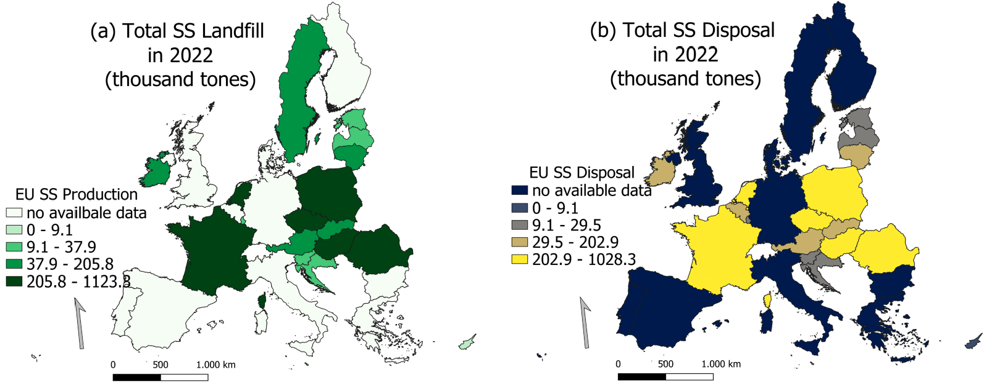
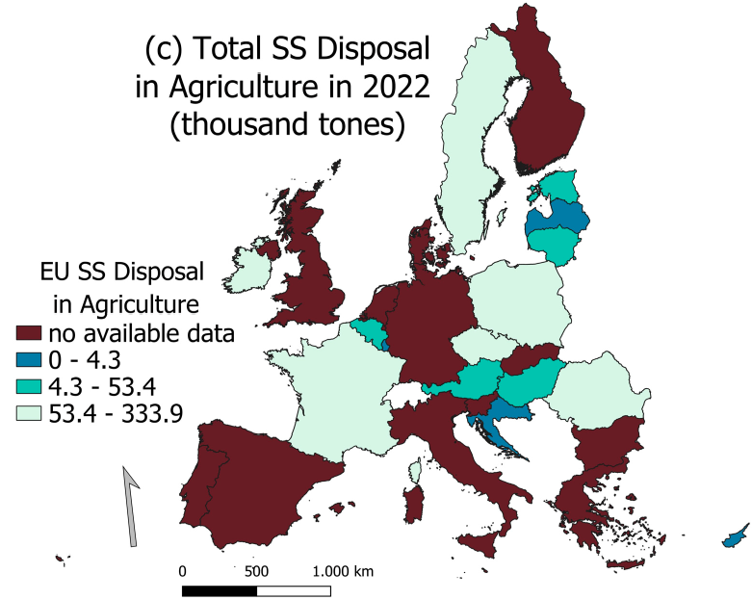
Figure 1. (a) SS production, (b) SS total disposal, and (c) SS disposal in agriculture in MSs in 2022.
Table 7. SS treatment in EU MSs in 2022. (Statistics|Eurostat, Sewage Sludge Treatment, https://ec. europa.eu/eurostat/databrowser/view/ten00030__custom_12135860/default/table?lang=en, accessed on 16 October 2024).
EU-28 | SS Treatment in MS (Thousand Tons)
 | Incineration | Landfill | Compost and Other Applications | Other
Austria | 87.61 | 0.27 | 38.80 | 19.68
Belgium | 118.53 | 0.00 | 0.00 | 3.39
Bulgaria | - | - | - | -
Croatia | 0.06 | 0.57 | 2.15 | 5.98
Cyprus | 0.47 | 0.00 | 4.80 | 2.29
Czech Republic | 26.72 | 19.23 | 112.59 | -
Denmark | - | - | - | -
Estonia | - | 2.34 | 2.79 | -
Finland | - | - | - | -
France | 137.63 | 2.80 | 526.80 | 27.16
Germany | - | - | - | -
Greece | - | - | - | -
Hungary | 10.50 | 2.76 | 193.34 | 0.00
Ireland | 0.00 | 0.00 | 4.21 | 0.00
Italy | - | - | - | -
Latvia | 1.47 | 0.00 | 0.91 | 15.40
Lithuania | 11.47 | 0.00 | 20.24 | 0.00
Luxembourg | 4.62 | 0.00 | 0.04 | 6.61
Table 7. Cont.
EU-28 | SS Treatment in MS (Thousand Tons)
 | Incineration | Landfill | Compost and Other Applications | Other
Malta | 0.00 | 9.26 | 0.00 | 0.00
The Netherlands | 290.43 | 1.49 | 0.00 | 8.12
Poland | 105.23 | 8.20 | 22.78 | 286.85
Portugal | - | - | - | -
Romania | 0.56 | 77.42 | 1.78 | 64.38
Slovakia | 10.33 | 11.21 | 28.80 | 4.71
Slovenia | 5.99 | 0.67 | 0.22 | 19.24
Spain | - | - | - | -
Sweden | - | - | - | -
The UK | - | - | - | -
TOTAL (MV) | (11) | (10) | (10) | (12)

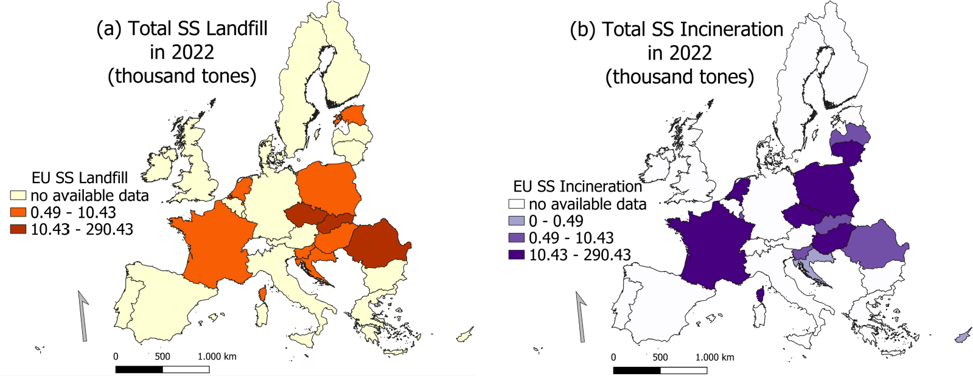
Figure 2. (a) SS landfill treatment, (b) SS incineration treatment in MSs in 2022.

3.2. Statistical Analyses Results
Statistical variables were created in the R integrated suite to collect and extract precise data for all HMs. Table 8 presents the primary statistical data obtained.
Table 8. Statistics of HM national permissible limits.
 |  |  |  |  |  | HM Statistics Data
 | Cd | Pb | Cu | Ni | Zn | Hg | Cr | As | Se | Co | Be | Sb | Th | V | Sn | Mo
No | 27 | 27 | 26 | 26 | 24 | 26 | 23 | 11 | 5 | 3 | 1 | 1 | 1 | 1 | 1 | 1
Mean | 7.66 | 335.13 | 274.43 | 126.44 | 218.08 | 5.47 | 204.04 | 23.18 | 7.60 | 35.50 | 2.00 | 17.50 | 0.35 | 55.00 | 55.00 | 4.00
Median | 3.00 | 165.00 | 100.00 | 61.25 | 4.00 | 1.75 | 100.00 | 20.00 | 10.00 | 50.00 | 2.00 | 17.50 | 0.35 | 55.00 | 55.00 | 4.00
Q1 | 1.50 | 120.00 | 21.18 | 50.00 | 2.50 | 1.00 | 72.50 | 16.00 | 3.00 | 28.25 | 2.00 | 17.50 | 0.35 | 55.00 | 55.00 | 4.00
Q3 | 10.00 | 500.00 | 450.00 | 200.00 | 400.00 | 8.75 | 200.00 | 27.50 | 10.00 | 50.00 | 2.00 | 17.50 | 0.35 | 55.00 | 55.00 | 4.00
Min. | 0.50 | 1.20 | 1.00 | 20.00 | 1.20 | 0.20 | 1.00 | 10.00 | 3.00 | 6.50 | 2.00 | 17.50 | 0.35 | 55.00 | 55.00 | 4.00
Max. | 40.00 | 1375.0 | 1375.0 | 400.00 | 800.00 | 25.00 | 800.00 | 50.00 | 12.00 | 50.00 | 2.00 | 17.50 | 0.35 | 55.00 | 55.00 | 4.00
St.D. | 10.05 | 327.28 | 337.28 | 113.90 | 276.12 | 6.89 | 211.20 | 12.45 | 4.27 | 25.11 | N/A | N/A | N/A | N/A | N/A | N/A
N/A: Not Applicable.
Figure 3 illustrates the distribution of SS production and disposal across the 28 MSs and highlights the share of the total output applied in the agricultural primary sector. Poland, the Netherlands, the Czech Republic, and Hungary are the leading states in production and disposal. At the same time, France, Poland, and Sweden demonstrate the most considerable proportions of SS usage in agriculture.
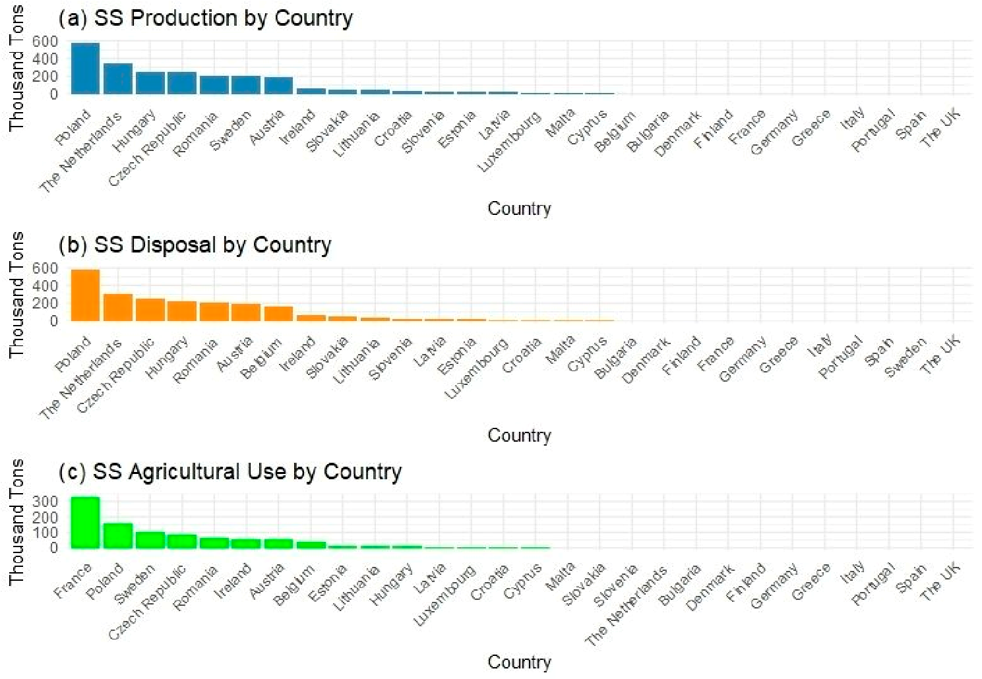
Figure 3. Total production, disposal, and use in agriculture.
In Figure 4, the boxplot illustrates the distribution and value ranges of HMs as dictated by the legislation of the 28 MSs. The analysis reveals that copper, chromium, lead, and zinc possess the most significant value ranges. In contrast, all the remaining HMs exhibit a minimal value variation, resulting in nearly identical values. Moreover, it is noteworthy that a substantial presence of outlier values characterizes chromium.
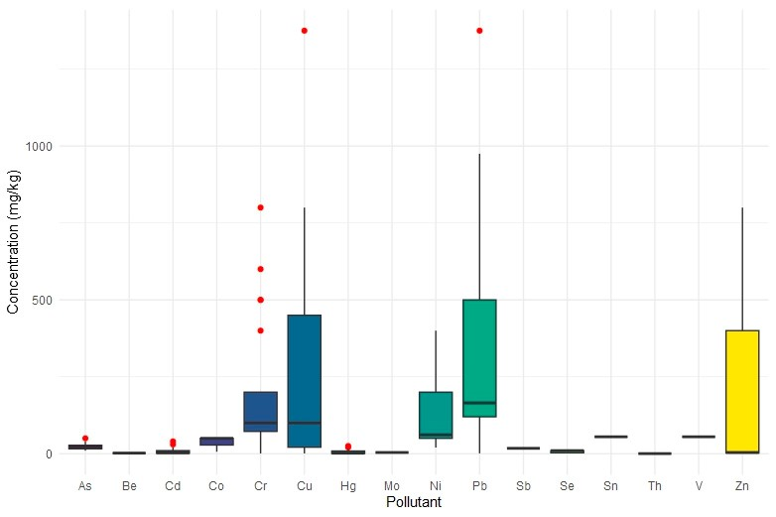
Figure 4. Distribution of pollutant concentrations. Red dots: Outliers concentration values.
The bar graph in Figure 5 quantitatively illustrates the distribution of SS treatment strategies among MSs. France and Hungary predominantly utilize composting for SS management. In contrast, the Netherlands, Belgium, Austria, and Poland favor incineration,
whereas Romania primarily resorts to landfill. Figure 6, presented in boxplots, illustrates each treatment method’s range of distributed values per MS. A pronounced wide range of quantitative differentiation exists among MSs, particularly in the incineration option, where opposing choices are starkly reflected in landfill preferences. Additionally, France’s status as an outlier in composting options and the Netherlands’ unique position in incineration options warrant attention.
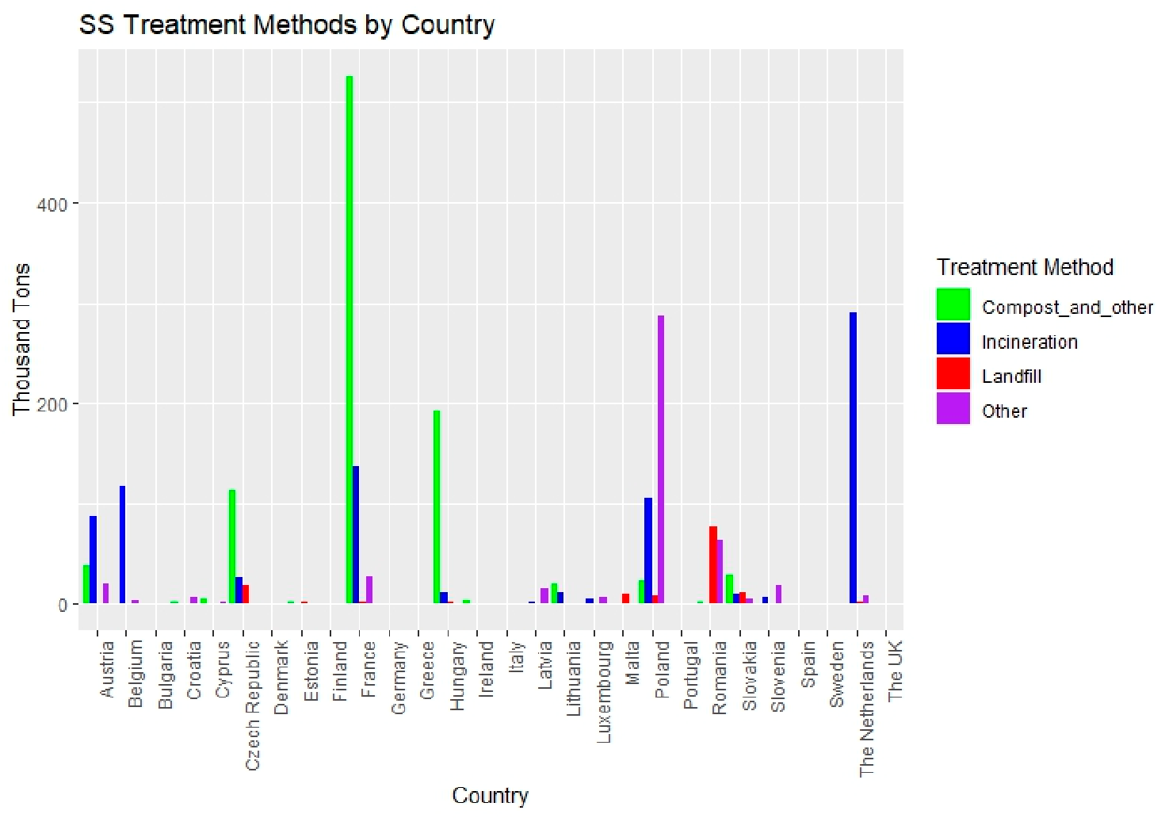
Figure 5. Treatment methods per MS.
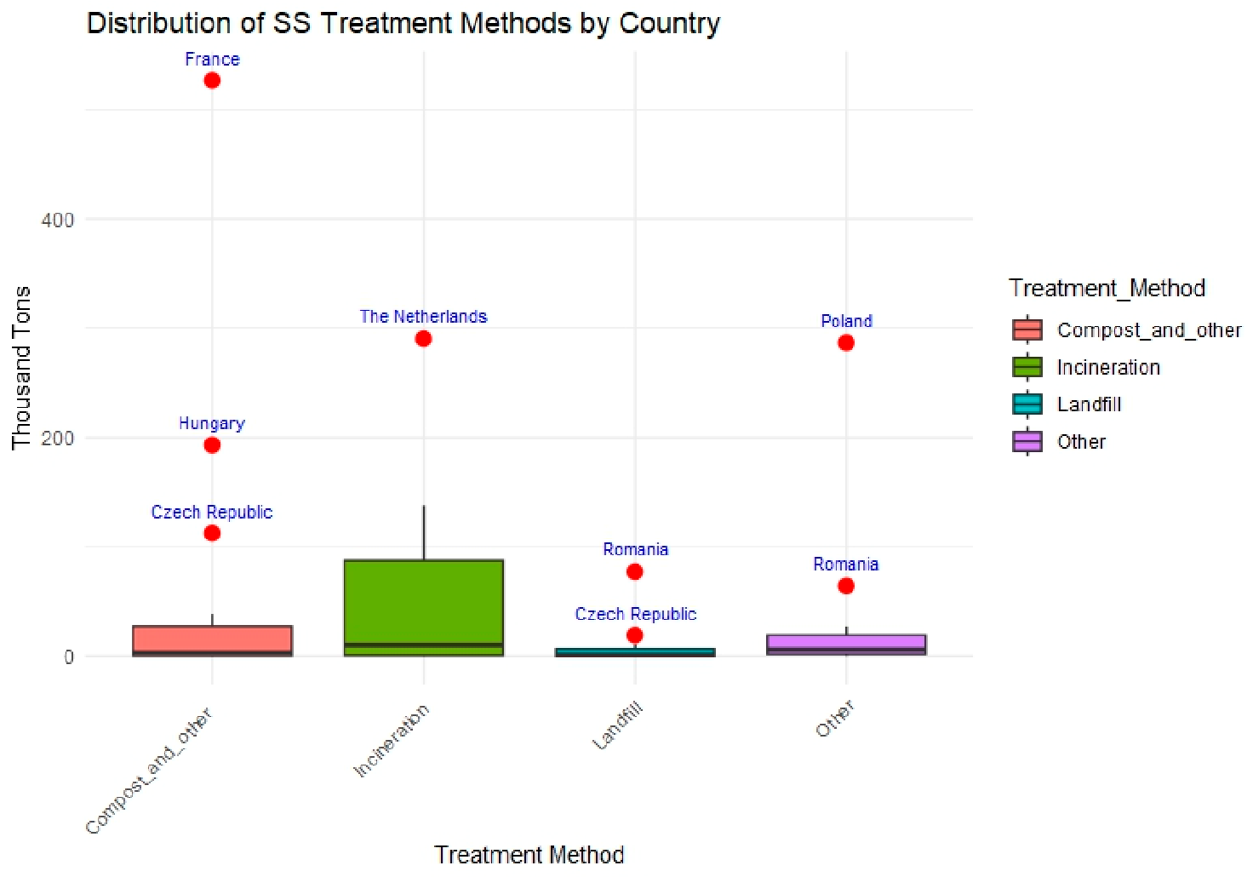
Figure 6. Distribution of SS treatment methods per MS.
The analysis presented in Figure 7 reveals the correlations between various SS treatment approaches. The highest positive correlation was identified between incineration and composting, yielding a correlation coefficient of r = 0.24. The overall results indicate that the treatment methods show minimal correlations, suggesting a lack of significant frequency between the treatments. Furthermore, a slight negative correlation is observed between incineration and landfill, with a coefficient of r = −0.16, indicating negligible correlational tendencies.
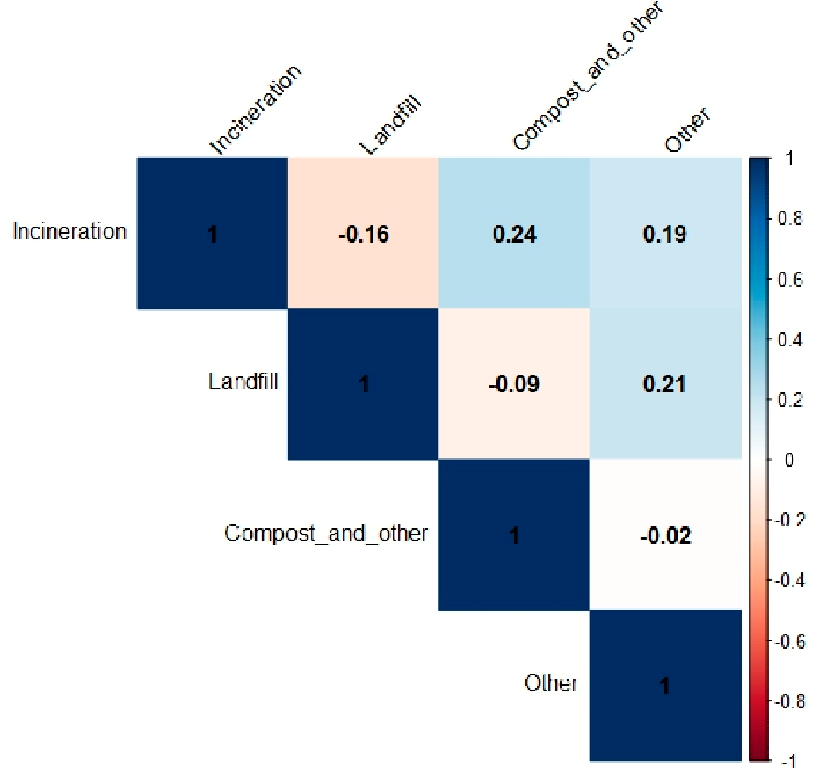
Figure 7. Correlation matrix between SS treatment methods.

4. Discussion
Water, energy, and food safety have ignited global environmental challenges in the last decades, primarily due to the increasing population. Global food safety will focus on finding new nitrogen, phosphorus, and potassium sources to address the fast-growing population and improve crop yields. Apart from soil enrichment with OM [32], the addition of SS could represent a renewable source of phosphorus. Currently, the EU Commission has included both white phosphorus (P4) and phosphate rock among the 20 Critical Raw Materials (CRMs), as reported in the ‘Report on Critical Raw Materials for the EU’ released in 2023 [33]. Hence, SS utilization is an opportunity for industries across the agriculture chain to restore phosphorus in European soils and minimize our reliance on chemicals. Despite the above, the levels of HMs and MPs in crop products, particularly in developing countries, have raised serious concerns about human health [34]. Therefore, strict guidelines and regulatory oversight are necessary to prevent the contamination of agricultural soils and ensure the safe use of SS and biosolids in food production and soil enhancement. The EU is instituting the Directive on Soil Monitoring and Resilience (Think Tank, European Parliament, https://www.europarl.europa.eu/thinktank/en/document/ EPRS_BRI(2024)757627, accessed on 16 October 2024) to promote secure soil health and avert further soil degradation. This directive integrates various soil health descriptors to monitor soil conditions throughout the MSs. Among them, these descriptors include the levels of extractable phosphorus and the concentrations of HMs like arsenic, antimony, cadmium, cobalt, chromium (both total and hexavalent), copper, mercury, lead, nickel, thallium, vanadium, and zinc, along with a selection of organic contaminants specified by the MSs.
Analyzing trends in the management and application of SS in the EU proves to be challenging because of differences in terminology, inconsistencies in data collection, and varying national objectives and limitations imposed by individual EU MSs. Ambiguities in terminology can give rise to diverse interpretations and inaccurate conclusions. For example, Eurostat’s definition of ‘agriculture’ may diverge from its interpretation in the Council Directive. Furthermore, Eurostat’s ‘composting and other processes’ classification may not correspond with its representation within the wider agricultural sector. Moreover, MSs may classify the sludge used for plant cultivation in compost production differently, for example, as ‘reuse in compost’ or ‘other’. Another case outlined in the SWD-2023-{final 158} working document pertains to Eurostat’s data on SS production and disposal routes, which discusses SS dry matter. At the same time, the Council Directive lacks a specific definition of dry matter. Additionally, it has been observed that Eurostat offers limited insights into SS disposal. The information in the data and literature reviewed is limited regarding the comprehensive understanding of sludge management processes in different countries. For instance, there is a notable absence of readily accessible data on the quantities of SS undergoing anaerobic digestion treatment as an intermediate step before the final disposal outcomes are documented. The high level of inconsistency and lack of coherence in the datasets provided by MSs necessitates further examination and resolution through consensus, synthesis, and collaboration among stakeholders, relevant parties, national authorities, and EU decision-making bodies.
Additionally, there is an inconsistency and absence of data provided by EU MSs regarding SS production, disposal, agricultural use, and other relevant aspects. Countries like Spain, Portugal, Greece, Germany, and Italy have not offered clear documentation and data until 2021 (EUR-Lex, https://eur-lex.europa.eu/legal-content/EN/TXT/HTML/ ?uri=CELEX:52004DC0248, accessed on 16 October 2024). Specifically, as of the reference year 2018, four MSs and three MS regions still need to supply data on the total amounts of SS production. Furthermore, for the indicator ‘SS used in agriculture’, three MSs and three MS regions have also lacked data, preventing the definitive identification of trends within the EU. Ultimately, it appears paradoxical when examining the SS issue, as it becomes evident that despite the EU Members establishing, for example, acceptable thresholds of HMs in soils, these limits can vary significantly in certain instances. Upon examining the values outlined in the individual state legislation, it is evident that there is no indication of uniformity and homogeneity. Significant inhomogeneity also exists in the case of the annual permitted HM limits that are deposited in soils by SS. This discrepancy suggests that soil within the EU will inevitably exhibit varying levels of health in the future. Additionally, as shown from data obtained from Eurostat, the treatment methods of SS again vary across the EU. The interpretation of soil contamination–soil health varies throughout the EU, resulting in diverse approaches to comprehending, controlling, and alleviating the adverse impacts of SS on soils.
Since SS amendment involves a multi-prism of pollutants posing risks in the triangle soil–food–human health to our best knowledge, it is necessary as an initial step to balance and set the SS issue in a proper and robust foundation to avoid different ‘translations’ and analyses of the SS matter. Moreover, in a holistic legislation framework, the upcoming revisions or additions must include standardized methods for sampling, contamination prevention, validation, and quality control procedures and reproducible analytical methods for analyzing at least a significant part of the common soil pollutants in SS, such as the MPs. To enhance the accuracy and validity of future analytical research and data on MPs, it is recommended to establish certified reference materials for MPs in soil, certified MP particle standards (with different polymer types, sizes, shapes, and degrees of ageing), and labeled polymer standards with and without chemicals (e.g., absorbed and additive chemicals) as an initial target. Currently, robust analytical techniques have been developed to monitor MPs in soil, such as Fourier-transform infrared (FTIR) and Raman spectroscopy; absorption methods, including the employment of eco-friendly materials (sponges or powders) [35]; and bioremediation methods (bacteria, fungi, seagrasses, and macrophytes) [36,37], which have recently seen a rise in interest, attributed mainly to their economic and environmentally friendly characteristics. Indicatively, towards monitoring MPs, a successful synthesis of an eco-friendly adsorbent with surface functionalities and magnetic attributes was achieved to remove polystyrene MPs from soils. This involved the modification of fly ash through the incorporation of iron ions [38]. Despite the numerous techniques proposed by soil science, it is crucial to advance reliable, precise methods to reach a broad European or global consensus on accepted in situ techniques for quickly detecting MPs. Furthermore, the suggested future legislative framework should incorporate automated purification protocols to decrease labor intensity, background contamination, and potential errors. To harmonize the EU-wide legislation on SS application, it is essential to establish thresholds for emerging contaminants such as MPs, PIE, and PSPs. These thresholds should be determined at the soil district level—geographical entities defined by MSs for soil health assessment and management [39]—accounting for soil types, climatic conditions, land use, and socio-economic and cultural factors [40]. Standardized analytical methods must complement these thresholds to ensure consistency in pollutant monitoring. Additionally, aligning SS legislation with the EU Green Deal’s principles of the circular economy and pollution prevention would promote the sustainable use of sludge as a resource, highlighting its role in nutrient recovery, environmental protection, and socio-economic resilience. These measures would address the regulatory gaps while fostering environmental sustainability and equitable development across the EU.

5. Conclusions
SS is abundant in nutrients, which makes it potentially valuable as a fertilizer or soil conditioner. However, the HMs in it restrict its applications or even make it impossible to use. The EU regulates the use of SS in agriculture through Directive 86/278/EEC. Despite that, the directive is limited in scope, addressing only a few specific organic pollutants and HM elements. Environmental pollutants, such as MPs, antibiotics, and PIE, present in biosolids have not been adequately investigated or regulated widely enough to mitigate the risk of their release into the environment and their adverse impact on ecosystems.
A comprehensive review and assessment of European legislative frameworks concerning SS has been conducted at the national level of the EU-28 MSs, considering the permissible levels of all HMs specified in their relevant regulations and directives. This study highlights significant diversity in the legislative frameworks across the EU-28. All MSs adopted different strategies in establishing regulations for applying SS in agricultural fields. Noteworthy differences exist in the limit levels for SS usage in the agriculture sector. This study reveals a lack of consensus regarding the optimal treatment strategies for SS, establishing a standardized definition of MPs, determining acceptable values, and specifying the types of HMs covered in the relevant legislation. Hence, the authors express skepticism regarding the practicality of these limited values in addressing health concerns at a broader level across the EU.
Furthermore, this study explored the involvement of the SWD-2023–{final 158} working document incorporating recommendations and guides for phosphorus recovery and initial efforts to oversee and regulate MPs. Endeavors are pinpointed here to reduce and define regulatory thresholds for MPs, specifically within the domains of cosmetics and medical procedures. In countries like France, the UK, Sweden, and Italy, national legislation prohibits the sale of any substance in the MP state that is 5 mm or less in size [41]. In Luxembourg, the concentration is calculated to be equal to or exceeding 0.01 percent, denoting the ratio between the mass of the MP and the total mass of the sample material that includes the MP. The diverse velocities in the EU-28 are also evident in the context of the phosphorus recovery strategies, which in plenty of MSs is not even included in their legislation, whereas it is currently being formulated in Sweden. The German strategy is a reference point for developing the Swedish strategy. Despite legislation on phosphorus recovery in the Netherlands since 2015, implementation has proven to be challenging.
Hitherto, we conclude that regulatory autonomy exists within the EU; however, to achieve harmonization in such a sensitive environmental matter and to embrace a harmonized holistic approach that accounts for the distinct soil and climatic features of each MS is imperative. Furthermore, it is essential to recognize that soil pollution is a shared challenge within the EU and requires a more standardized legal framework for effective management. Part of a future potential recommendation and suggestion could be to create separate SS management processes tailored to each treatment plant or even on greater scales referring to local regions, incorporating robust monitoring frameworks.
Author Contributions: Conceptualization, D.K. and I.V.; methodology, D.K.; software, D.K., Z.P. and I.V; validation, I.V.; formal analysis, Z.P.; investigation, D.K.; resources, D.K.; data curation, Z.P.; writing—original draft preparation, D.K.; writing—review and editing, D.K and I.V.; visualization, D.K., Z.P. and I.V.; supervision, I.V.; project administration, I.V. and D.H.; funding acquisition, I.V.
and D.H. All authors have read and agreed to the published version of the manuscript.
Funding: H2020 EXCELSIOR: grant number 857510 funded this research.
Institutional Review Board Statement: Not Applicable.
Informed Consent Statement: Not Applicable.
Data Availability Statement: The data presented in this study are available on request from the corresponding author.
Acknowledgments: The authors acknowledge the ‘EXCELSIOR’: ERATOSTHENES: Excellence
Research Center for Earth Surveillance and Space-Based Monitoring of the Environment H2020 Widespread Teaming project (www.excelsior2020.eu, accessed on 16 October 2024). The ‘EXCELSIOR’ project has received funding from the European Union’s Horizon 2020 research and innovation program under Grant Agreement No 857510, from the Government of the Republic of Cyprus through the Directorate General for European Programs, Coordination, and Development and the Cyprus University of Technology.
Conflicts of Interest: The authors declare no conflicts of interest.

References
- Martin, I. Main Drivers on Food Security Takled in Commission Document. European Compost Network. Available online: https://www.compostnetwork.info/main-drivers-on-food-security-takled-in-commission-document/ (accessed on 10 July 2024).
- Rastogi, M.; Verma, S.; Kumar, S.; Bharti, S.; Kumar, G.; Azam, K.; Singh, V. Soil Health and Sustainability in the Age of Organic Amendments: A Review. Int. J. Environ. Clim. Change 2023, 13, 2088–2102. [CrossRef]
- Bagheri, M.; Bauer, T.; Burgman, L.E.; Wetterlund, E. Fifty years of sewage sludge management research: Mapping researchers’ motivations and concerns. J. Environ. Manag. 2023, 325, 116412. [CrossRef] [PubMed]
- Occurrence of Pharmaceuticals and Their Metabolites in Sewage Sludge and Soil: A Review on Their Distribution and Environmental Risk Assessment. Trends Environ. Anal. Chem. 2021, 30, e00125. [CrossRef].
- Ivanová, L.; Mackul’ak, T.; Grabic, R.; Golovko, O.; Koba, O.; Stanˇová, A.V.; Szabová, P.; Grencˇíková, A.; Bodík, I. Pharmaceuticals and illicit drugs—A new threat to the application of sewage sludge in agriculture. Sci. Total Environ. 2018, 634, 606–615. [CrossRef]
- Eid, E.; Shaltout, K.; Alamri, S.; Alrumman, S.; Hussain, A.; Sewelam, N.; Ragab, G. Sewage sludge enhances tomato growth and improves fruit-yield quality by restoring soil fertility. Plant Soil Environ. 2021, 67, 514–523. [CrossRef]
- Mercl, F.; Košnárˇ, Z.; Pierdonà, L.; Ulloa-Murillo, L.M.; Száková, J.; Tlustoš, P. Changes in availability of Ca, K, Mg, P and S in sewage sludge as affected by pyrolysis temperature. Plant Soil Environ. 2020, 66, 143–148. [CrossRef]
- Kominko, H.; Gorazda, K.; Wzorek, Z. The Possibility of Organo-Mineral Fertilizer Production from Sewage Sludge. Waste Biomass Valorization 2017, 8, 1781–1791. [CrossRef]
- Dar, M.I.; Green, I.D.; Naikoo, M.I.; Khan, F.A.; Ansari, A.A.; Lone, M.I. Assessment of biotransfer and bioaccumulation of cadmium, lead and zinc from fly ash amended soil in mustard-aphid-beetle food chain. Sci. Total Environ. 2017, 584–585, 1221–1229. [CrossRef]
- Mohamed, B.; Mounia, K.; Aziz, A.; Ahmed, H.; Rachid, B.; Lotfi, A. Sewage sludge used as organic manure in Moroccan sunflower culture: Effects on certain soil properties, growth and yield components. Sci. Total Environ. 2018, 627, 681–688. [CrossRef] [PubMed]
- Cheng, M.; Wu, L.; Huang, Y.; Luo, Y.; Christie, P. Total concentrations of heavy metals and occurrence of antibiotics in sewage sludges from cities throughout China. J. Soils Sediments 2014, 14, 1123–1135. [CrossRef]
- Latosin´ska, J.; Kowalik, R.; Gawdzik, J. Risk Assessment of Soil Contamination with Heavy Metals from Municipal Sewage Sludge. Appl. Sci. 2021, 11, 548. [CrossRef]
- Delibacak, S.; Voronina, L.; Morachevskaya, E. Use of sewage sludge in agricultural soils: Useful or harmful. Eurasian J. Soil Sci. (EJSS) 2020, 9, 126–139. [CrossRef]
- Loutfy, N.; Fuerhacker, M.; Tundo, P.; Raccanelli, S.; El Dien, A.G.; Ahmed, M.T. Dietary intake of dioxins and dioxin-like PCBs, due to the consumption of dairy products, fish/seafood and meat from Ismailia city, Egypt. Sci. Total Environ. 2006, 370, 1–8. [CrossRef] [PubMed]
- He, S.; Wei, Y.; Yang, C.; He, Z. Interactions of microplastics and soil pollutants in soil-plant systems. Environ. Pollut. 2022, 315, 120357. [CrossRef]
- Dreshaj, A.; Millaku, B.; Gashi, A.; Elezaj, E.; Kuqi, B. Concentration of Toxic Metals in Agricultural Land and Wheat Culture (Triticum aestivum L.). J. Ecol. Eng. 2022, 23, 18–24. [CrossRef]
- Azeem, I.; Adeel, M.; Ahmad, M.A.; Shakoor, N.; Jiangcuo, G.D.; Azeem, K.; Ishfaq, M.; Shakoor, A.; Ayaz, M.; Xu, M.; et al. Uptake and Accumulation of Nano/Microplastics in Plants: A Critical Review. Nanomaterials 2021, 11, 2935. [CrossRef] [PubMed]
- Jia, H.; Wu, D.; Yu, Y.; Han, S.; Sun, L.; Li, M. Impact of microplastics on bioaccumulation of heavy metals in rape (Brassica napus L.). Chemosphere 2022, 288, 132576. [CrossRef] [PubMed]
- Ajith, N.; Arumugam, S.; Parthasarathy, S.; Manupoori, S.; Janakiraman, S. Global distribution of microplastics and its impact on marine environment—A review. Environ. Sci. Pollut. Res. 2020, 27, 25970–25986. [CrossRef] [PubMed]
- Song, Y.K.; Hong, S.H.; Jang, M.; Han, G.M.; Shim, W.J. Occurrence and Distribution of Microplastics in the Sea Surface Microlayer in Jinhae Bay, South Korea. Arch. Environ. Contam. Toxicol. 2015, 69, 279–287. [CrossRef]
- Batool, A.; Valiyaveettil, S. Surface functionalized cellulose fibers—A renewable adsorbent for removal of plastic nanoparticles from water. J. Hazard. Mater. 2021, 413, 125301. [CrossRef] [PubMed]
- Nizzetto, L.; Futter, M.; Langaas, S. Are Agricultural Soils Dumps for Microplastics of Urban Origin. Environ. Sci. Technol. 2016, 50, 10777–10779. [CrossRef]
- COMMISSION STAFF WORKING DOCUMENT Towards a Monitoring and Outlook Framework for the Zero Pollution Ambition Accompanying the Document Communication from the Commission to the European Parliament, the Council, the European Economic and Social Committee and the Committee of the Regions Pathway to a Healthy Planet for All EU Action Plan: “Towards Zero Pollution for Air, Water and Soil”. 2021. Available online: https://eur-lex.europa.eu/legal-content/EN/ALL/?uri=CELEX: 52021SC0141 (accessed on 10 July 2024).
- R: The R Foundation. Available online: https://www.r-project.org/foundation/ (accessed on 11 October 2024).
- Nunes, N.; Ragonezi, C.; Gouveia, C.S.S.; Pinheiro de Carvalho, M.Â.A. Review of Sewage Sludge as a Soil Amendment in Relation to Current International Guidelines: A Heavy Metal Perspective. Sustainability 2021, 13, 2317. [CrossRef]
- 6. Agricultural Use of Sewage Sludge. Available online: https://www.fao.org/4/T0551E/t0551e08.htm (accessed on 29 August 2024).
- Pescod, M. Wastewater Treatment and Use in Agriculture—FAO Irrigation and Drainage Paper 47. 1992. Available online:
https://www.semanticscholar.org/paper/Wastewater-treatment-and-use-in-agriculture-FAO-and-Pescod/e6e5fa11aa40cb1cc2 82c844005aa2421b557a21 (accessed on 10 July 2024).
- Chang, A.; Pan, G.; Page, A.; Asano, T. Developing Human Health-Related Chemical Guidelines for Reclaimed Waster and Sewage Sludge Applications in Agriculture; World Health Organization: Amsterdam, The Netherlands, 2001.
- Hudcová, H.; Vymazal, J.; Rozkošný, M. Present restrictions of sewage sludge application in agriculture within the European Union. Soil. Water Res. 2018, 14, 104–120. [CrossRef]
- Jordanian Standards 1145:2016; SSWM—Find Tools for Sustainable Sanitation and Water Management! Jordan Standards and Metrology Organization: Amman, Jordan, 2016. Available online: https://sswm.info/node/12558#:~:text=This%20Jordanian%20 standard%20defines%20mandatory,):%20Jordanian%20Standards%201145:2016 (accessed on 16 October 2024).
- Axford, I.; Hill, D.S.; Bird, G.; Singh, D.S.; Macintyre, K. A Feasibility Study Investigating Action Limits for Certain Heavy Metal Impurities in Cosmetic Products. Available online: https://assets.publishing.service.gov.uk/media/6411b8b9e90e0776a0d957c8 /heavy-metals-in-cosmetics.pdf (accessed on 16 October 2024).
- Epstein, E. Land Application of Sewage Sludge and Biosolids; CRC Press: Boca Raton, FL, USA, 2002; ISBN 978-0-429-14324-3.
- Directorate-General for Internal Market, Industry, Entrepreneurship and SMEs (European Commission); Grohol, M.; Veeh, C. Study on the Critical Raw Materials for the EU 2023: Final Report; Publications Office of the European Union: Luxembourg, 2023. [CrossRef].
- Lee, Y.; Cho, J.; Sohn, J.; Kim, C. Health Effects of Microplastic Exposures: Current Issues and Perspectives in South Korea. Yonsei Med. J. 2023, 64, 301. [CrossRef] [PubMed]
- Cao, Y.; Zhao, M.; Ma, X.; Song, Y.; Zuo, S.; Li, H.; Deng, W. A critical review on the interactions of microplastics with heavy metals: Mechanism and their combined effect on organisms and humans. Sci. Total Environ. 2021, 788, 147620. [CrossRef]
- Ebrahimbabaie, P.; Yousefi, K.; Pichtel, J. Photocatalytic and biological technologies for elimination of microplastics in water: Current status. Sci. Total Environ. 2022, 806, 150603. [CrossRef]
- Masiá, P.; Sol, D.; Ardura, A.; Laca, A.; Borrell, Y.J.; Dopico, E.; Laca, A.; Machado-Schiaffino, G.; Díaz, M.; Garcia-Vazquez, E. Bioremediation as a promising strategy for microplastics removal in wastewater treatment plants. Mar. Pollut. Bull. 2020, 156, 111252. [CrossRef]
- Zhao, H.; Huang, X.; Wang, L.; Zhao, X.; Yan, F.; Yang, Y.; Li, G.; Gao, P.; Ji, P. Removal of polystyrene nanoplastics from aqueous solutions using a novel magnetic material: Adsorbability, mechanism, and reusability. Chem. Eng. J. 2022, 430, 133122. [CrossRef]
- Proposal for a DIRECTIVE OF THE EUROPEAN PARLIAMENT AND OF THE COUNCIL on Soil Monitoring and Resilience (Soil Monitoring Law). 2023. Available online: https://eur-lex.europa.eu/legal-content/EN/TXT/?uri=CELEX:52023PC0416 (accessed on 3 December 2024).
- Wadoux, A.M.J.-C.; Courteille, L.; Arrouays, D.; De Carvalho Gomes, L.; Cortet, J.; Creamer, R.E.; Eberhardt, E.; Greve, M.H.; Grüneberg, E.; Harhoff, R.; et al. On soil districts. Geoderma 2024, 452, 117065. [CrossRef]
- Drohmann, D. Microplastics · Regulating Microplastics: The Global Status on Microbeads Control Legislation in Cosmetics & Personal Care Products. Int. Chem. Regul. Law Rev. 2018, 1, 79–86.
Disclaimer/Publisher’s Note: The statements, opinions and data contained in all publications are solely those of the individual author(s) and contributor(s) and not of MDPI and/or the editor(s). MDPI and/or the editor(s) disclaim responsibility for any injury to people or property resulting from any ideas, methods, instructions or products referred to in the content.

. Introduction Soil health is the sustained capacity of soil to function as a vital living ecosystem that supports plant, animal, and human life, while connecting agricultural and soil science to policy, stakeholder needs, and sustainable supply chain management [1]. Maintaining soil health is critical for ensuring the long-term sustainability of agriculture, safeguarding the environment, and promoting the well-being of populations. However, maintaining soil health faces several challenges, particularly regarding nutrient management and the replenishment of organic matter (OM) [2]. One potential solution to address these challenges, including the concept of the circular economy, is the utilization of SS in agriculture [3]. SS is a complex matrix due to its challenging nature and diverse composition [4]. According to the most recent information from Eurostat, in 2021, approximately 15 million tons of sludge (dry matter) was produced in the EU-28 [5].

