Exploitation of Copernicus satellite data for monitoring fishing shelters in
Cyprus using advanced InSAR techniques: The case study of Agios
Georgios Pegeias fishing shelter in Paphos, Cyprus

Kyriaki Fotiou*^{a,b}, Marios Tzouvarasª, Stavroula Alatza^{c}, Alex Apostolakis^{c}, Christodoulos Mettasª,
Charalampos Kontoes^{c}, Chris Danezis^{a,b}, Diofantos G. Hadjimitsis^{a,b}

ªERATOSTHENES Centre of Excellence, Department of Resilient Society, 82 Franklin Roosevelt,
3012 Limassol, Cyprus
^{b}Cyprus University of Technology, Department of Civil Engineering and Geomatics, P.O BOX
50329, Limassol, 3036, Cyprus
^{c}National Observatory of Athens, Operational Unit BEYOND Centre for Earth Observation
Research and Satellite Remote Sensing IAASARS/NOA, GR-152 36 Athens, Greece

ABSTRACT
Fishing shelters are among the critical infrastructures that necessitate continuous monitoring to ensure their functionality and safety in Cyprus. Currently, Cyprus hosts sixteen (16) operational fishing shelters, covering the coastline. In the last few decades, Advanced Interferometric SAR techniques have been the most effective methods for concurrent monitoring critical infrastructures. The current study investigates the potential of the A-InSAR techniques to identify displacements of the fishing shelters in Cyprus. Following various discussion with the relevant stakeholders, the Agios Georgios Pegeias fishing shelter in Paphos was selected as the pilot study for further investigation. The satellite dataset consists of 148 Copernicus Sentinel-1A in descending mode, covering a time span of 2019-2023, achieving comprehensive and cost-free monitoring. The PSI technique was carried out using the freely available snap2stamps and StaMPS toolboxes, as well as the Matlab and ArcGIS Pro commercial software. The results of this study presented a slight displacement of about -5 mm/year at the edge of the fishing shelter, while the broader area remains stable. The displacement rates are referred to the LoS and they are visualized in GIS environment.
Keywords: InSAR, fishing shelters, Sentinel-1, Cyprus, disaster risk reduction

INTRODUCTION
Fishing shelters serve as critical infrastructures, providing safe harboring and mooring for professional fishing vessels. Also, in every fishing shelter there are slipways that are open to the public and free of charge. Currently, there are sixteen (16) operational fishing shelters in Cyprus, covering the coastal zone of the island, as depicted in Figure 1. The continuous improvement works that are made on a constant basis, provide safety and cover the needs of each fishing shelter, on a buffer zone of 100m around each fishing shelter¹. The need for continuously monitoring these infrastructures is essential, ensuring their safety and effective use. Advanced Interferometric Synthetic Aperture Radar (A-InSAR) techniques are among the most effective methods for simultaneously monitoring multiple critical infrastructures, utilizing freely available Copernicus Sentinel-1 satellite imagery, resulting to a holistic monitoring without cost². Specifically, techniques such as Persistent Scatterer Interferometry (PSI)³ and Small BAseline Subset (SBAS)⁴ can detect potential displacement rates with an accuracy of millimeters to centimeters level. Several studies proved that the above-mentioned techniques serve as an important tool for estimating and monitoring the displacement rates in cases of critical infrastructures using remote sensing^{5–9}. The monitoring of displacements on the coastal zone areas is challenging due to their dynamic environment^{10– 13}. This study aims to use the above-mentioned techniques, exploiting the characteristics of the Copernicus Programme and its Sentinel-1¹⁴ SAR imagery to identify potential displacements in fishing shelters in Cyprus. After discussions with the national authorities responsible, i.e., the Department of Fisheries and Marine Research (Ministry of Agriculture, Rural Development, and Environment) and the Department of Public Works in Cyprus (Ministry of Transport, Communications
and Works), one region, the fishing shelter of Agios Georgios in Pegeia region, was selected as pilot site for further investigation.
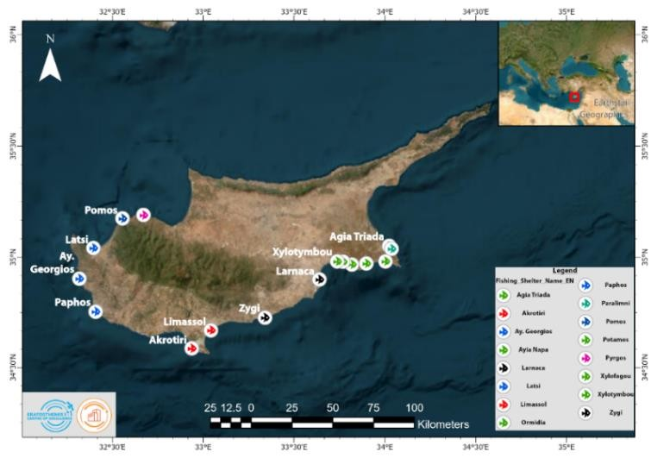
Figure 1: Fishing Shelters across the coastal zone of Cyprus

STUDY AREA
The Agios Georgios Pegeias fishing shelter is located in the area of Mandoullis of Agios Georgios Pegeias in Paphos and has a capacity of about 20 vessels, as shown in Figure 2. The fishing shelter was built in 1981 and since then, various improvements have been made. The fishing shelter took the form it has today in 2007. Exactly opposite the Agios Georgios fishing shelter there is a small island named Geronisos. Geronisos island stirs the interest of explorers and archeologists since it is a shelter for numerous birds, mainly seagulls, and presents archaeological remains. Additionally, Agios Georgios Pegeias fishing shelter offers panoramic views of the Mediterranean Sea. Therefore, the fishing shelter has, among others, a social, economic and tourist impact in the region¹⁵, developing the necessity to be further monitored.
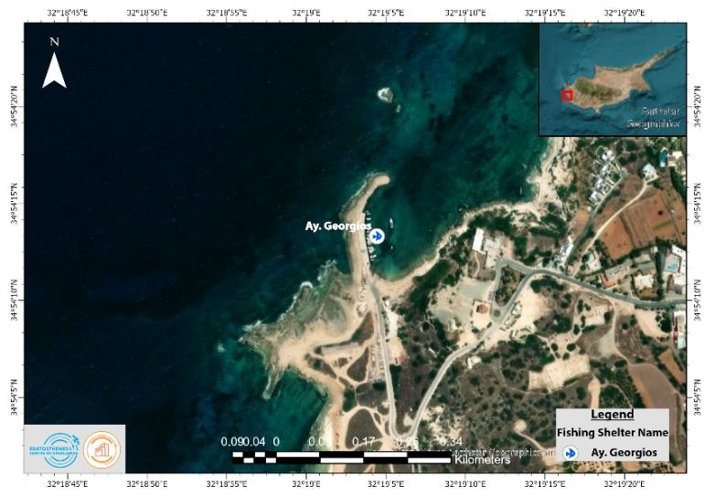
Figure 2: Map of the Agios Georgios fishing shelter in Pegeia, Paphos

METHODOLOGY

Data
The study utilized open-access data from the Copernicus Sentinel-1A¹⁶ constellation, ensuring the reusability and the expansion of the current endeavor to a larger scale, on a national level. The system of the Sentinel-1 satellites provides a repeat cycle of 6-12 days over Cyprus, functioning in C-band (5.4 GHz)¹⁷. The dataset is consisted of 148 Single-Look Complex (SLC) acquisitions in Interferometric Wide (IW) mode with similar characteristics, spanning from January 2019 to December 2023, as presented in Table 1. Moreover, the acquisitions were obtained in descending mode, from path 167, to ensure comprehensive coverage of the study area. The Vertical-Vertical (VV) polarization mode was selected as the preferable polarization, since it is mostly used for monitoring land displacements¹⁸. As the primary image of the dataset, the 30th of June 2021 was selected, since it minimizes the spatial and temporal decorrelation between the baselines of the acquisitions¹⁹.
Table 1: Calendar of Sentinel-1A dataset from 2019-2023

Month | 2019 | 2020 | 2021 | 2022 | 2023
January | 12, 24 | 07, 19, 31 | 01, 13, 25 | 08, 20 | 03, 15, 27
February | 05, 17 | 12, 24 | 06, 18 | 01, 13, 25 | 08, 20
March | 01, 13, 25 | 07, 19, 31 | 02, 14, 26 | 09, 21 | 04, 16, 28
April | 06, 30 | 12, 24 | 07, 19 | 02, 26 | 09, 21
May | 12, 24 | 06, 18, 30 | 01, 13, 25 | 08, 20 | 03, 15, 27
June | 05, 17, 29 | 23 | 06, 18, 30* | 01, 13, 25 | 08, 20
July | 11, 23 | 05, 17, 29 | 12, 24 | 07, 19, 31 | 02, 14, 26
August | 04, 16, 28 | 10, 22 | 05, 17, 29 | 12 | 07, 19, 31
September | 09, 21 | 03, 15, 27 | 10, 22 | 05, 17, 29 | 12, 24
October | 03, 15, 27 | 09, 21 | 04, 16, 28 | 11, 13 | 06, 18, 30
November | 08, 20 | 02, 14, 26 | 09, 21 | 04, 16, 28 | 11, 23
December | 02, 14, 26 | 08, 20 | 03, 15, 27 | 10,22 | 05, 17, 29

Data Processing
The processing of the dataset followed the PSI methodology. PSI workflow methodology was divided into three (3) main parts, as presented in Figure 3. The first part regards the pre-processing methodology of the dataset, in order to prepare the dataset for the PSI processing. Specifically in this part, the single-primary Differential Interferometry SAR (DInSAR) processing using the ESA SNAP v10.0 was conducted. The pre-processing was conducted using the open-source toolbox “snap2stamps” v.2²⁰. The second part was carried out using the StaMPS/MTI²¹ open-source toolbox. Following the first part, the selection of the PS candidates based on the coherence performance along with their statistics, the phase unwrapping and the filtering in each pair were applied using the Matlab²² software. Finally, the calculation of the LoS displacements of each PS were exported, enabling the visualization of the results. The latter was performed leveraging the ArcGIS Pro software, powered by ESRI.
Additionally to the satellite data, the primary sources that drive the current study include a DEM and external shapefiles. The Shuttle Radar Terrain Model (SRTM)²³ from USGS was used as the external DEM. Regarding the shapefiles of the fishing shelters in Cyprus, those are obtained from the Department of Fisheries and Marine Research which is under the Ministry of Agriculture, Rural Development and Environment.
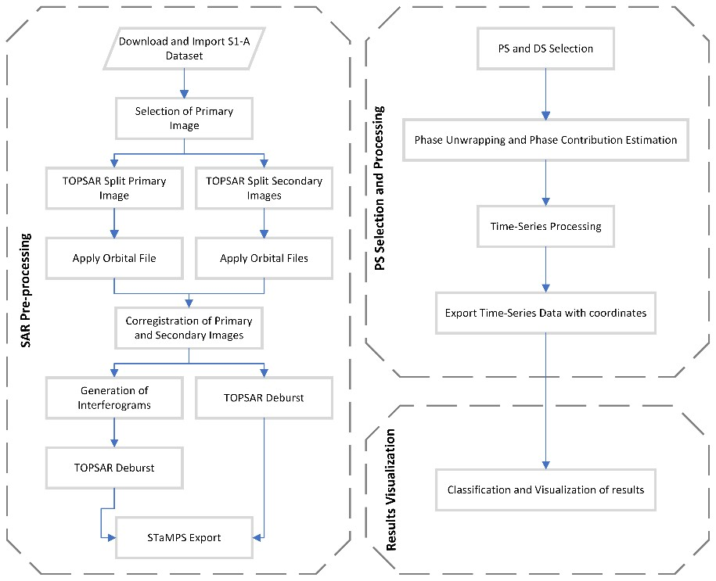
Figure 3: Overall methodology of PSI processing.

RESULTS AND DISCUSSION
Following the PSI methodology along with the additional resources, the geographic information of the PSs along with the LoS displacements were presented in Figure 4. The results were classified into six (6) classes for visualization purposes, covering the LoS displacement range of -6.0 mm/year to 4.5 mm/year. The results of the PSI processing indicated displacement rates up to -5 mm/year, especially at the edge of the fishing shelter. It is noteworthy that the geolocation of the points needs to be improved since no reliable reference point was selected during the data processing. Overall, the fishing shelter of Agios Georgios Pegeias seems to be stable except from the edge of the fishing shelter.

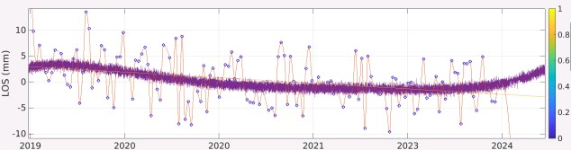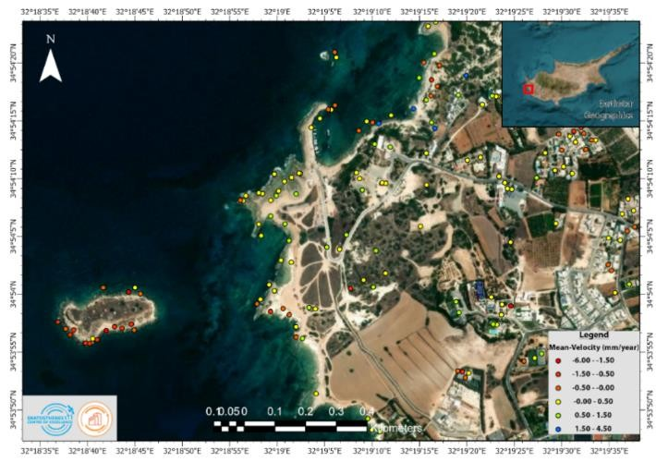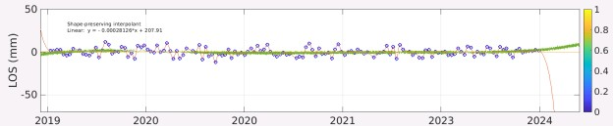

Figure 4: Displacement map of Agios Georgios Pegeias fishing shelter in Paphos, Cyprus

CONCLUSION AND FUTURE STEPS
The current study presents the preliminary results of monitoring fishing shelters in Cyprus using advanced InSAR techniques, and specifically the Agios Georgios Pegeias fishing shelter as the pilot study. Detected displacements using the A-InSAR techniques, such as the PSI showed an average LoS displacement rate up to -5 mm/year over the five-year study. This rate could be related to the design / construction condition or the swelling of the infrastructure as the structure is built in the sea. The importance of displacement monitoring fishing shelters in Cyprus is essential for the continuous monitoring of the stability of the infrastructure, ensuring the safety and resilience of the fisheries, the public and the broader environment. Through the knowledge transfer and close collaboration between the above-mentioned organizations, the displacement rates were successfully calculated. The current study is the beginning of continuous monitoring of critical infrastructures in Cyprus, including structures such as fishing shelters and dams in Cyprus, on a national level.

Last but not least, the study will be reinforced in multiple ways. Specifically, the analysis of the ascending dataset will provide a more sufficient understanding of the displacement rates. Following the latter, the decomposition of displacements in ascending and descending modes will result in retrieving the E-W-U components, enabling the comparison with geodetic measurements. Finally, the processing analysis can be carried out using various software and toolboxes such as the ISCE and SARscape and compare the differences or the accuracy that the results showed.

ACKNOWLEDGEMENTS
The authors acknowledge the 'EXCELSIOR': ERATOSTHENES: Excellence Research Centre for Earth Surveillance and Space-Based Monitoring of the Environment H2020 Widespread Teaming project (www.excelsior2020.eu). The 'EXCELSIOR' project has received funding from the European Union's Horizon 2020 research and innovation programme under Grant Agreement No 857510, from the Government of the Republic of Cyprus through the Directorate General for the European Programmes, Coordination and Development and the Cyprus University of Technology.

REFERENCES
- “Department of Fisheries and Marine Research - Fishing Shelters and Publicity.”,
<https://www.moa.gov.cy/moa/dfmr/dfmr.nsf/page12_en/page12_en?OpenDocument> (29 May 2024).
- Casagli, N., Bianchini, S., Ciampalini, A., Del Soldato, M., Ezquierro, P., Montalti, R., Shan, M., Solari, L. and Raspini, F., “Sentinel-1 InSAR Data for the Continuous Monitoring of Ground Deformation and Infrastructures at Regional Scale,” [Advances in Remote Sensing for Infrastructure Monitoring], V. Singhroy, Ed., Springer International Publishing, Cham, 63–80 (2021).
- Ferretti, A., Prati, C. and Rocca, F., “Nonlinear subsidence rate estimation using permanent scatterers in differential SAR interferometry,” IEEE Transactions on Geoscience and Remote Sensing 38(5), 2202–2212 (2000).
- Berardino, P., Fornaro, G., Lanari, R. and Sansosti, E., “A new algorithm for surface deformation monitoring based on small baseline differential SAR interferograms,” IEEE Trans. Geosci. Remote Sensing 40(11), 2375– 2383 (2002).
- Ramirez, R. A. and Kwon, T.-H., “Sentinel-1 Persistent Scatterer Interferometric Synthetic Aperture Radar (PS-
InSAR) for Long-Term Remote Monitoring of Ground Subsidence: A Case Study of a Port in Busan, South Korea,” KSCE J Civ Eng 26(10), 4317–4329 (2022).
- Negi, P., Kromanis, R., Dorée, A. G. and Wijnberg, K. M., “Structural health monitoring of inland navigation
structures and ports: a review on developments and challenges,” Structural Health Monitoring 23(1), 605–645 (2024).
- Natsuaki, R., Anahara, T., Kotoura, T., Iwatsuka, Y., Tomii, N., Katayama, H. and Nishihata, T., “Synthetic Aperture Radar Interferometry for Disaster Monitoring of Harbor Facilities,” Journal of Disaster Research 12(3), 526–535 (2017).
- Gao, Q., Crosetto, M., Monserrat, O., Palama, R. and Barra, A., “Infrastructure Monitoring using the Interferometric Synthetic Aperture Radar (InSAR) technique” The International Archives of the
Photogrammetry, Remote Sensing and Spatial Information Sciences XLIII-B3-2022, 271–276 (2022).
- D’Aranno, P. J. V., Di Benedetto, A., Fiani, M., Marsella, M., Moriero, I. and Palenzuela Baena, J. A., “An
Application of Persistent Scatterer Interferometry (PSI) Technique for Infrastructure Monitoring,” 6, Remote Sensing 13(6), 1052 (2021).
- Fotiou, K., Kakoullis, D., Pekri, M., Melillos, G., Brcic, R., Eineder, M., Hadjimitsis, D. G. and Danezis, C.,
“Space-Based Displacement Monitoring of Coastal Urban Areas: The Case of Limassol’s Coastal Front,” 4, Remote Sensing 14(4), 914 (2022).
- Xu, B., Feng, G., Li, Z., Wang, Q., Wang, C. and Xie, R., “Coastal Subsidence Monitoring Associated with Land Reclamation Using the Point Target Based SBAS-InSAR Method: A Case Study of Shenzhen, China,” 8, Remote Sensing 8(8), 652 (2016).
- Polcari, M., Albano, M., Montuori, A., Bignami, C., Tolomei, C., Pezzo, G., Falcone, S., La Piana, C., Doumaz,
F., Salvi, S. and Stramondo, S., “InSAR Monitoring of Italian Coastline Revealing Natural and Anthropogenic Ground Deformation Phenomena and Future Perspectives,” 9, Sustainability 10(9), 3152 (2018).
- Melet, A., Teatini, P., Le Cozannet, G., Jamet, C., Conversi, A., Benveniste, J. and Almar, R., “Earth Observations for Monitoring Marine Coastal Hazards and Their Drivers,” Surv Geophys 41(6), 1489–1534 (2020).
- Geudtner, D., Torres, R., Snoeij, P., Davidson, M. and Rommen, B., “Sentinel-1 System capabilities and applications,” 2014 IEEE Geoscience and Remote Sensing Symposium, 1457–1460 (2014).
- “Agios Georgios Pegeias Fishing Shelter.”, Cyprus Island, 4 November 2023,
<https://www.cyprusisland.net/attractions/agios-georgios-pegeias-fishing-shelter> (3 June 2024 ).
- Rostan, F., Riegger, S., Huchler, M., Croci, R., Torres, R. and Snoeij, P., “The Sentinel-1 C-SAR Instrument Design & Performance,” 8th European Conference on Synthetic Aperture Radar, 1–3 (2010).
- Torres, R., Snoeij, P., Geudtner, D., Bibby, D., Davidson, M., Attema, E., Potin, P., Rommen, B., Floury, N., Brown, M., Traver, I. N., Deghaye, P., Duesmann, B., Rosich, B., Miranda, N., Bruno, C., L’Abbate, M., Croci, R., Pietropaolo, A., et al., “GMES Sentinel-1 mission,” Remote Sensing of Environment 120, 9–24 (2012).
- Koppel, K., Zalite, K., Voormansik, K. and Jagdhuber, T., “Sensitivity of Sentinel-1 backscatter to characteristics of buildings,” International Journal of Remote Sensing 38(22), 6298–6318 (2017).
- Smittarello, D., d’Oreye, N., Jaspard, M., Derauw, D. and Samsonov, S., “Pair Selection Optimization for InSAR Time Series Processing,” Journal of Geophysical Research: Solid Earth 127(3), e2021JB022825 (2022).
- Foumelis, M., Delgado Blasco, J. M., Desnos, Y.-L., Engdahl, M., Fernandez, D., Veci, L., Lu, J. and Wong, C.,
“Esa Snap - Stamps Integrated Processing for Sentinel-1 Persistent Scatterer Interferometry,” IGARSS 2018 - 2018 IEEE International Geoscience and Remote Sensing Symposium, 1364–1367 (2018).
- Data preparation for StaMPS PSI processing with SNAP - Mexico City 2020 (version 1.1)., .
- The MathWorks Inc., “Statistics and Machine Learning Toolbox Documentation” (2022).
- Earth Resources Observation and Science (EROS) Center., “Shuttle Radar Topography Mission (SRTM) 1 ArcSecond Global” (2017).

