Mapping and measuring the phenomenon of precariousness in Cyprus: challenges and implications

Petros Kosmas, Antonis Theocharous, Elias Ioakimoglou, Petros Giannoulis, Leonidas Vatikiotis, Maria Panagopoulou, Lamprianos Lamprianou, Hristo Andreev and Aggeliki Vatikioti

Table of Contents
1. Introduction 4
2. Theoretical framework 5
3. The case of Cyprus 8
4. Methodological approach 9
4.1 Research Questions 9
4.2 Quantitative research design 9
4.2.1 Three Indicators 10
4.3 Qualitative Research Design 12
5. Empirical analysis 13
5.1 Quantitative analysis 13
5.1.1 Profiling and mapping the precarious workers and precariousness 13
5.1.2. Factors affecting labour income of the precarious workers 20
5.1.3. What makes a precarious worker? Determining factors affecting the risk of precariousness 28
5.1.4 Precarity: Where economic vulnerability and precarious work meet 29
5.2 Qualitative Analysis 34
6. Discussion and Conclusions 36
Limitations 37
Future Research 37
7. References 39

Mapping and measuring the phenomenon of precariousness in Cyprus: challenges and implications

Petros Kosmas, Antonis Theocharous, Elias Ioakimoglou, Leonidas Vatikiotis, Petros Giannoulis, Maria Panagopoulou, Lamprianos Lamprianou, Hristo Andreev and Aggeliki Vatikioti

ABSTRACT
This research study utilises a mixed design model to empirically measure and address the phenomenon of precarious work and precariousness. For the purposes of this study precariousness is perceived as a condition in which people face specific dangers, risk of disease or accident, material deprivation and poverty. Furthermore, as a result of precarious employment, insufficient income and lack of property, these individuals are not able to cope or be exposed to prolonged periods of unemployment and its subsequent social risks and dangers.
By analysing data from the EU-SILC (2020) for Cyprus, the characteristics of precarious employees were identified, along with the factors contributing to precariousness. The majority of precarious workers in Cyprus were women, immigrants and young people. Following this, precarity was examined as a condition in which precariousness and economic vulnerability intersect and interact. Precarious workers accounted for 9,5% of all employees in 2019, whereas those in precarity (i.e., precarious and economically vulnerable) amounted for 4,4% of all employees. The present research attempts to contribute to the discussion of class theory by bringing new variables and introducing new empirical approaches to the examination of precarious employment and precariousness. The results of this study are intended to provide stakeholders with an enhanced understanding of the phenomenon which will ultimately lead to new theoretical and policy avenues towards its reduction and elimination.
Keywords: Precarious work; Precariousness; Vulnerability; Class theory; Cyprus.

Acknowledgements: The study was funded by the A.G. Leventis Foundation and the Hellenic Observatory at the London School of Economics and Political Sciences. The authors would like to thank all those who participated in the project.

1. Introduction

The current study provides an empirical investigation of the rise of precarious work and the extent of precariousness in the labour market of Cyprus. The paper is structured as follows: Initially, a detailed discussion of the current debates on precarious work and precariousness is provided, as well as the challenges inherent in applying our methodological approach and addressing empirically the phenomenon. The statistical techniques that were employed are presented in the second section and finally the empirical results are presented and discussed.
By utilising data from EU-SILC (2020) database, the individuals who meet the criteria of precariousness were identified and their main characteristics were described (age, gender, level of education, work experience, job specialization, employment relationship etc.). Classification Tree Analysis (CTA) was used to describe the internal structure of precarious work and identify factors that affect labour income and the probability of workers experiencing precariousness. By rearranging Olsthoorn’s five aspects of precariousness, two indicators derived that examine: (a) Economic Vulnerability, defined as having a low income, a propensity to save, and no outright ownership of a house and (b) Precarity, as a condition in which Economic Vulnerability intersects and interacts with Precariousness (Olsthoorn, 2013).
Considering the complexity of the phenomena under study, a focus group was conducted to elaborate and investigate further research questions and fill in any possible research gaps from the previous empirical analysis. Among the primary areas of investigation were the characteristics of precarious workers in Cyprus, the role of the state and the labour unions. An overview of these findings is presented in the relevant chapter at the end of the third section.
The paper concludes with a discussion of key findings from this investigation and their implications for future research and policy guidance.

2. Theoretical framework

From the beginning of their implementation, neoliberal policies were intended to deregulation of the market, thereby reducing the subsistence levels of working-class people (Pulignano, 2018; Castel, 2016; Standing, 2009). Since the 1990s -and particularly intensely after 2000- this policy option has been pervaded by the deregulation of the labour market and the increasing precariousness of employment. In fact, these developments have played a crucial role in providing a favourable environment for the emergence of precarious work and, consequently, precariousness (Kalleberg, 2011; Barbier, 2002; Fine, 1998; Bourdieu 1998). This is also the period where concepts and approaches related to precarious work and precariousness beginning to emerge.
Scholars have become aware of the term precariousness following an intervention by the French philosopher Pierre Bourdieu in an international debate on the issue (Grenoble, 12-13 December 1997) where his main argument was that labour market insecurity is prevalent both in the private and public sectors. He further argued that this was due to the increase in precarious forms of employment (temporary, part-time, casual work), where the effects are more or less the same in all industries but become particularly visible in the extreme case of jobless and unemployed individuals. These effects are responsible for the destruction of existence, stripped of its temporal structures and for the deterioration of the relationship between oneself and the world (Bourdieu, 1998).
Since the 2000s, the combination of flexibility and security (flexicurity) of employment constituted the main policy tool for the further growth of precarious employment. In employment, flexibility leads to a reduction in working hours or wages which results in a decrease in the income of workers. These underemployment-derived incomes are often not sufficient for people to maintain a decent standard of living and are below the official poverty threshold. Even though they are not unemployed, precarious workers are included in the working poor scheme (Paugam, 2017).
Castel (2016) argues that neoliberalism has led to a shift in employment relations characterised by deregulation of the labour market, the reshaping of any protective schemes and the development of disconnection (Figure 1). Within Castel's theoretical framework, precariousness has reached the level where it constitutes a permanent layer of the division of labour, i.e., a sub-level below those employed in cases of traditional employment status (Castel, 2003). Moreover, precarious workers alternate between temporary employment and periods of unemployment, a situation that enables them to fall below a level of income, protection, and inclusion that society accepts as normal. In a figurative sense, the concentric circles represent the various levels of social cohesion in the workplace. The integration zone is characterized by stable social relations and stable employment in the core. An outer shell is characterized by a lack of involvement in productive activities and considerable social isolation. An outer shell is characterized by exclusion or disaffiliation. The precariousness zone is at the middle of this spectrum (Castel, 2003). The relationship between these three areas is fluid and dynamic, with the boundaries of the core and the periphery constantly being challenged.



Zone of Integration (stable work and durable social relationships)
Zone of Precariousness (Intermediate unstable zone of social vulnerability)
Zone of Exclusion or Disaffiliation (Absence of any participation in productive activities and relative social isolation)

Fig.1 The Three Zones of Social Cohesion, according to Castel, (2003).

Pitrou (1978b), was the first to list a host of dimensions leading to precariousness. Seven characteristics were observed: “precariousness” (which entails difficult working conditions and low wages, as well as absence of any career prospects); “scarce as well as irregular financial resources”; “instable or unsatisfactory housing conditions”; “health problems”; “uncertainty about the future number of children”; “relative lack of social links” and a “rather precarious balance in terms of the life of the couple” (Pitrou 1978b, p. 51-64).
The concept of precarious employment is explicated by Olsthoorn (2014) as a defining characteristic of the employment relationship, i.e., insecure jobs held by vulnerable employees who have limited entitlements to income support when unemployed (Figure 2). In his words “…precarious employment refers to employment relations that are precarious for the employee, while precarious employees and ‘the precariously employed’ refer to employees in an employment relation that is precarious for them...” (Olsthoorn, 2014: p. 424). Castel (2016), notes that precarious workers shift between informal work and periods of unemployment, a situation that causes them to lower their standard of living, protection, and social inclusion below what is considered normal in society.
A state of precariousness can be defined as a heterogeneous situation, which may take on many forms beyond the wage or income. Furthermore, the term may also refer to a lack of social security and to the inability of the welfare state to provide social protection to individuals in the face of poverty, unexpected unemployment, deprivation, accidents, and illnesses, and in general, the precarious nature of daily life which afflicts many parts of society (Hauben, et. al., 2020; Lewis, et. al., 2019; Olsthoorn, 2014).
Standing (2009) describes precarity as a unique concept. "To obtain by prayer" is the Latin etymological root of precariousness. The ‘precariat’ is a neologism in sociology and economics for a social class formed by people suffering from precarity (Standing, 2011). Members of the precariat in it are losing their citizenship rights: social, civil, economic, cultural, and political rights. As a consequence, they feel like supplicants and are treated as such. The continuing interaction of neoliberal policies in labour markets with restrictive immigration policies has led to the development of the "framework of hyper-precarity trap" (Lewis et., al., 2019). According to De Genova, (2002), there are three ways in which hyper-precarity as a nexus of precarious employment and immigration precarity can be manifested: (a) The "displacement of daily life" which functions as the sole and ultimate mechanism of discipline; (b) High probability of occupational injuries and deaths due to high-risk jobs in specific economic sectors (such as construction, agriculture, catering and cleaning etc.) accompanied by limited or no access to health care; and (c) Informal, human networks usually fill this gap (De Genova, 2002).
The present study explores precariousness as an aspect of precarious work, based on a framework which includes forms of employment relationship offering low levels of control over work, low income, and low social protection. In other words, precariousness is not only seen as a matter of employment but also of status to denote a mode of living within the 'world of work' (Kalleberg, 2018; 2011; De Vilhena, et. al., 2016; Barbier, 2004; Olsthoorn, 2013; Waite, 2009; Pitrou, 1978).



Vulnerable Employees
Insecure Jobs
Unsupportive Entitlements
Precarious Employment

Fig.2: Olsthoorn’s conceptual model for precarious employment

3. The case of Cyprus

The Cyprus labour market is characterised by relatively high shares of non-standard employment and labour fragmentation and has also been marked by one of the highest adjusted wage gaps in the EU between permanent and temporary employees (Da Silva and Turrini, 2015). It is estimated that the informal sector represents over 25% of the Cypriot economy, which is the sixth largest in the EU. Only eastern European countries have larger informal economies (OECD, 2015). Currently, Cyprus is an expanded international tourist, business and service economic hub that relies on precarious employment arrangements. Seasonal work may also be considered precarious for low-skilled workers within sectors of the economy with strong financial turnover, such as the construction and hospitality industries, due to the proliferation of temporary contracts, the majority of which are not voluntary (Eurofound, 2010; Zopiatis et. al., 2014; Vassou et. al., 2017).
Non-standard employment is more likely to be held by women, foreigner workers, and young persons (Anderson, 2007). According to the Cyprus Department of Labour, in 2020 there were 23,107 immigrant domestic workers for household assistance and care. They made up about 36% of the total migrant labour force in Cyprus, which was one of the highest ratios in Europe (Hadjigeorgiou, 2020). Most of them were women, mainly from the Philippines, Sri Lanka, Nepal, India and Vietnam. According to a study on the socio-legal challenges faced by foreign domestic workers in Cyprus (Hadjigeorgiou, 2020) 40% of the domestic workers in Cyprus work more hours than their employment contract provisions.
Following the financial crisis in Cyprus after 2012, non-standard employment also increased considerably among individuals with high accumulate human capital. For example, over the last decade precarious employment affected research and teaching staff in terms of their working conditions and their income and benefits (Ioannou, 2014; Demetriou, 2015). According to the data of a report of the Pancyprian Federation of Labour on Economy and Employment (PEO, 2019), in 2018 approximately 8.5% of wage laborers was at risk of poverty and social exclusion (p.5), which was due to maintaining wages in the low levels as formed already during the period of the economic crisis which simultaneously led to the increase of profitability of the firms. Therefore, during the period of economic recovery (2016-2019) an increase in employment was accomplished under worse terms related to both wages and the employment conditions.

4. Methodological approach

4.1 Research Questions

A mixed-method empirical approach to measure and address the phenomenon of precarious work and precariousness is utilised. This integrated approach aimed at providing empirically grounded results to address the following three (3) main Research Questions (RQ) under investigation.

RQ₁: What is the profile of precarious workers and how they can be mapped in the Cyprus labour market?
RQ₂: Which are the determining factors affecting the risk of precariousness?
RQ₃: Does economic vulnerability and precarious work meet each other and where?

Those RQ also constitute the follow-up steps of both the quantitative and qualitative analysis of the study.

4.2 Quantitative research design

Mapping precariousness
Olsthoorn's methodological conceptualisation of precarious employment is used at the basis of the empirical analytical framework. The methodology proposed by Olsthoorn (2013) incorporates a composite indicator that takes into account the following five primary elements of precariousness:

(1) $W_{i}:$ the wage of $i$ worker, relative to the median;
(2) ${NpC}_{i}:$the kind of contract (permanent or temporary work) of the $i$ worker;
(3) ${Tu}_{i}:$the duration of unemployment periods of the $i$ worker;
(4) $S_{i}:$ the supplementary income of the $i$ worker (Duclos and Mercader-Prats, 2005); and
(5) ${UB}_{i}:$the $i$ worker's entitled unemployment benefits (UB).

A synthetic indicator that integrates in Olsthoorn’s five aspects of precariousness is estimated for each worker. Additionally, we rearrange Olsthoorn's five aspects of precariousness into two indicators, one that focuses on the labour market and one that scrutinizes the social reproduction process. Rather than using eligibility for unemployment benefits, which is low in Cyprus, we use Home Ownership (Ho_{i}), defined as being the outright owner of his or her principal residence with no outstanding loans or mortgages, which is a rather frequent occurrence in Cyprus.
In addition, the economic structure, which is the system of economic relationships that remains constant in all developed countries, exhibits infinite variations because contingency circumstances differ from country to country (and therefore can only be evaluated empirically). According to the proposed model to analyse precarity, all variables (W_{i}, NpC_{i}, Tu_{i}, S_{i}, Ho_{i}) pertain to country-invariable relationships, whereas thresholds describe contingent country-specific conditions framed by history, geography, productivity, and wealth. In contrast, the standard models establish operationally and statistically convenient, but economically arbitrary thresholds that render blind spots concerning the specific conditions of every country. Therefore, the proposed method makes use of the standard rule for defining thresholds in a purely statistical manner as a starting point, deviations from it are accepted as an alternative approach to introduce national idiosyncrasies into the analysis as needed.

Determining the factors affecting the risk of precariousness
The underline objective is to describe the main characteristics of precarious workers. Having identified precarious workers in the first part of this empirical analysis, their main characteristics of precarious workers in terms of age, gender, education, professional experience, industry sector, occupations, social status etc., are described. By using Classification Tree Analysis (CTA), the divisional characteristics of the group of precarious workers are defined. At a next step the factors that affect: (a) the labour income of the precarious workers and (b) the likelihood of a worker becoming precarious are identified.

Intersections between economic vulnerability and precariousness
The next and final step in our analysis is the examination of (a) Economic Vulnerability defined as having a low income, a low propensity to save, and no outright ownership of a house and (b) Precarity as a condition in which Precariousness and Economic Vulnerability intersect and interact.

4.2.1 Three Indicators
To address empirically the research questions under investigation three indicators were defined. As noted earlier, in the present empirical study, the term precarity refers to a combination of precariousness (Indicator 1) and vulnerability (Indicator 2), which results in a third indicator (Indicator 3) equal to the product of Indicators 1 and 2 that identifies if and how precariousness and economic vulnerability intersect and interact.

Indicator 1: Precariousness Indicator
An indicator of precariousness is considered indicator 1, which is composed of W_{i} and NpC_{i}. These two variables describe the conditions under which working capacities are sold within the labour market. Tu_{i} identifies the irregular relationship between the worker and the labour market. The W_{i} variable represents a worker's position within the wage set or his/her precarious wage; NpC_{i} represents the contract aspect of precarious employment by identifying whether a worker has a permanent or temporary job; and NpC_{i} represents the length of the unemployment period for each precarious worker.

${Precariousness Indicator}_{i}=W_{i}∙{NpC}_{i}∙{Tu}_{i}$ (1)
Where:
${Precariousness Indicator}_{i}$: is the Precariousness Indicator of the $i$ worker;
$W_{i}$: the wage of the $i$ worker, which is relative to the median in order to capture the worker’s position in the wage set or else if he/she has a precarious wage;
${NpC}_{i}:$ the contract aspect of precarious employment of the $i$ worker by identifying if an individual has a permanent or temporary work, which corresponds to a contract with a limited duration (value 1 for temporary work, otherwise 0);
${Tu}_{i}:$ the duration of the unemployment periods for $i$ precarious worker. If the unemployment duration is below a certain threshold, the variable takes on value 0 and value 1 otherwise.

Indicator 2: Vulnerability
This indicator (Vulnerability Indicator) is comprised of two variables in the Olsthoorn’s methodology of, S_{i} and Ho_{i} (instead of UB_{i}), both of which assess social reproduction, i.e., the ability of a worker to maintain and reproduce working capacity on a daily basis (and perhaps on a generational basis) (Olsthoorn, 2013). We consider home ownership (Ho_{i}, defined as the outright ownership of a primary residence without a mortgage or loan on it), which is quite widespread in Cyprus, rather than eligible unemployment benefits, which are extremely low. In this stage, two variables will be used to assess economic vulnerability. The first variable is Low Savings, which refers to a family's inability to save a significant amount of money from its income. Based on the assumption that the lower the household income, the lower their propensity to save, we utilize the Equivalent Household Disposable Income (as reported by the EU-SILC survey, variable EQ INC20) to estimate Low Savings, with the income of €1,500.00 month as a threshold..

${Vulnerability Indicator}_{i}=S_{i}∙{Ho}_{i}$ (2)
Where:
${Vulnerability Indicator}_{i}$: the vulnerability indicator of the $i$ worker;
$S_{i}:$ the supplementary income of the $i$ worker;
${Ho}_{i}:$ the home ownership (instead of unemployment benefits) of the $i$ worker

Indicator 3: Precarity
Indicator 3 refers to the set of variables included in the Precariousness Indicator (Indicator 1), which contains the first set of variables (W, NpC, Tu) and their product $\left(W_{i}∙{NpC}_{i}∙{Tu}_{i}\right)$ and is defined as the Indicator of Vulnerability (Indicator 2), which includes the second set of variables (S, Ho) and is defined as their product $\left(S_{i}∙{Ho}_{i}\right)$. The concept of precariousness is kept at this stage for workers with low employment incomes, job insecurity, and a high probability of unemployment (indicator 1), and the concept of vulnerability is kept for workers without a home that they own outright (indicator 2).
As can be seen from Equation (3), we measure precarity by integrating all variables that represent country-invariant relations (W_{i}, NpC_{ι}, Tu_{i}, S_{i}, Ho_{i}), while thresholds describe contingent conditions which are related to country-specific characteristics such as history, geography, productivity and wealth. This is in opposition to standard models that establish operationally and statistically convenient but economically arbitrary thresholds, producing blind spots regarding the specific conditions of each country.

$${Precarity Indicator}_{i}= {Precariousness Indicator}_{i}∙{Vulnerability Indicator}_{i}$$
$⇒{Precarity Indicator}_{i}$ $= \left(W_{i}∙{NpC}_{i}∙{Tu}_{i}\right)∙\left(S_{i}∙{Ho}_{i}\right)$ (3)

All the empirical findings of this study have derived from the analysis of the data from Eurostat, EU Statistics on Income and Living Conditions (EU-SILC, 2020).

4.3 Qualitative Research Design

Given the complex nature of the phenomenon under study, it was decided to employ a qualitative method in addition to the quantitative design. The rationale behind the investigation of a mixed method design was to allow a more rigorous and thorough analysis and to fill in blind spots. Thus, an online focus group discussion was organized not only because focus groups are well suited for exploratory studies in little-known domains (Brinkmann, 2014) but because the real strength of this method is in providing insights into the sources of complex behaviours and motivations (Morgan & Krueger 1993). Three academics/researchers and two trade union representatives were present after being selected due to their considerable experience in precarious employment issues. The session lasted for about 80 minutes and all participants (three women and two men) granted consent to be recorded. Recording and summarising the views and experiences of this focus group provided a better understanding of precariousness in Cyprus and enabled the definition of policies that could be effective in combating precarious employment. The discussion revolved around three main axes: the characteristics of precarious workers in Cyprus, the role of the state and the role of trade unions. The main findings of this process are presented in the relevant chapter (Qualitative analysis).

5. Empirical analysis

5.1 Quantitative analysis

5.1.1 Profiling and mapping the precarious workers and precariousness
Utilising microdata from the EU-SILC (2020) and a set of three variables (Low annual labour income, Temporary Work Unemployment, and Potential Unemployment over 1 month) workers in Cyprus who were employed in precarious circumstances during 2019 were identified. Low annual labour income (or low wage) was defined as an income lower than two-thirds of the median Gross Annual Labour Income of €10,400.00 (or €800.00 monthly for 13 months). Temporary Work corresponded to a work contract with a limited duration. For each precarious worker, his or her Potential Unemployment duration was estimated regardless of whether she/he was unemployed during 2019. This was accomplished by regressing the duration of unemployment of precarious workers observed in 2019 against their individual characteristics.
In this study, it is assumed that a precarious worker in Cyprus who becomes unemployed will suffer severe economic hardships immediately following his or her job loss. Thus, the threshold value of 0 in the analysis was used, but occasionally the value of 1 was also used merely for sensitivity analysis, resulting in a minimum and a maximum value for the estimated number of precarious workers.
CTA was employed to determine the profile of precarious workers in Cyprus (Figure 3). A total of 106,888 people had low annual labour income. Assuming that precarious workers face severe economic difficulties from their first day of unemployment, it was estimated that in 2019 there were 37,629 precarious workers, out of which 25,556 were female (approximately 2/3 of all precarious workers). There were 31,983 persons (85% of all precarious workers) who were classified as unskilled or semi-skilled (ISCO categories 4 to 9). Approximately 64% of the temporary workforce was classified as precarious.
Following the findings of this analysis, the characteristics of the precarious were described, their economic activities, and occupations, as well as the distribution of their labour income. Table 1 indicates that for 2019, the estimated number of precarious workers was between 9,5% and 7,3% of total employees, depending on the assumption regarding the unemployment duration threshold. Female workers were one to two times more likely to be precarious.
Under the assumption that the economic circumstances of precarious workers in Cyprus tend to change dramatically within a short period of time after being laid off, it is estimated that in 2019 there were 37,629 precarious workers employed in Cyprus (10,5% of all wage earners) of whom 25,500 were women. Under the alternative assumption that a precarious worker’s economic situation deteriorates abruptly after one month in unemployment, the number of precarious workers in 2019 was estimated to be 28,800 of which 20,900 were women.
Table 1. Percentage of precarious workers in total employment (2019)
 | Precarious employees | Total employees | Precarious workers  (% max) | Precarious workers  (% min)
Female | 25,556 | 188,579 | 13,6% | 11,1%
Male | 12,073 | 205,660 | 5,9% | 3,8%
Σ | 37,629 | 394,239 | 9,5% | 7,3%
Data source: EU-SILC (2020)

According to Table 2, the level of education of precarious workers is significantly lower than that of non-precarious workers (tertiary education accounts for 23.1% of males and 33.1% of females, respectively). Approximately 32% of female precarious workers obtained a primary education certificate compared to 9% of female non-precarious workers.

Table 2. Educational level of precarious workers (2019)
 | Precarious workers |  | Non precarious workers |  | Difference
 | Males | Females | Males | Females | Males | Females
Primary education | 18,9% | 31,9% | 16,0% | 9,3% | 2,9% | 22,6%
Secondary Education | 58,0% | 35,0% | 45,2% | 39,9% | 12,8% | -4,9%
Tertiary Education | 23,1% | 33,1% | 38,8% | 50,8% | -15,7% | -17,7%
Data source: EU-SILC (2020)

By examining Tables 1 and 2, two interesting findings emerge. Firstly, female precarious workers were in a significantly more vulnerable position than their male counterparts, and subsequently, females constituted two-thirds of all precarious workers. In part, these findings may be due to the fact that female domestic workers, who were primarily immigrants, represented nearly 40% of all precarious workers.
In total, there were nine economic activities that employed 82,5% of precarious workers, whereas five economic activities (Domestic Work, Education, Restaurants, Accommodation, and Retail Trade) were responsible for 70% of all precarious workers. In the distribution of precarious workers by occupation and economic sector (Table 3), 69.4% of all precarious workers belonged to five occupational groups: Domestic Workers, Teaching Professionals, Child Carers in the Education Sector and Teachers’ Aides, Sales in Retail Trade, and Personal Service Workers in Accommodation and Restaurants.
Workers in precarious positions tended to be young. In terms of their age distribution (Figure 4), half of them were under the age of 31, and the average age was 35 (while the corresponding figures for non-precarious workers are 40 and 42). Figure 4 provides some insight into the young age of precarious workers in other sectors: half of them were under the age of 29, and the average age is 32 years. By dividing the same population into those who were working in households as domestic personnel and those who were working in other sectors (Figure 5), it becomes evident that they were even younger: half of them were under 29 years of age and the average age is 32 years. Precarious domestic workers were slightly older than their non-precarious counterparts, with a median age of 35 years and an average age of 36 years.

Table 3. Distribution of precarious workers in economic activities and occupations (2019)
Precarious Workers | Retail Trade | Accommodation | Restaurants | Education | Households | Total
Teaching Professionals |  |  |  | 6,4% |  | 6,4%
Personal Services Workers |  | 4,5% | 4,7% |  |  | 9,2%
Sales | 6,5% |  |  |  |  | 6,5%
Child Care Workers and Teachers’ Aides |  |  |  | 6,2% |  | 6,2%
Domestic Workers |  |  |  |  | 41,1% | 41,1%
Σ | 6,5% | 4,5% | 4,7% | 12,5% | 41,1% | 69,4%
Data source: EU-SILC (2020), Note: The classification of economic activities and occupations was adopted from the International Labour Office-ILO and the International Standard Classification of Occupations-ISCO .2008

Figure 6 indicates the distribution of professional experience among all employees in Cyprus in 2019. Half of them have worked in paid jobs for more than 15 years, with an average of 18 years. Interestingly, the distribution of precarious workers by duration of professional experience (Figure 4) was quite different: half of them had been employed for less than five years, with the average being ten years. In the distribution of all employees, the coefficient of variation was 0,7, while the coefficient of variation was 1,1 in the distribution of precarious workers, indicating a concentration of values around the average in this distribution (as can be seen simply from comparing Figures 5 and 6). The findings suggest that precarious workers accumulated professional experience at a much slower rate than non-precarious workers.
By using Linear Regression Analysis (LRA) it was found that professional experience decreased with respect to four variables that appear to be tenuously related to the labour market: temporary employment, change of job since last year, part-time employment, and being unemployed for several months during the survey year (Table 5).

Figure 3: A classification tree for determining the number of precarious of workers in Cyprus and their income.
Node 1
Mean 26243.068
Std. Dev. 29280.309
n 287351
% 72.9
Predicted 26243.068
Annual Gross Wage
Low wage worker is less than 10400 annual gross wage
Adj. P-value=0.000, F=51315.061
df1=1, df2=394237
<=0; <missing>
<=0
>0
>0.00
Unemployment more than 1 month
Adj. P-value=0.000, F=197.146
df1=1, df2=37627
<=0
Node 0
Mean 20732.959
Std. Dev. 26621.309
n 394239
% 100.0
Predicted 20732.959
Node 2
Mean 5919.928
Std. Dev. 2836.803
n 106888
% 27.1
Predicted 5919.928
Node 5
Mean 6327.189
Std. Dev. 2826.230
n 69259
% 17.6
Predicted 6327.189
Node 6
Mean 5170.333
Std. Dev. 2700.125
n 37629
% 9.5
Predicted 5170.333
Node 7
Mean 4837.667
Std. Dev. 2767.569
n 9618
% 2.4
Predicted 4837.667
Node 8
Mean 5284.559
Std. Dev. 2667.073
n 28011
% 7.1
Predicted 5284.559
PL140 Temporary Work Contract
Adj. P-value=0.000, F=4214.655
df1=1, df2=106886
>0

Data source: EU-SILC (2020)
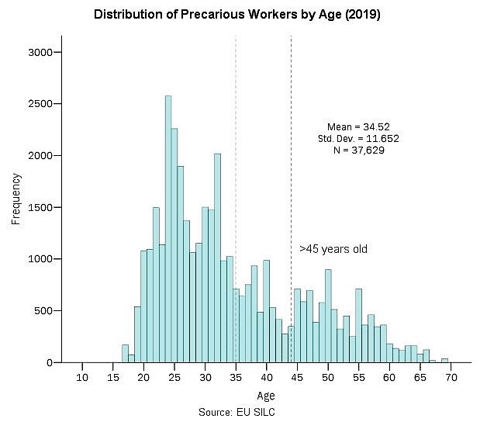
Figure 4: Distribution of precarious workers by age (2019)
Data source: EU-SILC (2020)

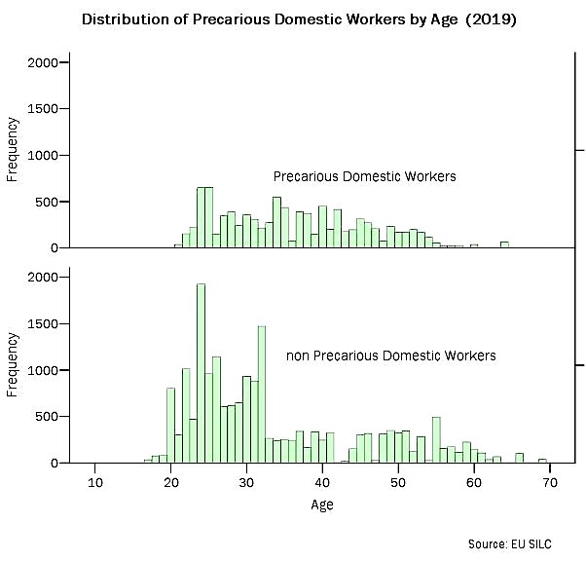
Figure 5: Distribution of precarious domestic workers by age (2019)
Data source: EU-SILC (2020)
Figure 6. Distribution of all employees by duration of professional experience (2019) 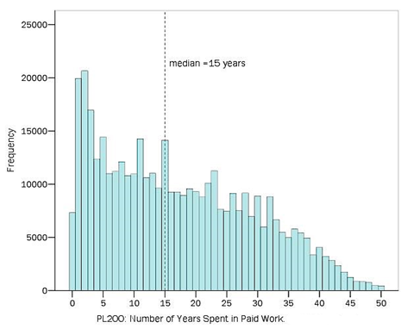
Data source: EU-SILC (2020)

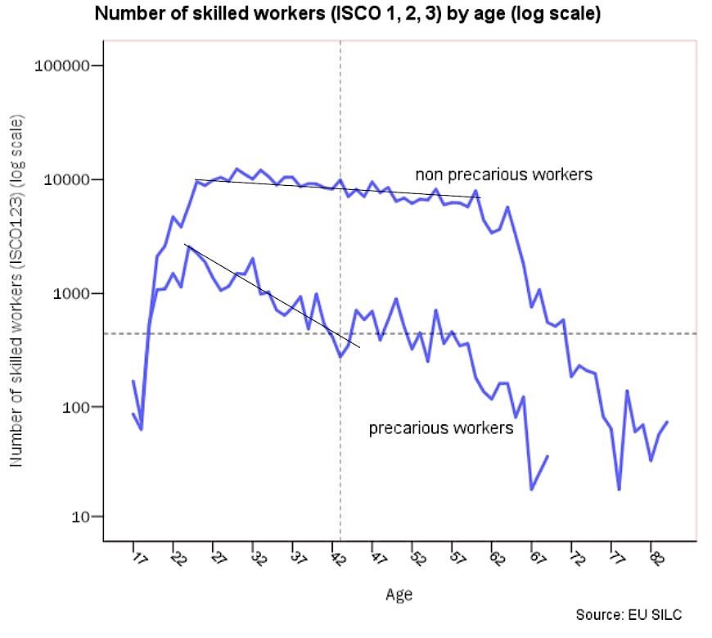
Figure 7: Number of skilled workers (ISCO 1,2,3) by age (log scale, 2019)
Data source: EU-SILC (2020)

Moreover, the number of skilled workers (ISCO 1, 2 and 3) in the population of precarious workers is lower than in the population of non-precarious workers. For many precarious skilled workers, especially those who have completed tertiary education, precarious employment is a temporary, but prolonged experience. As depicted in figure 6, the number of skilled precarious workers decreases rapidly between the ages of 25 and 40 years. Skilled labour, however, appears to accumulate professional experience more rapidly. As a result of the factors outlined above, the accumulation of professional experience among precarious workers is low (median = 5,1 years) (Figure 8).

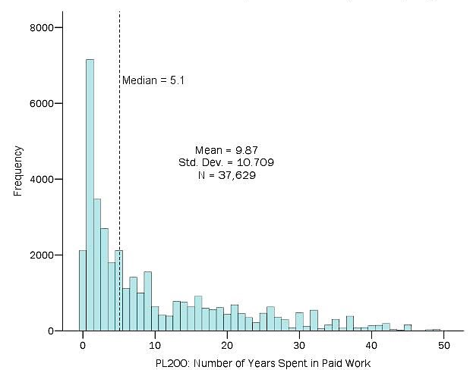
Figure 8: Distribution of precarious workers by professional experience
Data source: EU-SILC (2020)

It can be concluded that the unskilled and less skilled (ISCO 4-9) precarious workers slow rate of professional experience accumulation is part of a vicious circle: Precarious work constricted the process of accumulating professional experience, reducing in this way the likelihood of obtaining a better-paying, more stable, non-precarious job. Hence, precariousness tends to reproduce itself becoming a trap. Thus, the only way to break the precariousness vicious circle is through external forces such as state labour market policies and/or the involvement of trade unions.
To address the issue of the overrepresentation of domestic workers in the total number of precarious workers and in order to control for potential bias enable to distort the distribution of professional experience was divided. The results confirmed that the findings applied to both domestic and non-domestic precarious workers (see Figure 9).

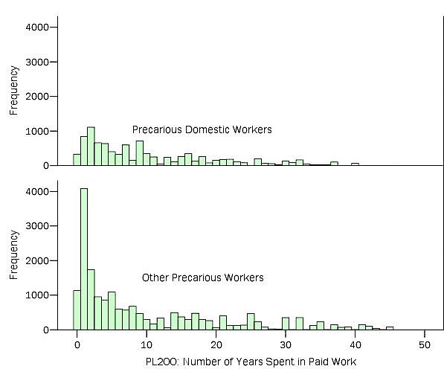
Figure 9: Distribution of precarious Domestic Workers by duration of professional experience (2019)
Data source: EU-SILC (2020)

5.1.2. Factors affecting labour income of the precarious workers
Precarious workers' wages are determined by income, which is the annual gross earnings independent of the number of hours they worked. As a proxy for annual gross wages, the annual gross labour income was used (net of employer's social security contributions).
Figure 10 shows the distribution of 37,629 precarious workers by their annual gross wages in 2019. The median annual gross labour income was €4,980.00, and the average was €5,170.00. Approximately one in four precarious workers earned between €7,200.00 and €10,400.00 per year (or €550.00 and €800.00 per month for 13 months). All remaining precarious workers earned less than €7,200.00 per year. The proportion of precarious workers within the income range of €4,000.00-€5,200.00 per year was high.
Figure 11 illustrates clearly the distinction between precarious domestic workers and non-domestic workers. More specifically it shows that those in the range of €4,000.00-€5,200.00 are classified as precarious domestic workers. Based on the assumption that they were paid for 12 months, their gross monthly earnings would be at the range of €350.00-€450.00. However, not all domestic workers were precarious, as approximately 9,528 precarious and 1,500 non-precarious domestic workers were recorded.

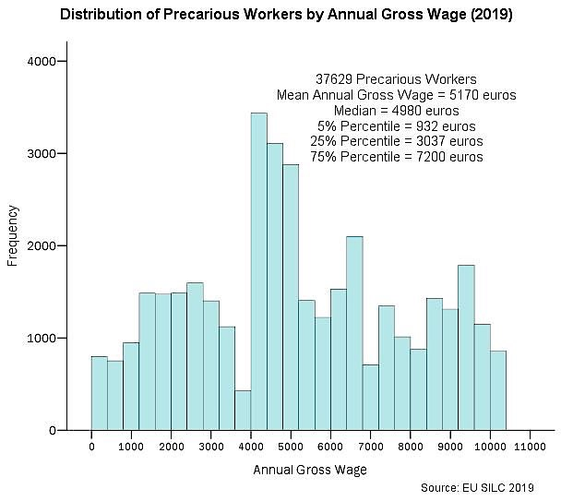
Figure 10: Distribution of precarious workers by annual gross labour income (2019)
Data source: EU-SILC (2020)

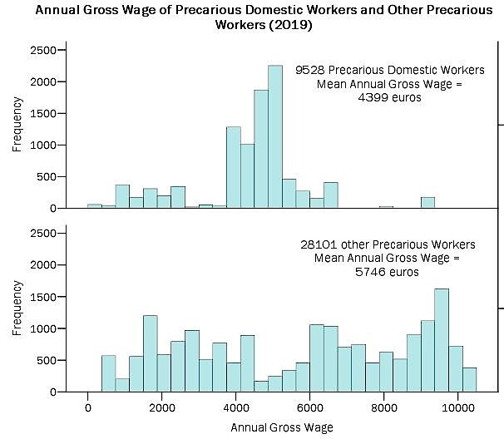
Figure 11: Distribution of precarious domestic workers by annual gross labour income (2019)
Data source: EU-SILC (2020)

If the income the earned by domestic workers is excluded, the average gross labour income for non-domestic precarious employees comes up to €5,745.00 annually (or €440.00 for 13 months). One-half of these workers had a gross annual income of €5,032.00 (or a monthly income of €387.00). For 25% of non-domestic precarious workers, the average gross labour income ranged from €8,703.00 to €10,400.00 (or €670.00 to €800.00 per month, over a period of 13 months).
Nearly one in two precarious workers were unemployed for several months during 2019. The average duration was 2,75 months, whereas the median was 3,5 months. Precarious workers were more likely than non-precarious workers to face prolonged periods of unemployment. In 2019, 19,953 out of 37,629 precarious workers (53%) were unemployed for several months before being reemployed, whereas 48,689 out of 356,610 non-precarious workers (13,7%) were unemployed for several months before being reemployed.
Therefore, unemployment contributes substantially to the precarious' low level of gross annual income and to their ongoing precariousness. As can be seen in Figure 12, precarious workers' income decreases in parallel to the duration of their unemployment. As a result of unemployment, income decreases at a constant rate of €630.00 per month. It is pertinent to note that this conclusion applies to both precarious domestic and non-domestic employees (see Figure 13).

Figure 12: Annual gross labour income of precarious workers as a function of unemployment duration (2019)
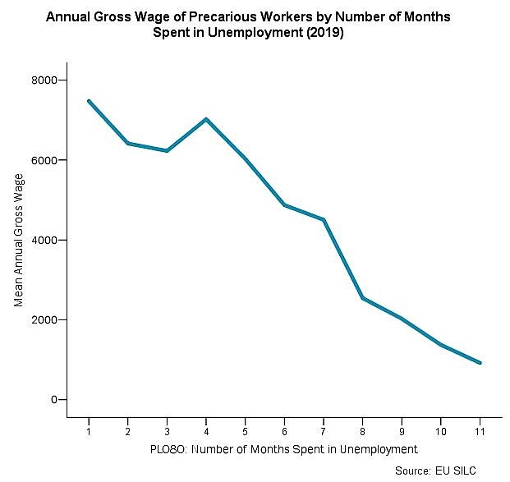
Data source: EU-SILC (2020)

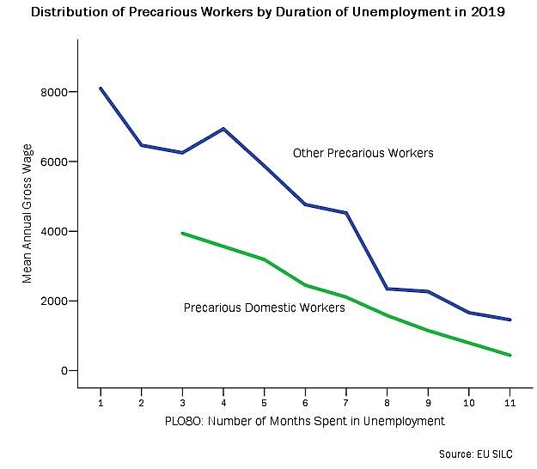
Figure 13: Average annual gross labour income of precarious domestic workers as a function of unemployment duration (2019)
Data source: EU-SILC (2020)

Utilising LRA, the factors contributing to low wages of precarious workers was identified. These variables originate from the EU-SILC (2020) (Table 4) and the results are presented in Table 5.
Table 5 presents the regression results. It can be noted that the duration of unemployment and number of hours typically worked each week were factors that affected the gross labour income of precarious workers. This is because unemployment duration both increased and decreased the number of hours of actual paid work in 2019. Domestic work paid significantly less than the average for other occupations. Professional experience and skilled work (ISCO 1, 2, and 3) raised wages and income, while changing jobs was penalized.
Based on the results of the preceding regression, the internal divisions of the population of precarious workers were examined. For the authors of this study, the separation of precarious workers into domestic workers and non-domestic workers is of fundamental importance, since domestic workers represent slightly less than a third of precarious people and perform their duties in unusual and idiosyncratic circumstances. For this reason the CTA examines domestic and non-domestic segments separately (Figures 14 and 15).

Table 4: Definition of variables of linear regression for the determination of factors affecting labour income of the precarious
Independent variables | Definition | Designed to capture
Female |  | Employers’ preferences, female employees’ family responsibilities etc
ln (Age) | Age of worker | Employer’s disfavour for older employees
Occupations 123 | Occupations in skilled intellectual work (scientific personnel, technicians etc) | Skilled work
ln (Professional Experience) | Number of years spent in paid work | Professional Experience
Hours usually worked weekly | Hours usually worked weekly | Differential bargaining power depending on working time
ln (Months in Unemployment) | Unemployment duration | Lower annual income, lower bargaining power
Changed job since last year | Changed job since last year | Employers’ preferences, lower bargaining power of the employee
Cypriot, Greek, OAS, NME | Citizenship | Employer’s preferences and/or discrimination
Precarious Domestic Work |  | Occupational idiosyncrasy
Upper Secondary Education, Tertiary Education | Education attainment level | Formal knowledge and skills, ability to perform complicated tasks
Dependent variable: ln (Annual Gross Labour Income) | Logarithm of Annual Gross Labour Income
Data source: EU-SILC (2020)

Table 5. Results of the Regression: Factors affecting labour income of the precarious
Dependent Variable: ln (Annual Gross Labour Income) | Unstandardised Coefficients |  | Stand.  Coefficients | T | Sig.
 | B | Std Error
ln (Months in Unemployment) | -0,586 | 0,006 | -0,494 | -93,338 | 0,000
Hours usually worked weekly | 0,035 | 0,000 | 0,509 | 98,887 | 0,000
Precarious Domestic Work | -0,769 | 0,016 | -0,261 | -48,824 | 0,000
ln (Professional Experience) | 0,128 | 0,003 | 0,201 | 38,124 | 0,000
NME | -0,847 | 0,032 | -0,139 | -26,271 | 0,000
Changed job since last year | -0,208 | 0,009 | -0,123 | -23,64 | 0,000
Occupations 123 | 0,274 | 0,012 | 0,121 | 23,305 | 0,000
Constant | 7,827 | 0,018 |  | 431,656 | 0,000
R squared = 0,69
Variables excluded for collinearity | Collinearity Tolerance
Female | 0,830
ln Age | 0,206
Cypriot | 0,663
Greek | 0,658
OAS | 0,115
Upper Secondary Education | 0,815
Tertiary Education | 0,697
Data source: EU-SILC (2020)
Figure 14 illustrates the internal divisions of precarious domestic workers. Among the 9,528 domestic workers (with no missing values), the average gross annual income is approximately 4,400.00 euros. Of these individuals, 5,545 had more than five years of professional experience and earn an average gross annual income of €4,800.00 euros, while 3,983 have less than five years of professional experience and earn an average gross annual income of €3,839.00 euros. The income gap between the two groups of domestic workers was approximately 25% of the income of the less experienced.
Being unemployed for several months during the survey year is regarded as the second most significant internal divisional characteristic among domestic employees. The average reduction in income resulting from unemployment is 50%. Additionally, the third most important divisional characteristic can be attributed to the stability of employment relations. In particular, as a result of changing jobs within the last year, the average gross income was reduced by 25%.
It is noteworthy that the two out of the three most important divisional characteristic refer to the stability of the employment relationship, which in the event of a break (whether by choice to find a new job or by unemployment) is heavily affected in terms of income loss. This presumably can explain the empirical observation that domestic workers employment is less frequently interrupted by unemployment when compared to the corresponding unemployment of non-domestic workers.
Figure 15 illustrates the internal divisions in precarious employment other than domestic employment. There are four classification variables which are considered as the most important: skilled and unskilled workers (ISCO 1, 2, 3) as well as unskilled or semi-skilled workers (ISCO 4-9), professional experience, full-time employment, and unemployment for several months during the survey year (2019). The first two classification variables are related to skills, knowledge, and accumulation of experience, whereas the last two are associated with the continuity of an employment relationship. The division of the non-domestic precarious workers into four subgroups (see Figure 15) demonstrated that a small group of approximately 1,000 (5,3%) skilled (ISCO 1, 2, 3), long professional experience employees who earn annual labour income of €7,629.00 were compared to approximately 3,200 (17,1%) skilled, short professional experience employees earning €5,391.00. With respect to unskilled or less skilled labour (ISCO 4-9), 77.6% (14,445 individuals) of those who worked full time in 2019 earned €6,345.00, while those working part-time earned €4,704.00.

Figure 14: Internal divisions of precarious domestic workers.
Node 1
Mean 3839.202
Std. Dev. 1650.911
n 3983
% 41.8
Predicted 3839.202
Annual Gross Wage
Professional experience more than 5 years
Adj. P-value=0.000, F=1028.191
df1=1, df2=9526
0
1
Has been Unemployed during the year
Adj. P-value=0.000, F=1777.198
df1=1, df2=3981
<=0
<=0
<=0
>0
>0
>0
Changed job since last year
Adj. P-value=0.000, F=64.234
df1=1, df2=5197
0
Node 0
Mean 4398.782
Std. Dev. 1519.549
n 9528
% 100.0
Predicted 4398.782
Node 2
Mean 4800.731
Std. Dev. 1274.266
n 5545
% 58.2
Predicted 4800.731
Node 3
Mean 4268.517
Std. Dev. 1478.860
n 3267
% 34.3
Predicted 4268.517
Node 4
Mean 1880.304
Std. Dev. 710.066
n 716
% 7.5
Predicted 1880.304
Node 5
Mean 4944.935
Std. Dev. 1127.810
n 5199
% 54.6
Predicted 4944.935
Node 6
Mean 2633.916
Std. Dev. 1380.877
n 346
% 3.6
Predicted 2633.916
Node 7
Mean 4963.255
Std. Dev. 1116.746
n 5089
% 53.4
Predicted 4963.255
Node 8
Mean 4097.409
Std. Dev. 1304.733
n 110
% 1.2
Predicted 4097.409
Has been Unemployed during the year
Adj. P-value=0.000, F=1321.122
df1=1, df2=5543

Figure 15: Internal divisions of precarious workers other than domestic.
Data source: EU-SILC (2020)
Node 1
Mean 5695.442
Std. Dev. 2898.732
n 14445
% 77.6
Predicted 5695.442
Annual Gross Wage
ISC0123
Adj. P-value=0.000, F=18.282
df1=1, df2=18605
0
1
Work less than 31 hours per week
Adj. P-value=0.000, F=1199.016
df1=1, df2=14443
<=0
<=0
<=0
<=0
<=0
>0
>0
>0
>0
>0
Professional experience more than 5 years
Adj. P-value=0.000, F=2416.464
df1=1, df2=8728
Has been Unemployed during the year
Adj. P-value=0.000, F=787.152
df1=1, df2=5713
Professional experience more than 5 years
Adj. P-value=0.000, F=384.200
df1=1, df2=4160
Work less than 31 hours per week
Adj. P-value=0.000, F=317.785
df1=1, df2=3177
Node 0
Mean 5745.681
Std. Dev. 2987.270
n 18607
% 100.0
Predicted 5748.681
Node 2
Mean 5920.046
Std. Dev. 3270.437
n 4162
% 22.4
Predicted 5920.046
Node 3
Mean 6344.764
Std. Dev. 2848.899
n 8730
% 46.9
Predicted 6344.764
Node 4
Mean 4703.564
Std. Dev. 2685.799
n 5715
% 30.7
Predicted 4703.564
Node 5
Mean 5391.315
Std. Dev. 3290.812
n 3179
% 17.1
Predicted 5391.315
Node 6
Mean 7629.950
Std. Dev. 2538.161
n 983
% 5.3
Predicted 7629.950
Node 7
Mean 4935.762
Std. Dev. 2646.394
n 4102
% 22.0
Predicted 4935.762
Node 8
Mean 7593.624
Std. Dev. 2405.053
n 4628
% 24.9
Predicted 7593.624
Node 9
Mean 5991.100
Std. Dev. 2331.251
n 1972
% 10.6
Predicted 5991.100
Node 10
Mean 4025.226
Std. Dev. 2611.223
n 3743
% 20.1
Predicted 4025.226
Node 11
Mean 6097.036
Std. Dev. 3237.028
n 2111
% 11.3
Predicted 6097.036
Node 12
Mean 3996.393
Std. Dev. 2932.729
n 1068
% 5.7
Predicted 3996.393

Data source: EU-SILC (2020)

5.1.3. What makes a precarious worker? Determining factors affecting the risk of precariousness
Following the estimation of the indicator of precariousness and the identification of precarious workers, logistic regression analysis was used to estimate the indicator against workers' characteristics (level of education, experience, etc.) so as to determine the factors that affect the probability of workers experiencing precariousness. Since this division is considered to be of critical importance to be critical, two separate regression models were developed: one for domestic workers and one for non-domestic workers (see Table 7).

Table 6: Definition of variables of logistic regression for the determination of personal characteristics affecting the risk of precariousness
Independent variables | Definition | Designed to capture
Female | Gender (1=Female) | Employers’ preferences, female employees’ family responsibilities etc
Education Primary, Lower, Secondary, Upper Secondary | Education attainment levels | Formal knowledge and skills, ability to perform complicated tasks
Professional Experience more than 5 years | Number of years spent in paid work | Professional Experience
Unemployment more than 3 months per year | Unemployment duration | Lower annual income, lower bargaining power
Cypriot, Greek, OAS, NME | Citizenship | Employers’ preferences and/or discrimination
Dependent variable | Risk of precariousness of domestic workers | Determinants of the risk of precariousness of domestic workers
Data source: EU-SILC (2020)

The results of the logistic regression for domestic workers are presented in Table 7 and for non-domestic workers in Table 8. The results of the logistic regression analysis in Table 7 indicate that professional experience exceeding 5 years significantly reduce the probability of being a precarious domestic worker. An immigrant from an Asian country had a high probability of being a precarious domestic worker. Women who were unemployed for at least three months had a higher probability of being precarious domestic workers. In other words, a young immigrant Asian woman worker with less than five years of professional experience, who had been unemployed for at least 3 months during the survey year, would most likely have worked as a domestic worker in 2019 (see Table 7).
Table 8 presents the results of logistic regression analysis for non-domestic workers. Those with professional experience exceeding five years were less likely to become precarious workers other than domestic workers. An individual who was unemployed for at least three months during the survey year increased the likelihood mentioned above by nine times. Being a female or having completed primary or lower secondary education increased the probability by one time. The probability increased by 35% if one had completed upper secondary education. Being from Asia increased the probability by six times, whereas being from the Balkans (mainly from Greece, Bulgaria and Romania) increased the probability by one time.

Table 7. Results of stepwise logistic regression: personal characteristics affecting the risk of precariousness of domestic workers
Data source: EU-SILC (2020), Note: Total number of domestic workers 11,054 persons (199 unweighted count)
Dependent variable: risk of precariousness of domestic workers (n=11,054) | B | Std Error | Wald | Sig. | exp(B)
Female | 21,592 | 940,599 | 0,001 | 0,982 | 2E+09
Professional Experience more than 5 years | -2,107 | 0,147 | 206,288 | 0,000 | 0,122
Unemployment more than 3 months per Year | 36,905 | 1401,74 | 0,001 | 0,979 | 1E+16
OAS | 5,176 | 0,129 | 1614,429 | 0,000 | 176,949
Constant | -22,109 | 940,599 | 0,001 | 0,981 | 0,000
Nagelkerke R square = 0,658
Cox & Snell R Square = 0,363
Variables excluded by stepwise logistic regression
Education Primary, Lower, Secondary, Upper Secondary

Table 8. Results of stepwise logistic regression: personal characteristics affecting the risk of precariousness of other than domestic workers
Dependent variable: risk of precariousness of other than domestic workers (n=350,780) | B | Std Error | Wald | Sig.
Female | 0,597 | 0,017 | 1255,000 | 0,000
Education Primary, Lower, Secondary | 0,700 | 0,026 | 702,787 | 0,000
Upper Secondary | 0,305 | 0,018 | 275,974 | 0,000
Professional Experience more than 5 years | -1,663 | 0,017 | 9422,518 | 0,000
Unemployment more than 3 months per year | 2,320 | 0,018 | 15945,344 | 0,000
Greek | 0,694 | 0,033 | 432,101 | 0,000
BG and RO | 0,563 | 0,029 | 376,154 | 0,000
OAS | 1,949 | 0,053 | 1335,857 | 0,000
Constant | -2,834 | 0,019 | 23283,250 | 0,000
Nagelkerke R square = 0,236
Cox & Snell R Square = 0,080
Data source: EU-SILC (2020), Note: total number of other than domestic workers are 350,780 persons (except those with missing values). Their unweighted count is 3,902 persons.
**No variable is excluded by stepwise logistic regression.

5.1.4 Precarity: Where economic vulnerability and precarious work meet
To address empirically RQ₃ CTA was employed. Precarious workers who were economically vulnerable in Cyprus were identified as being in a condition of precarity (see Figure 16). From the 37,629 precarious workers, 19,304 were not outright owners of a house or apartment (approximately half of them). Most of them had a disposable household income less than €1,500.00 per month (considered in our analysis as a threshold), and consequently were unable to save a significant amount of money to cope with the effects of unemployment (since they were not the outright owners of a residence). Accordingly, it is estimated that 17,443 workers in Cyprus were precarious and at the same time economically vulnerable in 2019.
Taking into consideration the results in relation to the number of workers categorised as in precariousness and in precarity, precarious workers constituted for 9,5% of all employees in 2019, whereas those in precarity (i.e., precarious and economically vulnerable) constituted for 4,4% of all employees. The percentage of workers in precarity could have been at the level of 3,3% if they were provided with the resources necessary to manage the difficulties associated with the first month of being unemployed.
Additionally, it was found that precarious work and economic vulnerability, which are the two components of precarity, were not correlated. This is outlined in a series of figures, of which the most significant ones are presented below (Figures 17-20). The analysis provided in previous sections of this empirical study showed that in general, the characteristics of precarious workers and their relationship to the labour market were almost identical for vulnerable and non-vulnerable workers, with a few minor differences.

Figure 16: Determination of vulnerable workers in Cyprus (2019)
Node 1
Mean 5288.495
Std. Dev. 2788.222
n 18325
% 48.7
Predicted 5288.495
Annual Gross Wage
No Outright Owner
Adj. P-value=0.000, F=68.531
df1=1, df2=37627
<=0
>0
Low savings income as a proxy for savings income threshold 1500 euros gross per month
Adj. P-value=0.000, F=121.224
df1=1, df2=19302
Node 0
Mean 5170.333
Std. Dev. 2700.125
n 37629
% 100.0
Predicted 5170.333
Node 2
Mean 5058.164
Std. Dev. 2608.876
n 19304
% 51.3
Predicted 5058.164
Node 5
Mean 5689.140
Std. Dev. 2801.816
n 1861
% 4.9
Predicted 5689.140
Node 6
Mean 4990.845
Std. Dev. 2578.428
n 17443
% 46.4
Predicted 4990.845
<=0
>0

Data source: EU-SILC (2020)
Figure 17: Distribution of precarious workers by age and Economic Vulnerability (2019)
Data source: EU-SILC (2020)

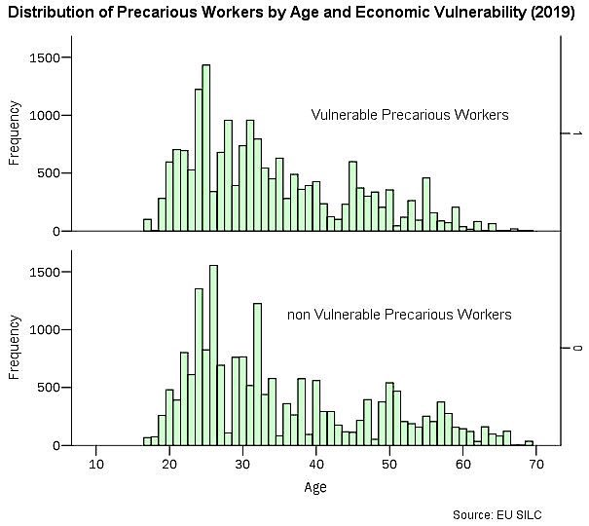
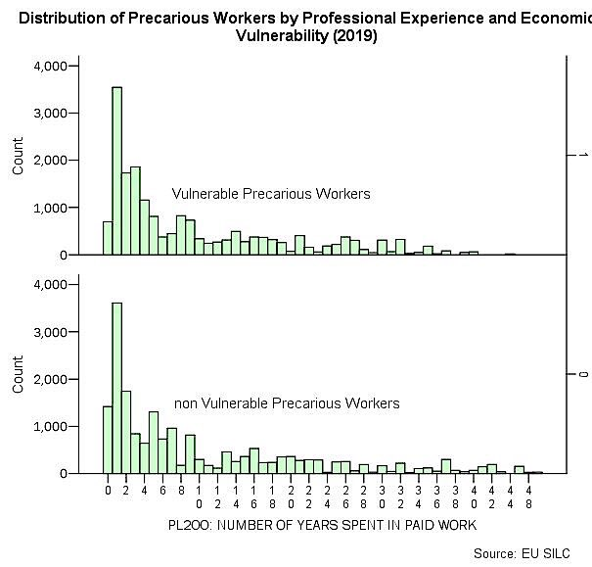
Figure 18: Distribution of precarious workers by professional experience and Economic Vulnerability (2019)
Data source: EU-SILC (2020)

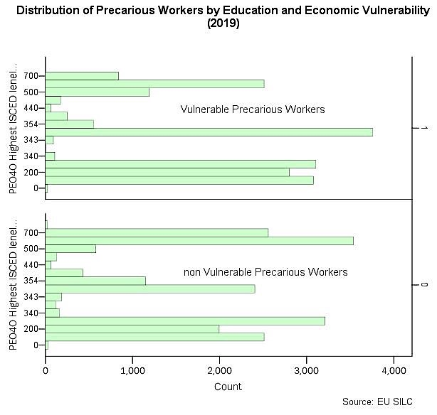
Figure 19: Distribution of precarious workers by education and economic vulnerability (2019)
Data source: EU-SILC (2020)

Figure 20: Annual gross wage as a function of duration of unemployment and economic vulnerability
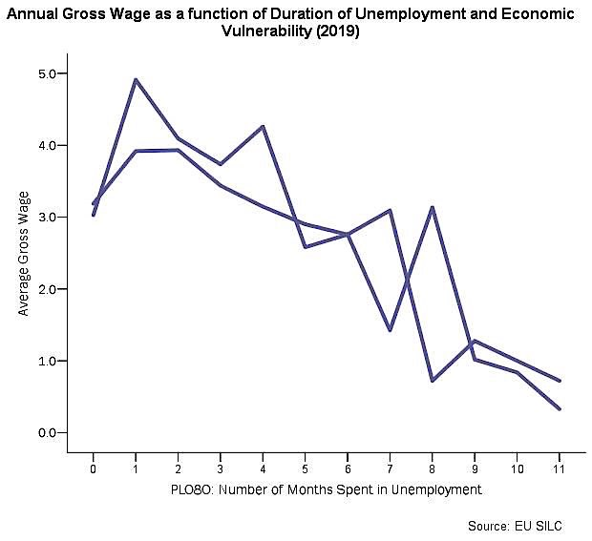
Data source: EU-SILC (2020)
Precarious Vulnerable Workers
Precarious
non-Vulnerable Workers

5.2 Qualitative Analysis
Taking into consideration the complex nature of the phenomenon under study it was decided to employ a qualitative analytical framework through the utilisation of a focus group. Participants of the focus group discussion perceive the concept of precariousness as a wide spectrum of people who might share some common characteristics but at the same time demonstrate very important differences. Thus, they argue that perhaps the focus should be on defining the characteristics and implications of precariousness rather than strictly specifying certain social groups. Nevertheless, they agree that if population groups included in the spectrum of precariousness are to be identified, they should include migrant workers, most of the self-employed workers, as well as new labour market entrants.
Regarding immigrant workers, the discussion focused on two large groups of people living and working in conditions of precariousness in Cyprus: domestic workers, the vast majority of which are women and land workers. Despite the fact that the working conditions of domestic workers are described in their employment contract, the responsibility for ensuring compliance with the terms of the contract does not lie with the Ministry of Labour, but the Police and the Migration Department (Ministry of Interior). Employers and private employment agencies are able to comply with or violate their contractual obligations without any consequences thus setting domestic workers to higher risk of precariousness. In addition, until 2019, domestic workers were contractually not allowed to be members of trade unions in Cyprus. Even after 2019, when this provision was deemed unconstitutional, there are no domestic workers among union members. In order to reverse these extremely unfavourable conditions for domestic workers, participants suggested that unions should try to effectively incorporate domestic workers into their ranks through targeted campaigns. Finally, a crucial issue is that the whole process of regulating domestic workers’ employment -from the issuance of employment permits to monitoring of their employment conditions- should become the sole responsibility of the Ministry of Labour as it is the case with all other employees.
Land workers who work -and very often live- in farms also face similar issues. According to the participants, there is no monitoring on whether the terms of their employment contracts are implemented, both regarding their salary and the living conditions standards (housing, food, other resources, etc.). it was suggested that the way to deal with the issue would be to set up and operate a wide range of joint control bodies consisting of Ministry of Labour officials, trade unions and agricultural organisations. Focus group participants considered also crucial to elect migrant workers from the most affected sectors of labour to key positions within the trade union movement.
Regarding self-employed workers, participants note that a very large proportion of them are included in the spectrum of precariousness because they are in fact pseudo self-employed professionals being forced into this employment status by their employers to escape from their responsibilities (clearly defined salary and working hours, health care, accident insurance, access to unemployment benefits, severance pay etc.). This status of fictitious (or false) self-employment includes a very wide range of employees from delivery workers to employees of the wider public sector (e.g., teachers) who have the same job duties as their full-time colleagues, but do not enjoy the same employment status.
In addition, several genuine self-employed people live in precarious conditions, as they do not have guaranteed jobs and/or income for the next period. The phenomenon of pseudo self-employment has reached alarming proportions as it is often imposed not only by employers but also in the public sector. On the other hand, a small percentage of employees who have the expectation of greater immediate earnings also accept this situation. Utilising a “carrot and stick” method, employers often try to tempt them with slightly higher earnings, provided that they accept to work on a self-employed status. This short-term benefit is nullified by the expulsion of all the provisions entailed in an employment contract. According to the participants, there is a need to highlight the issue of the pseudo self-employed workers in Cyprus, but also to highlight the pitfalls of accepting a short-term personal economic benefit to the detriment of medium/long-term individual and collective interests.
Data source: EU-SILC (2020)
According to the focus group participants, most new entrants in the labour market are employed in precarious jobs and are likely to continue being in the same situation for many years. This is particularly true in workplaces or sectors where no unions exist or they are very weak. As a result, collective claims require the simultaneous action of new entrants and unions. In other words, new employees need to take up the initiative for a trade union formation and at the same time, the unions need to support them decisively and effectively in the face of the -most likely- hostile reactions of the employers.
Focus group participants have also asserted that in order to deal with the negative consequences of precariousness, all employees in Cyprus should be entitled to a legally guaranteed minimum wage and adequate employment conditions, even if a sectoral collective agreement is not in force. However, according to a participating trade unionist, the provision for a national minimum wage should only apply to employees who are not covered by sectoral collective agreements. That is, when sectoral agreements are in force, the salary provided by the contract should be provided, whereas in cases where no such agreement exist, the national minimum wage should apply. The trade unionist made explicit reference that with the current conditions in the labour market, it is more likely that wages will be driven down by the horizontal application of a minimum wage. The trade unionist refers to the sectoral agreement in the construction industry which sets the salary of new entrants at €1,800.00. If a horizontal minimum wage which prevails over sectoral agreement is established, employers will only have a legal obligation to pay the minimum wage, which will definitely be significantly lower. Along with the establishment of a national minimum wage, the expansion and legal establishment of collective agreements should be claimed in as many labour sectors as possible.
Participants have acknowledge the fact that in order to implement measures aiming at reducing precariousness in the Republic of Cyprus, the collective action of the precarious workers will be needed along with the solidarity of the workers not affected by precarious work conditions. Although much remains to be done, steps have been taken in that direction. Participants cite as an example the creation of DEDE, a union which basically represents precarious workers in higher education. They also refer to the work of PEKAMOUS, a union which leads the fight for the protection of precarious workers’ rights in music schools with actions that recently culminated in a strike for two and a half months. With its persistence, PEKAMOUS managed to unite workers, gain recognition, respect and access to the media and that is what allows its members to believe that they will eventually improve their working conditions.

6. Discussion and Conclusions
The present research outlines a three-stage empirical process to measure and address the phenomenon of precarious work and precariousness. Based on the EU-SILC (2020) data for Cyprus, the characteristics of precarious employees, as well as the factors contributing to precariousness, have been identified. In “the new world of work”, precarious workers comprise a heterogeneous group of individuals dealing with the multiple aspects of precariousness.
Among the precarious workers in Cyprus, women, immigrants, and young people in the labour market constituted the majority. Females constituted two-thirds of all precarious workers and were in a significantly more vulnerable position than their male counterparts. More than 40% of precarious workers were female migrant domestic workers. Over half of all precarious workers were under the age of 31.
The nature of employment relationships affects workers’ employment status since many temporary employees were employed on a precarious basis. In contrast, job specialisation was a crucial factor in ensuring safe work since the participation of skilled workers in precarious employment was relatively low. Instead, precarious work was associated with low and semi-skilled work, with a concentration in five main categories of professions (ISCO categories 4 to 9). Approximately half of the precarious workers had paid work experience for less than 5 years when the total number of employees had an average of 14 years paid work experience. This finding showed that precarious workers were accumulating professional experience at a much slower rate than non-precarious workers.
A key finding of this study is that precariousness tends to reproduce itself and become a downward spiral that traps workers in precarious existence. Empirical findings have clearly demonstrated that the unskilled and less skilled precarious’ slow rate of professional experience accumulation was part of a vicious circle. Precarious work constricted the process of accumulating professional experience, reducing the likelihood of obtaining a better-paying, more stable, non-precarious job. Therefore, only external forces, such as government and/or trade union interventions, will be able to break this downward spiral that keeps workers in a precarious position by implementing appropriate labour market reforms.
Unemployment at regular intervals tended to be more prevalent among precarious workers compared to non-precarious workers. Additionally, both unemployment and the number of working hours contributed significantly to the precarious' low-income levels and continued precariousness. As indicated in the study, precarious workers' income decreased at a constant rate of €630.00 per month during the duration of their unemployment.
Migrant domestic workers find themselves trapped in conditions of ‘hyper-precarity’ with different vulnerabilities compared with those of other groups of workers. The empirical findings showed that an event of a break, whether by choice in order to find a new job or by unemployment, was heavily penalised in terms of lost income. This can explain why domestic workers' employment was less frequently interrupted by unemployment as compared to their non-domestic counterparts but at the same time due to the existing legislation, their employers are able to comply with or violate their contractual obligations without any consequences thus, setting domestic workers to higher risk of precariousness. Overall, however, this can be explained as the result of migrant domestic workers in Cyprus experiencing the three elements which constitute the ‘framework of hyper-precarity trap’: precariousness, vulnerability, and legislation (Lewis et. al., 2019; Anderson, 2007). For non-domestic precarious workers, skills, working experience and the continuity of the employment relationship were the main contributors of income.
An aspect of precarious work in Cyprus that was not uncovered in the quantitative research was revealed during the qualitative analysis. Self-employed individuals should be included in the spectrum of precariousness as they are in fact false (or pseudo) self-employment professionals that have been forced into an employment relationship by their employers. The status of false self-employment applies to a variety of workers, from delivery workers to employees of the broader public sector.
Mapping precariousness in Cyprus confirms Castel's concept of precariousness: the geography of precariousness lies between a protected interim social zone that is distinct from the stable and secure zone of employment and the zone of social exclusion (Castel, 2003). Precarious work is characterised by the constant rotation between non-typical or temporary work and unemployment periods. As an impact of this situation, numerous workers in the labour market of Cyprus do not enjoy a regular income that would provide them with security and a smooth social integration. The incomes derived from underemployment were often inadequate for people to maintain a decent standard of living. Many precarious workers earned incomes that were below the official poverty threshold. Even though they are not unemployed, they were covered by the working poor scheme (new poverty) (Paugam, 2020).
After identifying the characteristics of precarious employees and the factors that contribute to precariousness, our next step was to investigate precarity as a condition of precariousness intersecting with economic vulnerability. Taking into consideration the results in relation to the number of workers categorized as in precariousness and in precarity, precarious workers constituted for 9,5% of all employees in 2019, whereas those in precarity (i.e., precarious and economically vulnerable) constituted for 4,4% of all employees.
Last but not least, it is important to note that any internal divisions within the range of world of work resulting in phenomena such as precarious work and “precariats” do not negate the fact that the working class is a unified and indivisible social class. In a neoliberal era, this research contributes to the discussion of class theory by: (a) including new variables and introducing new empirical approaches and (b) providing researchers and policy makers with a deeper understanding of the phenomenon which will ultimately lead to new theoretical and policy avenues towards its reduction or even elimination.

Limitations
This study was not able to investigate the effect of the Covid-19 pandemic period on the phenomenon of precarious work and precariousness in Cyprus. As a result of the fact that relevant statistical data were unavailable or incomplete at the time of the implementation of this research, Covid-19 pandemic period was still ongoing.

Future Research
A future study dealing with the same research issues in specific industries, such as tourism and hospitality in Cyprus, will help to identify and highlight the key characteristics and dynamics of each economic activity that contribute to precariousness and precarious employment. An additional future study suggestion that addresses the limitations of the current empirical investigation is to examine the effect of the Covid-19 -pandemic as proxy for future crisis events- on precarious work and precariousness. Finally, there is a need to examine the issue of the pseudo self-employed workers in Cyprus since the phenomenon of fictitious self-employment has reached alarming proportions as it is often imposed not only by employers but also by the State.

7. References

Anderson, B. (2007), “A Very Private Business: Exploring the Demand for Migrant Domestic Workers”. European Journal of Women’s Studies 14(3): 247-264.
Anderson, B., (2010), ‘Migration, immigration controls and the fashioning of precarious workers’, Work, employment and society, Vol., 24, pp. 300‐317.
Angeli, D., (2016), Trafficking and exploitation in domestic work in Cyprus, Global Governance Programme, European Policy Brief, Demand AT, (accessed 15 September 2020).
Barbier, J. C., (2004), A comparative analysis of ‘employment precariousness’ in Europe. Learning from employment and welfare policies in Europe, European Xnat Cross-national research papers, Seventh series, 7-18.
Barbier, J., (2002), “A Survey of the Use of the Term Précarité in French Economics and Sociology”. Centre d’ Etudes de l’ Emploi, Working Paper 19, https://bit.ly/3qhK7sy
Bourdieu, P. (1998), Acts of Resistance Against the New Myths of our Time, Polity Press.
Brinkmann, S., (2014). Unstructured and semi-structured interviewing. The Oxford handbook of
Castel. R. (2016), “The Rise of Uncertainties”, Critical Horizons, 17:2, pp. 160-167, DOI: 10.1080/14409917.2016.1153886
Castel. R. (2016), “The Rise of Uncertainties”, Critical Horizons, 17:2, pp. 160-167, DOI: 10.1080/14409917.2016.1153886.
Da Silva, A. and C., Turrini, (2015), 'Precarious and less well-paid? Wage differences between permanent and fixed-term contracts across the EU countries', European Economy, Economic Papers No. 544.
De Genova, N.P., (2002). “Migrant “Illegality” and Deportability in Everyday Life. Annual Review of Anthropology, 31, pp. 419–447.
Demetriou, C. (2015), The impact of the crisis on fundamental rights across Member States of the EU: Country Report on Cyprus, Directorate General for Internal Policies, European Parliament.
Duclos, J., and M., Mercader-Prats, (2005), Household needs and Poverty: With application to Spain and the UK, The Review of Income and Wealth, Vol., 45(1), pp. 77-98
Eurofound, (2010), Cyprus: Flexible forms of work: 'very atypical' contractual arrangement, Observatory EurWORKTopic: Published on: 04 March 2010, (accessed 15 September, 2021).
Fine, B. (1998), Labour Market Theory – A Constructive Reassessment, Routledge.
Hadjigeorgiou N., (2020), Exploring the Socio-legal Challenges Faced by Foreign Domestic Workers in Cyprus (Report funded by the London School of Economics Hellenic Observatory), Retrieved 23 November 2021, available at: https://www.lse.ac.uk/Hellenic-Observatory/Research/Cyprus-Projects-2019-2020/Exploring-the-Socio-legal-Challenges-Faced-by-Foreign-Domestic-Workers-in-Cyprus
Hauben (ed.), H. Lenaerts, K. and Waeyaert, W. (2020), The platform economy and precarious work, Publication for the committee on Employment and Social Affairs, Policy Department for Economic, Scientific and Quality of Life Policies, European Parliament, Luxembourg.
Ioannou, G., (2014), Employment in crisis: Cyprus 2010-2013, The Cyprus Review, Vol., 26, No. 1, pp. 107-126.
Kalleberg, A. (2011), Good jobs, Bad Jobs, The Rise of Polarized and Precarious Employment Systems in the United States, 1970s to 2000s, A Volume in the American Sociological Association’s Rose Series in Sociology, Russell Sage Foundation, New York.
Kalleberg, A.L., (2018), Job insecurity and well-being in rich democracies, The Economic and social review, 49(3, Autumn), pp. 241-258.
Lewis, H. Dwyer, P. Hodkinson, St. & Waite, L. (2015), “Hyper-precarious lives: Migrants, work and forced Labour in the Global North”, Progress in Human Geography, Vol. 39(5) pp. 580-600, DOI: 10.1177/0309132514548303
Morgan, D. L. (1993). Successful focus groups: Advancing the state of the art (Vol. 156). Sage.
OECD (2015), ‘Policy Brief on Informal Entrepreneurship Entrepreneurial Activities in Europe’, European Union/OECD, 2015.
Olsthoorn, M., (2014), “Measuring Precarious Employment: A Proposal for Two Indicators of Precarious Employment Based on Set-Theory and Tested with Dutch Labour Market-Data”, Social Indicators Research, March, Vol. 119, No. 1, March, pp. 421-441, Springer, www.jstor.org./stable/24721088
Paugam, S., (2017) Poverty and Attachment Regimes in Modern Societies. In: Schroeder J., Seukwa L., Voigtsberger U. (eds) Soziale Bildungsarbeit - Europäische Debatten und Projekte. Soziale Arbeit als Wohlfahrtsproduktion, vol 14. Springer VS, Wiesbaden. https://doi.org/10.1007/978-3-658-17016-5_2
PEO - Cyprus Labor Institute (2019), Report on Economy and Employment 2019.
Pitrou, A., (1978). La vie précaire: des familles face à leurs difficultés (Vol. 21), Caisse nationale des allocations familiales.
Pulignano, V., (2018), Precarious work, regime of competition and the case of Europe, Research in the Sociology of Work, 31, pp. 33-60.
Spyridakis, M., (2018), Homo Precarious: Experiences of Vulnerability during the crisis (in Greek), Ed. Pedio.
Standing, G., (2009), Work after Globalisation: Building occupational Citizenship, Edward Elgar.
Standing, G., (2011), The Precariat, the New Dangerous Class, Bloomsbury.
Standing, G., (2009), Work after Globalisation: Building occupational Citizenship, Edward Elgar.
Vassou, C., A., Zopiatis, and A.L., Theocharous, (2017), Intercultural workplace relationships in the hospitality industry: Beyond the tip of the iceberg, International Journal of Hospitality Management, Vol., 61, pp. 14-25.
Vono de Vilhena, D., Y., Kosyakova, E., Kilpi-Jakonen, and P., McMullin, (2016), Does adult education contribute to securing non-precarious employment? A cross-national comparison, Work, employment and society, 30(1), pp. 97-117.
Waite, L., (2009), A place and space for a critical geography of precarity?, Geography Compass, 3(1), 412-433.
Zopiatis, A., P., Constanti, and A.L., Theocharous, (2014), Migrant labour in hospitality: The Cyprus experience, International Journal of Hospitality Management, Vol., 37, pp. 111-120.

Lecturer, School of Management and Economics, Cyprus University of Technology (CUT), Researcher at Heraclitus Research Centre. Project coordinator and corresponding author: petros.kosmas@cut.ac.cy
Associate Professor, School of Management and Economics, CUT, Researcher at Heraclitus Research Centre of CUT.
Independent researcher, Invited senior researcher at the Cyprus Labour Institute (INEK PEO), Invited researcher at Heraclitus Research Centre of CUT.
Independent researcher, Journalist, Invited researcher at Heraclitus Research Centre of CUT.
PhD (cand) and researcher at Heraclitus Research Centre of CUT.
Researcher at Heraclitus Research Centre of CUT.
Visiting Lecturer, School of Management and Economics at the CUT.
PhD (cand) and researcher at Heraclitus Research Centre.
Researcher at Heraclitus Research Centre of CUT.
The construction sector was the second largest migrant labour force sector, alone attracted 8.4% of migrants.
Data of PEO are based on the statistics of Eurostat and Cystat.
“The purchasing power of the average wage in terms of money during the second quarter of 2019 was equal to the equivalent of 2013:1. In the meantime (2013:1 to 2019:2), for almost seven consecutive years, the purchasing power of the average wage remained at lower levels than the equivalent of 2013:1 but also of the entire period 2006:1-2013:1. Even during 2019:2, in a period of economy overheating that will require remedial measures to restore GDP in levels more compatible with the basic macroeconomic equilibria, the purchasing power of the average wage was by 3% lower than it has been during the period 2006:1-2011:4.” (PEO: 2019, p.15)
Home ownership in Cyprus was 69% in 2019 when the corresponding percentage in the Eurozone was 65.8%
For example, the threshold for low wages or poverty is set at 2/3 or 60% of the median wage or income respectively, which is a threshold that may decrease abruptly in times of deep crisis, leading thus to paradoxical results.
The threshold for low wages or poverty is set at 2/3 or 60% of the median wage or income respectively, which is a threshold that may decrease abruptly in times of deep crisis, leading thus to paradoxical results.
The coefficient of variation is equal to the ratio of the mean value on standard deviation.
The online focus group was organized on 6/12/2021

