Monitoring of archaeological sites submerged in shallow waters using Earth observation
K. Themistocleous*^{a,b}, Dante Abateª, Eleftheria Kalogirou^{a,b}, Thomas Krauss^{c} ªEratosthenes Centre of Excellence, Limassol, Cyprus
^{b}Cyprus University of Technology, Limassol, Cyprus ^{c}German Aerospace Center - DLR, Germany

ABSTRACT
Archaeological sites that are submerged in shallow waters are subject to various environmental threats, including anthropogenic factors, climate change and environmental conditions. Due to their archaeological significance, they are vulnerable to extreme risks from deterioration due to land deformation, flooding, acid rain, erosion, and man-made hazards like illegal excavations and tourist activities. Such threats not only endanger the structural integrity of these monuments, but they also may cause total destruction, and loss of cultural heritage and history. This paper explores the capabilities of using Earth observation and aerial images and the capabilities of satellite-based remote sensing techniques for monitoring cultural heritage sites under shallow water conditions. The processing and analysis of Earth observation time series images provide information about the site's condition over time, enabling the detection of subtle changes that might be unnoticed with conventional methods. The case study focuses on the submerged port of Amathous archaeological site along the coast of Cyprus. The site's unique geographical and historical characteristics make it an exemplary model for applying advanced remote sensing technologies. By integrating various Earth observation satellite images with aerial imagery, the study aims to examine a methodology for the monitoring of underwater cultural heritage sites. This approach provides an understanding of the impacts of climate change as well as the human impact of various activities that affect the coastlines of cultural heritage sites and also provides a tool for developing proactive measures to safeguard heritage assets.
Keywords: Earth observation, remote sensing, cultural heritage, Underwater Archaeology, Amathous, Submerged Sites

INTRODUCTION
Underwater archaeology is a field that has evolved significantly over the past few decades, driven by advances in technology and a growing recognition of the importance of submerged cultural heritage [1,2]. This field focuses on the study of human interaction with aquatic environments, exploring submerged sites such as shipwrecks, ancient ports, and coastal settlements. These sites are often well-preserved due to the unique conditions underwater, which can protect artifacts from the decay processes that occur on land. One of the primary challenges in underwater archaeology is the monitoring and preservation of submerged sites. These sites are often located in dynamic environments where natural forces such as currents, tides, and sedimentation can rapidly alter the site. Furthermore, human activities such as coastal development, fishing, and tourism can pose significant threats to these fragile sites [3].
The ancient shallow-water port of Amathous in Cyprus presents a compelling case for the application of remote sensing technologies in underwater archaeology. Amathous was one of the most important city-states in ancient Cyprus, with a history that dates back to the early Iron Age. The city's natural harbor, constructed during the Hellenistic period, played a crucial role in the economic prosperity of the area. However, over time, the harbor became silted up and eventually submerged due to a combination of natural sedimentation and sea-level changes. Today, the submerged ruins of the harbor lie under 1 to 4 meters of water, offering a unique opportunity to study the ruins of the port using modern remote sensing technologies [4]. The application of remote sensing in archaeology, and particularly in underwater archaeology, has expanded considerably in recent years [1,2]. Traditional methods of underwater exploration, such as diving surveys and the use of remotely operated vehicles (ROVs), while effective, are often limited by logistical challenges, costs, and the need for favorable weather conditions. These methods also tend to cover only small areas, making them less effective for
Earth Resources and Environmental Remote Sensing/GIS Applications XV, edited by Karsten Schulz,
the continuous monitoring of large or remote sites [5]. Remote sensing offers a complementary approach that can overcome many of these limitations. Satellite-based remote sensing provides a means of multitemporal observation of large areas using time-series satellite images to monitor changes over time. Several studies have demonstrated the potential of remote sensing in underwater archaeology; satellite imagery has been used to map submerged ruins, detect changes in coastal geomorphology, and monitor the impact of environmental factors such as sedimentation and erosion [6].
The use of indices such as the Normalized Difference Vegetation Index (NDVI) and the Normalized Difference Water Index (NDWI) has been particularly promising in the study of submerged sites [7]. NDVI, traditionally used for monitoring vegetation, has been explored in aquatic environments to assess its potential in identifying submerged features. However, NDWI is specifically designed to enhance the presence of water bodies and has shown effectiveness in detecting submerged structures [8]. Yet, the application of these indices in underwater archaeology is still being studied and more research is necessary. While NDVI has proven useful on land, its effectiveness in underwater environments is limited by the properties of water, which absorbs light at greater depths, particularly in the near-infrared range [9]. NDWI has shown more promise in underwater applications, but high-resolution imagery can be more effective [10]. This study seeks to investigate how Earth observation techniques can be used to monitor archaeological sites submerged in shallow waters for the ancient port of Amathous and evaluating the effectiveness of various indices in detecting and monitoring submerged archaeological ruins.

METHODOLOGY
The ancient port of Amathous consisted of two main parts: the outer and inner harbors. The outer harbor, which was larger, measured approximately 100 meters by 180 meters and was protected by a breakwater to the south (Figure 1). Over time, the harbor became silted up, and the coastline prograded, eventually leading to the submersion of the port. Today, the submerged ruins of the harbor lie at a depth of 1 to 4 meters, offering a unique opportunity for archaeological study [4].
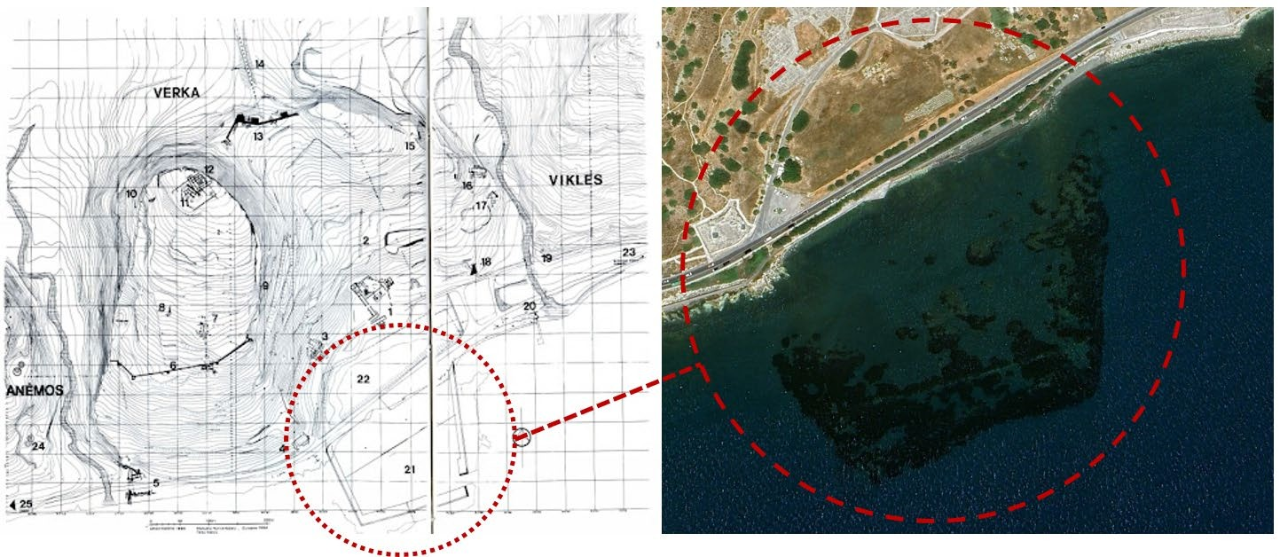
Figure 1. The ancient port of Amathous measured approximately 100 meters by 180 meters
(left graphic: From the Guide to Amathus 2000)
This study employed a combination of satellite and aerial imagery to monitor the submerged archaeological site. The primary sources of satellite data were Sentinel -2 and PlanetScope images. The Sentinel-2 multispectral imagery provides a resolution of 10m per pixel and PlanetScope provides 3m per pixel. Satellite images were collected for three different time periods: April 2022, April 2023, and March 2024. The higher resolution of Planet imagery allows for more detailed analysis of small-scale features [6], which is particularly important for the detection of submerged archaeological sites. In addition to satellite images, aerial imagery was obtained using a 3K camera system during the CERAD aerial campaign from the German Aerospace Agency (DLR) in October 2023. The aerial imagery provided high-resolution images of the shallow water region where the ancient port is located, thereby complementing the satellite data.
Three indices were employed in the analysis of the remote sensing data:
- Normalized Difference Vegetation Index (NDVI): NDVI is calculated using the formula (NIR - Red) / (NIR + Red), where NIR is the near-infrared band and Red is the red band of the electromagnetic spectrum. NDVI is widely used in terrestrial applications to monitor vegetation health and coverage. In this study, NDVI was applied to evaluate its potential in detecting submerged archaeological features, particularly in areas where seagrass or other aquatic vegetation might obscure artifacts [8].
- Normalized Difference Water Index (NDWI): NDWI is calculated using the formula (Green - NIR) / (Green + NIR). This index is designed to highlight water bodies by enhancing the contrast between water and other types of land cover. NDWI was used in this study to distinguish water bodies from submerged structures and to assess its effectiveness in detecting underwater archaeological features [9].
- Exaggerating Green (ExG): The ExG index emphasizes the green spectrum of the visible light range, making it particularly useful for detecting aquatic vegetation such as seagrass. In the context of this study, ExG was used to monitor the growth of seagrass around the submerged site and to assess its impact on the visibility and preservation of archaeological features [11].
The data were analyzed using a multitemporal approach, allowing for the detection of changes over time. By comparing imagery from different time periods, the study aimed to identify trends and patterns in the growth of seagrass, the stability of submerged structures, and the overall geomorphology of the site. The effectiveness of each index was evaluated based on the resolution of the input data, with particular attention to the differences between Sentinel-2 and Planet imagery [9]. The methodology used in the study is presented in Figure. 2.
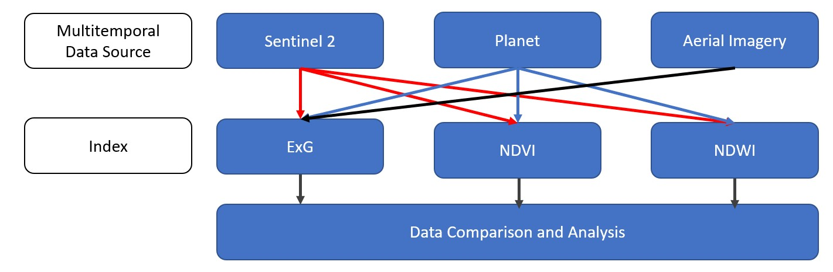
Figure. 2 Remote Sensing shallow water monitoring methodology

RESULTS
The NDVI analysis produced mixed results when applied to the submerged archaeological site (Figure 3). While NDVI is a powerful tool for monitoring vegetation on land, its application in aquatic environments is limited by the optical properties of water, which absorbs and scatters light in the visible and near-infrared regions of the spectrum [8]. As a result, NDVI was found to be largely ineffective in detecting submerged archaeological features. In some cases, the index produced false positives, where areas of seagrass were incorrectly identified as submerged ruins. This suggests that NDVI may not be suitable for use in underwater archaeology, particularly in shallow water environments where aquatic vegetation is prevalent.

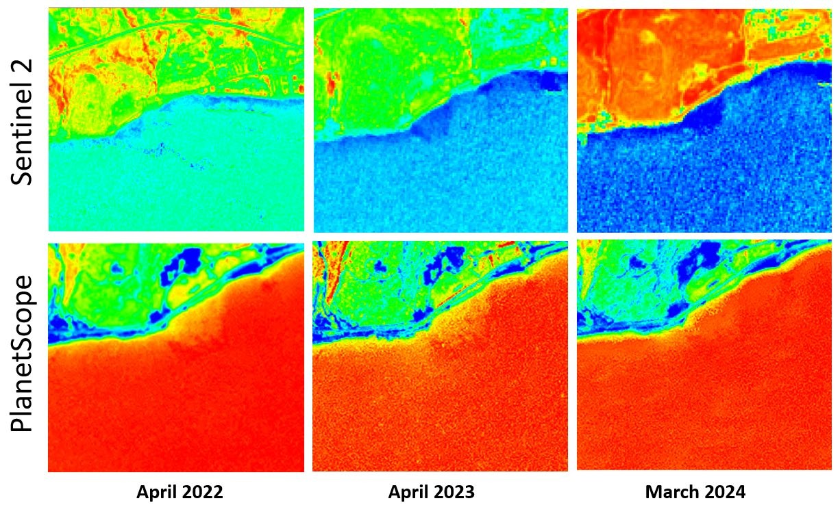
Figure 3. NDVI results using Sentinel-2 and PlanetScope imagery for April 2022, April 2023 and March 2024

In contrast, the NDWI analysis proved to be highly effective in identifying submerged features, particularly when applied to high-resolution Planet imagery (Figure 4). The NDWI consistently distinguished between the water column and the submerged structures of the ancient port, regardless of the time period. The multitemporal analysis revealed that NDWI was able to detect subtle changes in the site’s geomorphology, such as shifts in sediment deposition, seagrass growth and erosion patterns. These changes were particularly evident in the imagery from March 2024, which showed increased sedimentation in the southern part of the harbor. The consistency of NDWI across different resolutions and time periods suggests that it is a robust tool for the monitoring of submerged archaeological sites.

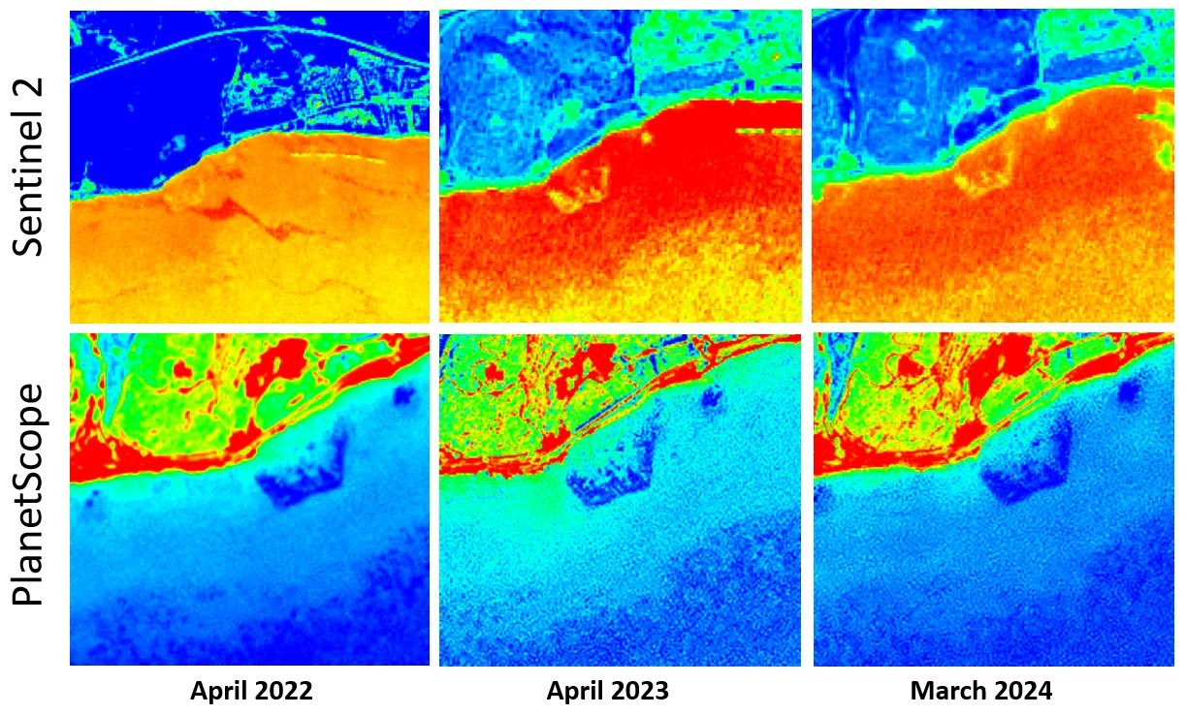

Figure 4. NDWI results using Sentinel-2 and PlanetScope imagery for April 2022, April 2023 and March 2024

The ExG index was particularly useful for monitoring the growth of seagrass around the submerged site. The high-resolution Planet imagery provided detailed insights into the distribution and density of seagrass, which has both protective and destructive implications for submerged archaeological features. The multitemporal analysis revealed that the extent of seagrass increased slightly between April 2022 and March 2024, potentially complicating future archaeological investigations (Figure 5). The growth of seagrass could obscure important features, making it more difficult to detect and study submerged ruins [11]. However, the presence of seagrass can also stabilize the sediment, protecting artifacts from the water stream erosion and other forms of physical damage.

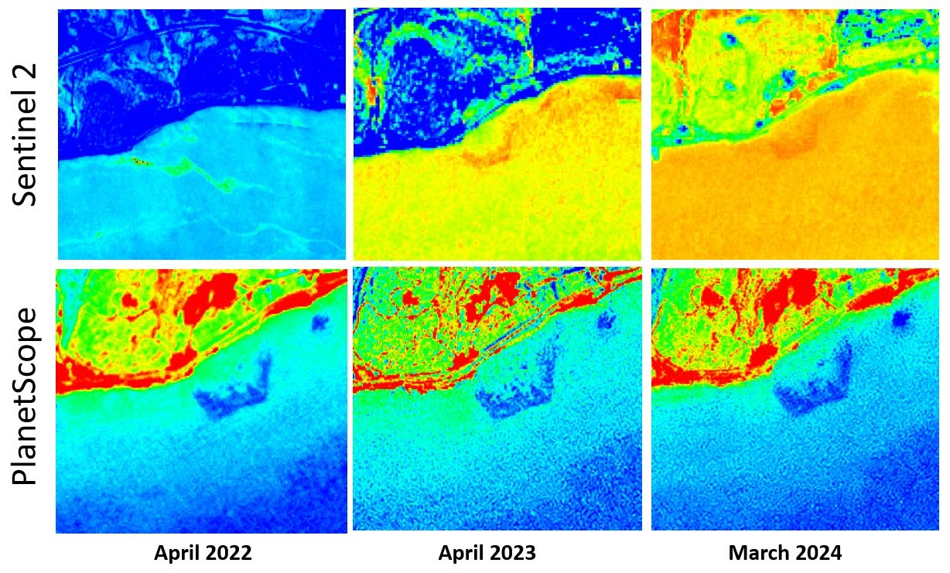
Figure 5. ExG results using Sentinel-2 and PlanetScope imagery for April 2022, April 2023 and March 2024

Since the ExG index was computed on RGB channels, it was also applied to the RGB image acquired by the aerial campaign by DLR in October 2023 in Cyprus. The image was acquired by the DLR research aircraft, a Dornier Do 228212, using the optical 3K camera system developed by DLR. (Figure 6).
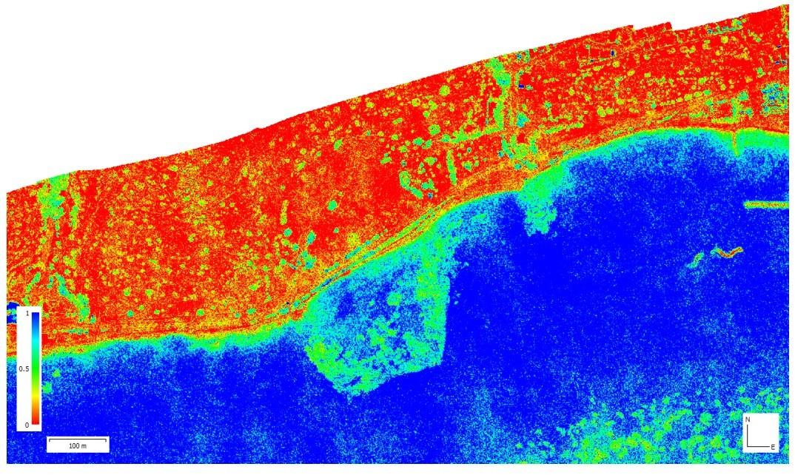
Figure 6. ExG results using a 3K RGB camera system during the CERAD aerial campaign from DLR in October 2023

DISCUSSION
The results of this study have important implications for the field of underwater archaeology and the conservation of submerged cultural heritage. The effectiveness of remote sensing indices, such as NDWI and ExG, in detecting and monitoring submerged sites suggests that these tools can play a critical role in the preservation of underwater heritage. The successful application of NDWI in this study underscores its potential as a primary tool for the monitoring of submerged archaeological sites. The success of NDWI in this research highlights its effectiveness as a primary tool for monitoring submerged archaeological sites, particularly due to its ability to detect changes in underwater geomorphology and consistently identify submerged structures across various resolutions. This is especially valuable in areas where underwater sites face natural and human-induced threats, such as coastal development, fishing, and tourism.
The study also reveals the limitations of traditional vegetation indices like NDVI in aquatic environments. While NDVI is commonly used to identify areas of stress or damage in agricultural and vegetation studies, it proves less effective underwater, suggesting that researchers should be cautious when applying it in such contexts. Instead, indices specifically designed for aquatic settings, such as NDWI and ExG, should be prioritized for further exploration.
Monitoring submerged sites over time is essential for developing effective heritage management strategies. The ExG index, which detects seagrass growth, illustrates how such vegetation can protect submerged artifacts by stabilizing sediments and reducing the impact of currents and waves. However, dense seagrass can obscure important features, complicating archaeological surveys and site monitoring. The species Posidonia oceanica is particularly notable due to its high carbon storage capacity, playing a vital role in climate regulation by capturing carbon in its root system. Additionally, Posidonia oceanica offers several ecological benefits: it purifies water, protects coastlines from erosion, recycles nutrients, and provides habitat for diverse marine life. The multitemporal approach used in this study offers a powerful tool for heritage managers, allowing them to track changes in submerged sites over time and to identify emerging threats before they cause irreversible damage. For example, the increased sedimentation detected in the southern part of the harbor in March 2024 could indicate the need for targeted conservation efforts to prevent the burial of key archaeological features.
While this study demonstrates the potential of remote sensing for monitoring submerged archaeological sites, it also points to several areas for future research. One promising avenue is the integration of remote sensing with other technologies, such as sonar, photogrammetry, and 3D modeling, to provide additional data layers for a more comprehensive analysis of submerged sites. Furthermore, applying machine learning and artificial intelligence (AI) to remote sensing data analysis could automate the detection of submerged features, enhance data processing efficiency, and reveal patterns that might missed by human analysts. Finally, developing new remote sensing indices specifically tailored to underwater archaeology could significantly enhance the capabilities of remote sensing in this field, building on the successes of NDWI and ExG.

CONCLUSIONS
This study has explored the application of remote sensing technologies for the monitoring of the submerged ancient port of Amathous in Cyprus. The findings suggest that while traditional indices like NDVI may have limited applications in underwater environments, indices such as NDWI and ExG offer significant potential for the detection and monitoring of submerged archaeological sites. By employing a multitemporal approach, the study successfully identified changes in the site's geomorphology and the growth of seagrass, offering valuable insights into the long-term preservation of the area. These results have significant implications for the conservation of submerged cultural heritage and highlight the need for further research into the application of remote sensing in underwater archaeology. Future studies should aim to refine these methods, investigate the integration of remote sensing with other technologies, and develop new indices specifically designed for the challenges unique to underwater archaeology. By enhancing the tools and techniques available, remote sensing can play a vital role in preserving cultural heritage.

ACKNOWLEDGEMENTS
The authors acknowledge the ‘EXCELSIOR’: ERATOSTHENES: Excellence Research Centre for Earth Surveillance and Space-Based Monitoring of the Environment H2020 Widespread Teaming project (www.excelsior2020.eu). The ‘EXCELSIOR’ project has received funding from the European Union’s Horizon 2020 research and innovation programme under Grant Agreement No 857510, from the Government of the Republic of Cyprus through the Directorate General for the European Programmes, Coordination and Development and the Cyprus University of Technology.

REFERENCES
- Momigliano, N. (2015). "Underwater Archaeology and Remote Sensing: A Synergy for Maritime Heritage Management." Journal of Maritime Archaeology, 10(3), 245-258.
- Conlin, D. (2018). "Submerged Archaeology and Remote Sensing: Techniques for Maritime Heritage Preservation." International Journal of Nautical Archaeology, 47(1), 85-102.
- Papatheodorou, G., & Geraga, M. (2014). Submerged Cultural Heritage Sites: The Role of Marine Geophysical Techniques in Site Management. In Marine Geophysics: Applications for Submerged Cultural Heritage Management (pp. 55-78). Springer.
- Themistocleous, K., Abate, D., Kalogeriou, E., & Hadjimitsis, D. (2024). Remote sensing monitoring methodology for submerged archaeological sites. Presented at EGU 2024, Vienna.
- Kaimaris, D., & Georgopoulos, A. (2020). The Role of Remote Sensing in Submerged Archaeological Site Detection: A Case Study from Greece. Journal of Archaeological Science, 115, 105099.
- Athanasiou, A., & Agapiou, A. (2019). "Exploring the Use of High-Resolution Satellite Imagery for Underwater Archaeology: The Case Study of the Akrotiri-Dreamer’s Bay Ancient Port, Cyprus." Heritage, 2(3), 2302-2324. [7] Kalogeriou, E., Hadjimitsis, D. G., & Michaelides, S. (2022). "Assessing the Potential of Multispectral Remote Sensing for the Detection of Submerged Cultural Heritage Sites." Remote Sensing, 14(12), 2367.
- Smith, D. (2017). "The Role of Seagrass in Submerged Archaeology: Preservation and Obfuscation." Aquatic Conservation: Marine and Freshwater Ecosystems, 27(2), 245-256.
- Morrell, K. (2016). Multitemporal Analysis in Remote Sensing for Archaeological Sites: Advantages and Limitations. Advances in Archaeological Practice, 4(3), 250-261.
- Bruno, F., & Mossa, M. (2019). Photogrammetric Techniques for Underwater Archaeological Site Recording and 3D Modeling: A Review. Journal of Cultural Heritage, 37, 214-231.
- Barone, V., & Musci, S. (2017). Application of Machine Learning in Underwater Archaeology: Case Studies from the Mediterranean. Journal of Archaeological Science, 83, 45-57.

