FLOOD HAZARD ASSESSMENT USING HEC-RAS MAPPING IN GARYLLIS RIVER BASIN, CYPRUS
J.Kountouri,^{1,2 *}, S.Sigourou³, V.Pagana³, A.Tsouni³, C. F. Panagiotou¹, C.Mettas^{1,2} , E.Evagorou¹,
C.Kontoes³, D.Hadjimitsis^{1,2}
- ERATOSTHENES Center of Excellence, Franklin Roosevelt 82, 3012 Limassol, Cyprus
- Department of Civil Engineering and Geomatics, Cyprus University of Technology, Limassol, Cyprus 3 National Observatory of Athens, Institute of Astronomy, Astrophysics, Space Applications & Remote
Sensing, Operational Unit BEYOND Center of Earth Observation Research and Remote Sensing,
Athens, Greece

ABSTRACT
In recent years, there has been a noticeable escalation in both the frequency and severity of flood events around the globe, a situation exacerbated by climate change and human activities. This increasing trend is strongly connected with substantial risks to human lives, property, and cultural heritage, establishing floods among the most catastrophic natural disasters worldwide. This study is motivated by the necessity for effective flood management strategies to mitigate the growing risks. It focuses on assessing the spatial extent of flood events within Garyllis river basin in Cyprus, an area known to be highly susceptible to extreme weather events, being subjected to land use and land cover changes, and economic development. By adopting a comprehensive approach that combines modeling tools and techniques, such as remote sensing, Geographic Information Systems (GIS) and hydraulic modeling, together with multiple types of datasets and field observations, this research assesses flood hazards and projects their potential effects on the basin's residential, agricultural, and village areas. This study utilizes the open-source HEC-RAS software to simulate the spatio-temporal evolution of surface water depths during a hypothetical 24-hour flood event with a 1,000-year recurrence interval, revealing the presence of high-risk regions located at the southern part of the catchment area close to the urban area. The results provide insights for policymakers and urban planners to design effective flood mitigation strategies, aiming to lessen the adverse effects of floods on communities and economic activities.

Keywords: Flood hazard, flood vulnerability, HEC-RAS, Garyllis river basin

INTRODUCTION
Floods represent one of the most severe natural disasters, induced by a combination of climatic and anthropogenic factors, for example heavy precipitation, urban expansion, deforestation, and insufficient drainage infrastructure [1], having negative impact on people's health, cultural and socioeconomic development [2]. Recent studies indicate the presence of an increasing trend in the intensity and frequency of floods which are closely related to rapid changes in climate and land use [3], urging the European authorities to establish a generic framework for the assessment and management of flood risks, known as the Floods Directive 2007/60/EC, focusing on developing effective strategies for mitigating damages, identifying the areas most vulnerable to flooding, and designing optimal emergency plans and infrastructure [4]. Given the intricate nature of this phenomenon, it is necessary to use datasets from multiple sources, including the numerical solutions of physical models that are used for simulating hydrological processes, in-situ measurements that involve direct data collection from ground-based sensors and monitoring stations, as well as data collected during field visits, and earth observation systems, which provide high-resolution satellite imagery and remote sensing data [5] [6]. This integration can provide a holistic assessment of the spatio-temporal evolution of flood risk, enabling the design of improved flood mitigation policies in terms of preparedness, response, and forecast [6]. The combination of physical models and Geographical Information Systems (GIS) allows the quantification of the impact of several anthropogenic causes, such as
land-use changes, urbanisation, wildfires and deforestation in general, and meteorological aspects, such as temperature, precipitation, and storm patterns, and clarifying the relationship between these factors and the flood risk metrics. In addition,this approach makes it possible to estimate possible damage levels, with respect to properties, infrastructure, and human life. Governmental authorities and policymakers may compile and implement well-informed decisions, targeted at reducing flood risks and boosting community resilience based on the finding of these studies[7], [8]. HEC-RAS (Hydrologic Engineering Center's River Analysis System), is a software that is frequently used to conduct hydraulic modeling and river system analysis in this context [9]. It solves the flow transport equations to provide estimations of water surface profiles under unsteady (changing flow rate) and steady (constant flow rate) conditions. In addition, the software has the ability to take into account the impact that of physical barriers, such as elevated structures, weirs, bridges, and culverts allowing more realistic and precise modeling of river systems and flood scenarios [10]. Numerous studies exist that describe how HEC-RAS can be incorporated in various GIS software programs, for example ArcGIS and the HECGeoRAS extension. Khalil and Khan [11] estimated the maximum flow rate and the time delay between the water entrance and outlet while analyzing HEC-RAS, ArcGIS, and HEC-GeoRAS extension to ascertain the depth of feeding zones and identify regions of flooded areas around the river Indus in Pakistan.
. In a similar work, Khattak et al. [12] evaluated flood occurrences in the Medjerda Basin of North Africa in 2015 using HEC-GeoRAS under various return periods. Their results assisted the national authorities to assess the possibility and impact of floods, which allowed them to create effective mitigation policies. The amalgamation of these instruments enabled an in-depth evaluation of flood hazards and bolstered the creation of preventive strategies to protect the most vulnerable areas. Moreover, Salajegheh et al. [13] mapped the floodplain in the Polasjan River Basin, which is situated in the central plateau of Iran, by combining HEC-RAS and ArcGIS. The authors usedof ArcView GIS to automatically analyze the HEC-RAS findings, enabling regular updates to floodplain maps in response to shifting hydrologic and hydraulic conditions. This technique enhances flood preparedness and response operations by improving the speed and quality of floodplain delineation and ensuring that maps reflect the most recent information and circumstances. Islam et al. [14] also combined ArcGIS and HEC-RAS to assess the flood hazards in Bangladesh's Teesta River basin, being able to compile spatial maps of the flood susceptibility levels. Their findings were used by the local officials crucial information that helped them create focused evacuation and flood prevention preparations. Furthermore, Rahmati et al. [15] modeled flood scenarios in the Iranian Dez River Basin by integrating HEC-RAS with ArcGIS. They identified flood hazard zones and examined flood , providing insights on how floodwaters evolve under extreme situations, such as severe weather conditions and dam failures. The resulting flood hazard maps played a crucial role in shaping emergency response plans and infrastructure development strategies, guaranteeing that the most vulnerable areas were prioritized by the authorities during the compilation of preventive measures. The National Observatory of Athens conducted a similar study following the floods in the region of Attica, Greece. This research utilized an integrated methodology for flood risk assessment, which included remote sensing, geo-spatial data, in-situ observations, and hydrologic and hydraulic simulations. This study aims to identify the areas most prone to flood events within the Garyllis River basin by utilizing HECRAS, for simulating the spatio-temporal patterns of the water surface during a 24-hour event with a 1000-year return period.

STUDY AREA AND DATA

The catchment area of the Garyllis River covers around 103,50 square kilometers in the southern and southwestern regions of Cyprus. It consists of a hydrographic network totaling approximately 9.68 kilometers in length (Figure 1). According to Copernicus Land-Monitoring Service [Urban Atlas Land Cover/Land Use 2018, Europe, Copernicus Land Monitoring Service [16]], Its northern region is classified as semi-mountainous to hilly, whereas the southern portion of the catchment is primarily characterized by a continuous urban fabric along with a variety of industrial, commercial, public, military, and private units. At the same time, the northern part of the basin is primarily composed of arable land, herbaceous vegetation associations, and forests, according to

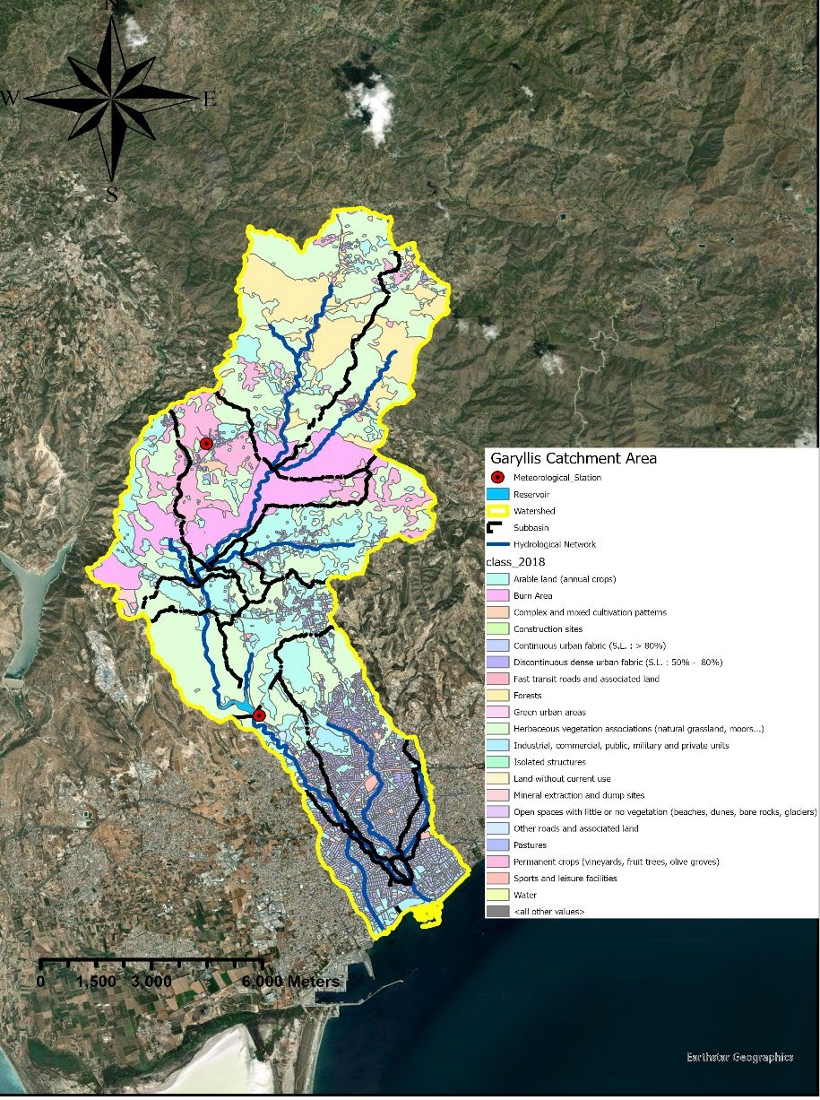
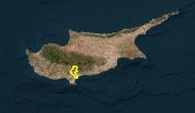
According to the national authorities, Garyllis River is highly vulnerable to flash floods and urban flooding; a residential area without designated protection zones is traversed by the Garyllis River around 1300 meters downstream of the Polemidia Dam. Historical records of flood events going back to 1880 reveal a great deal of damage and casualties within this area. For instance, the Garyllis River overflowed in November 1880 and 1894 due to excessive rainfall, resulting in significant damage. In the 1894 incident, there were casualties and structural failures in over a hundred dwellings, including St. Anthony's Church and an adjacent mosque. Two hundred fifty animals drowned and over 20 human deaths—including paediatric deaths—were reported. The combined effects of severe precipitation and overflow of the Polemidia Dam led to significant structural damages in the center of the Limassol urban region during the recent floods at the beginning of 2019 and 2020. Through the years, the authorities conducted a series of activities to reduce the occurrence of these events, such as the construction of Polemidia dam with capacity of around 3.4 million cubic meters and the redirection of the riverbed. Except situations when the dam overflows, the construction of the Polemidia Dam, combined with the river's diversion, enabled the significant reduction of flood damages. Nevertheless there are no designated protection zones and land use changes (e.g., the establishment of public units such as parks and playgrounds).
Figure
1
:
Land use and land cover map of the Garyllis River Basin, displaying
the river network in blue

Table 1 shows details of the multiple datasets which have been collected by several sources. Discharge and water level data are obtained from the Water Development Department of Cyprus, whereas precipitation data are provided by the Meteorological Department of Cyprus. The Intensity-Duration-Frequency (IDF) curve at the river basin's most upstream meteorological station, located close to
Kalo Horio village, is used to construct the hyetograph for a 24-hour period of rainfall. A 5-meter spatial resolution Digital Elevation Model (DEM) is provided by the Department of Lands and Surveys Cyprus to calculate terrain features like slope, flow accumulation, flow direction, and river basin boundaries.
Land cover data of the study area are extracted from Urban Atlas Land Cover/Land Use for 2018, [16], enriched with the burnt areas for the wildfire events in September of 2022 and in August of 2023 derived by European Forest Fire Information System (EFFIS)[17]. The regional distribution of the runoff Curve Number (CN) is utilised as well to determine the hydrological losses and the precipitation excess. These datasets, together with the hydrographic network of the river basin, are used as inputs for the development of a two-dimensional hydraulic model. Additional information has been also collected from the Cypriot Statistical Service to quantify the vulnerability of the exposed elements, such as humans and buildings, to flood events.

Table 1 Information and data collected about the Garyllis river basin

Data | Information | Resources
Digital Elevation Model (DEM) | 5-m resolution | Department of Lands and Surveys Cyprus DLS Portal (moi.gov.cy)
Road Network | 2016 | Department of Lands and Surveys Cyprus DLS Portal (moi.gov.cy)
Rainfall timeseries | 2011-2023 | Meteorological Department of Cyprus  Home Page | Department of Meteorology (moa.gov.cy)
Intensity-Duration-Frequency  (IDF) curve | Kalo-horio station | Meteorological Department of Cyprus  Home Page | Department of Meteorology (moa.gov.cy)
Discharge and water level timeseries | 1980-2023 | Water Development Department of Cyprus Water Development Department | Home Page (moa.gov.cy)
Hydrographic network | - | Water Development Department of Cyprus Water Development Department | Home Page (moa.gov.cy)
Land Use/ Land Cover | 2018 | Copernicus Land Monitoring Service (CLMS),  Urban Atlas Land Cover/Land Use 2018 (vector), Europe, 6-yearly — Copernicus Land Monitoring Service
Population statistics | 2011 | Statistical Service  (cystat.gov.cy)
Runoff Curve Number (CN) | 2009 | Water Development Department of Cyprus  Water Development Department | Home Page (moa.gov.cy)

METHODOLOGY

This study implements a two-dimensional (2D) simulation of unsteady flow using HECRAS 6.4.1 to estimate the depths of surface water and identify the submerged areas during a 24-hour rainfall event that has a 1000-year return period, which is the most severe scenario requested by the EU Floods Directive. Figure 2 shows an overview of the research methodology which is adopted to generate the flood risk and vulnerability maps. The hydrographic network is embedded as 2D breaklines into the hydraulic model, whereas the topographical attributes are derived by the DEM. By directing water circulation along linear features like high ground, these breaklines ensure robust solution of water flow equations at each cell of the 2D grid. ArcGIS is used to generate the model geometry, whereas HEC-RAS is used to discretize the grid. The best spatial resolution for the 2D mesh and breaklines is chosen based on the desired accuracy of the final result and often depends on the size of the basin.. Flood hazard assessment in the study area utilizes the spatially distributed rainfall method, known as rain-on-grid. The hyetograph, derived from the IDF curve of a nearby meteorological station via the alternative block method for a 24-hour rainfall duration, is used as input into HEC-RAS model. CN polygons representing medium antecedent soil moisture conditions are employed to estimate rainfall excess using the SCS method, also known as the Runoff Curve Number (CN) method, with abstraction ratios corresponding to each CN class. Additionally, Manning’s roughness coefficients, which are crucial for calculating energy friction losses of surface flow, are assigned based on land cover polygons and used as input to the physical model.
The results of the hydraulic simulations are subsequently used to develop a spatial representation of flood hazards in ArcGIS. For that purpose, flood hazard levels are classified into five categories based on depth: very low (depths less than 1 m), low (1–2 m), moderate (2-3 m), high (3-5 m), and very high (greater than 5 m). This classification provides a detailed and nuanced understanding of flood risks in the study area [17].
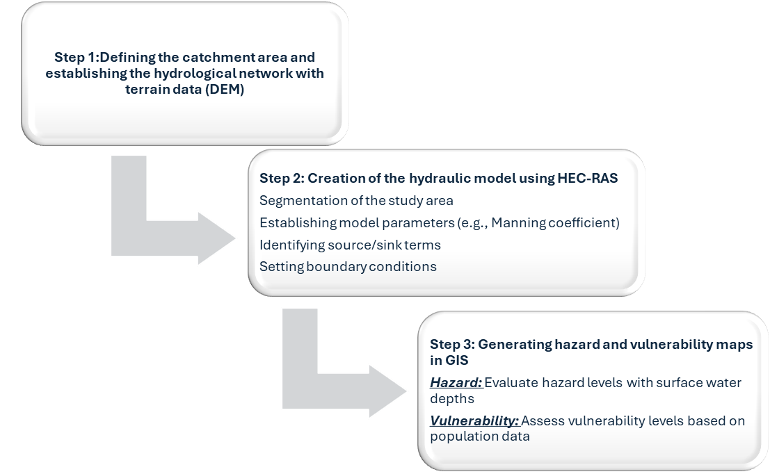
•
Geometry

•
River
Network
•
DEM
•
Depth of surface
water
•
Flow Velocity

•
Land Use/Land
Cover
•
Curve Number

•
Popu
lation

Figure 2: Overview of the current methodology

Regarding flood vulnerability, the national authorities have supplied further data to determine the density of the human population that is directly impacted by flood events. Particularly, the vulnerability levels are represented by the density of the human population, estimated by dividing the total number of people living along each main road in the research region by the whole length of the road.

PRELIMINARY RESULTS
Figures 3 and 4 show preliminary findings for the flood hazard assessment for a 24-hour rainfall duration and a 1000year return period scenario, and for the vulnerability, respectively for the study area. The results show that high flood depths are present in the southern and southwestern regions of the , being subjected to high flood risks. The spatial variation of the water profiles shows the presence of high depth levels at distances up to500 meters away from the hydrological network, hence affecting a larger area This finding highlights the need to include the peripheral areas as part of the flood risk management programs. As expected, the findings suggest that the southern portion of the basin is the most vulnerable to flood risk, vulnerable as they are close to large cities and highways, mainly due to the presence of both high water depths and human population, enhanced by the low permeability of the ground surface.. Furthermore, the southern portion of the basin exhibits a greater vulnerability to flood dangers due to its residential districts, business zones, and vital transit links.
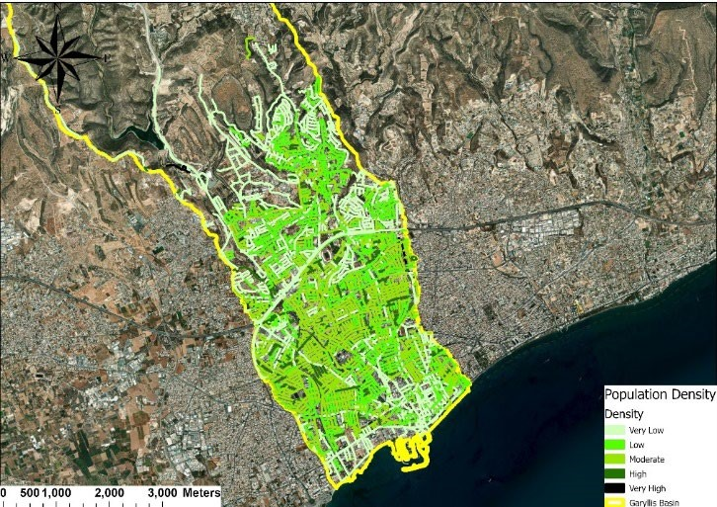
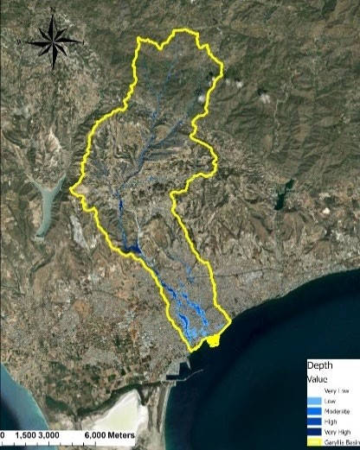
(a) (b)
Figure 3: (a)Flood Hazard Map of Garyllis river basin for 24-h rainfall duration and 1000-year return period scenario. (b) Vulnerability Map of Garyllis river basin.

CONCLUSION
This study provides initial results for the flood vulnerability and hazard assessment of the Garyllis river basin under the extreme scenario of a 1000-year return period rainfall. The HEC-RAS hydraulic model was used to conduct twodimensional simulations, whereas ArcGIS procedures were employed to edit the associated data and examine the model's simulated output. The initial findings suggest that a flood event with a 1000-year return period would significantly impact a large section of the urban area, characterized by high population densities. As expected, the flood hazard assessment indicates the presence of extremely high hazard classes, especially in the areas surrounding the river, which is located in the middle and southern regions of the catchment area. These results underscore the importance of effective flood management and the implementation of mitigation measures to safeguard these highly vulnerable areas. The study utilized IDF curves from 2009. It is recommended to develop more recent IDF curves to better reflect the current situation. Updating these curves would enhance the accuracy of risk assessments and the reliability of flood forecasts. The vulnerability map shows that the most susceptible locations are in the predominantly urbanized southern portion of the basin, as expected. The high population density and critical infrastructure in this area increase its vulnerability. The southern sector, due to its urban units, is especially prone to significant disruptions and damage related to major flooding. To provide a current and accurate assessment of the study area, it is imperative to update the vulnerability assessment with more recent demographic data. Including the latest demographic data in flood risk management decisions will offer a more accurate picture of the current threats. In summary, this study emphasizes the critical importance of having up-to-date data and models to improve evaluations of flood risk and vulnerability. Future research can provide more precise and reliable estimates by incorporating more recent IDF curves and demographic data, ultimately contributing to the development of more effective flood mitigation plans for the Garyllis river basin.

.

ACKNOWLEDGEMENTS
The authors acknowledge the “EXCELSIOR”: ERATOSTHENES: Excellence Research Centre for Earth Surveillance and Space-Based Monitoring of the Environment H2020 Widespread Teaming project (www.excelsior2020.eu). The “EXCELSIOR” project has received funding from the European Union’s Horizon 2020 Research and Innovation.

REFERENCES
- S. Ramly and W. Tahir, “Application of HEC-GeoHMS and HEC-HMS as Rainfall–Runoff Model for Flood Simulation,” in ISFRAM 2015, Springer Singapore, 2016, pp. 181–192. doi: 10.1007/978-981-10-0500-8_15.
- D. Guha-Sapir, P. Hoyois, and R. Below, “Annual Disaster Statistical Review 2015: The numbers and trends,” 2015.
- A. Derdour, A. Bouanani, and K. Babahamed, “Modelling rainfall runoff relations using HEC-HMS in a semiarid region: Case study in Ain Sefra watershed, Ksour Mountains (SW Algeria),” Journal of Water and Land Development, vol. 36, no. 1, pp. 45–55, Mar. 2018, doi: 10.2478/jwld-2018-0005.
- H. Madsen, D. Lawrence, M. Lang, M. Martinkova, and T. R. Kjeldsen, “Review of trend analysis and climate change projections of extreme precipitation and floods in Europe,” J Hydrol (Amst), vol. 519, no. PD, pp. 3634– 3650, Nov. 2014, doi: 10.1016/j.jhydrol.2014.11.003.
- K. H. V. Durga Rao, V. Bhanumurthy, and P. S. Roy, “Application of satellite - based rainfall products and SRTM DEM in hydrological modelling of Brahmaputra basin,” Journal of the Indian Society of Remote Sensing, vol. 37, no. 4, pp. 587–600, 2009, doi: 10.1007/s12524-009-0051-5.
- X. Wang and H. Xie, “A review on applications of remote sensing and geographic information systems (GIS) in water resources and flood risk management,” Water (Switzerland), vol. 10, no. 5, pp. 1–11, 2018, doi:
10.3390/w10050608.
- H. Meresa, “Modelling of river flow in ungauged catchment using remote sensing data: application of the empirical (SCS-CN), Artificial Neural Network (ANN) and Hydrological Model (HEC-HMS),” Model Earth Syst Environ, vol. 5, no. 1, pp. 257–273, Mar. 2019, doi: 10.1007/s40808-018-0532-z.
- S. Natarajan and N. Radhakrishnan, “Simulation of extreme event-based rainfall–runoff process of an urban catchment area using HEC-HMS,” Model Earth Syst Environ, vol. 5, no. 4, pp. 1867–1881, Dec. 2019, doi:
10.1007/s40808-019-00644-5.
- A. M. Awad, “Hydraulic Model Development using HEC-RAS and Determination of Manning Roughness Value for Shatt Al-Rumaith”, doi: 10.18081/mjet/2016-4/9-13.
- “HEC-RAS River Analysis System HEC-RAS User’s Manual.”
- U. Khalil and N. M. Khan, “ASSESSMENT OF FLOOD USING GEOSPATIAL TECHNIQUE FOR INDUS RIVER REACH: CHASHMA-TAUNSA,” Sci.Int.(Lahore), vol. 27, no. 3, 2015.
- M. S. Khattak, F. Anwar, T. U. Saeed, M. Sharif, K. Sheraz, and A. Ahmed, “Floodplain Mapping Using HECRAS and ArcGIS: A Case Study of Kabul River,” Arab J Sci Eng, vol. 41, no. 4, pp. 1375–1390, Apr. 2016, doi:
10.1007/s13369-015-1915-3.
- A. Salajegheh, M. Bakhshaei, S. Chavoshi, A. R. Keshtkar, and M. Najafi Hajivar, “Floodplain mapping using HEC-RAS and GIS in semi-arid regions of Iran.” [Online]. Available: http://jdesert.ut.ac.ir
- M. M. Islam, K. Ujiie, R. Noguchi, and T. Ahamed, “Flash flood-induced vulnerability and need assessment of wetlands using remote sensing, GIS, and econometric models,” Remote Sens Appl, vol. 25, Jan. 2022, doi:
10.1016/j.rsase.2021.100692.
- O. Rahmati, H. R. Pourghasemi, and A. M. Melesse, “Application of GIS-based data driven random forest and maximum entropy models for groundwater potential mapping: A case study at Mehran Region, Iran,” Catena (Amst), vol. 137, pp. 360–372, Feb. 2016, doi: 10.1016/j.catena.2015.10.010.
- “Urban Atlas Land Cover/Land Use 2018 (vector), Europe, 6-yearly — Copernicus Land Monitoring Service.” [17] “European Forest Fire Information System EFFIS.”

