Monitoring Forest Dynamics Between 1987-2023: An NDVI Analysis of Three Dominant Species in Paphos Forest, Cyprus

Christos Theocharidis*^{a,b}, Marinos Eliades ª, Ioannis Gitas^{c}, Chris Danezis^{b,a}, Diofantos Hadjimitsis^{b,a a}ERATOSTHENES Centre of Excellence, Franklin Roosevelt 82, 3012 Limassol, Cyprus; ^{b}Cyprus
University of Technology, Limassol, Cyprus; ^{c}Aristotle University of Thessaloniki, School of
Forestry and Natural Environment, Thessaloniki, Greece

ABSTRACT
Species-level monitoring in satellite remote sensing is crucial, providing detailed insights into biodiversity and ecological interactions. Each species responds differently to environmental shifts, and their health directly impacts ecosystem functioning. In this study, a comprehensive temporal analysis of vegetation dynamics was conducted in the Paphos forest in Cyprus, a unique ecological region hosting a variety of endemic species. This study focuses on the three dominant species: Pinus brutia, Quercus Alnifolia, and Cedrus Brevifolia. Monthly Landsat satellite images (Landsat 4,5, 7, 8, and 9) from
1987 to 2023 have been processed to assess the species vegetation dynamics with the Normalised Difference Vegetation Index (NDVI) compared with precipitation derived from the Climate Hazards Group InfraRed Precipitation with Station data (CHIRPS). Image harmonisation was performed via the Google Earth Engine (GEE), applying a scaling factor within the Landsat missions to ensure consistency and comparability across the different Landsat missions. The results revealed an overall increase in NDVI values for all three species during the study period, possibly related to the reforestations conducted in the last decades combined with the increased precipitation for the years of study. Contrary to the environmental stress (e.g., climate change, deforestation, etc) that the Mediterranean forests have been facing in the last century, our results indicate an enhancement in the health and productivity of these species over the past three decades. Understanding these temporal changes is crucial for biodiversity conservation and forest management. The findings of this study contribute significantly to our understanding of forest dynamics while delivering valuable information for future conservation strategies in the Paphos forest.

Keywords: Pinus Brutia, Quercus Alnifolia, Cedrus Brevifolia, Time-series analysis, NDVI, CHIRPS, Landsat, Cyprus

INTRODUCTION
In the last decades, satellite remote sensing science has become an invaluable tool to monitor vegetation dynamics at various spatial and temporal scales, creating the opportunity to assess various ecosystems’ health¹ and biodiversity². Monitoring vegetation at the species level is particularly critical, as it provides detailed insights into the responses of individual species to environmental changes affecting ecosystem functioning and resilience^{3,4}. Examining vegetation dynamics through different remote sensing techniques at the species level offers a unique perspective of how species respond to environmental shifts such as land use^{5–7}, invasive species^{8–10}, habitat fragmentation^{11,12}, and pest infestation^{13,14}. Understanding in depth these responses is essential for effective biodiversity conservation and ecosystem management strategies. Advances in satellite technology and image-processing techniques have ushered in a new era of continuous monitoring of forest ecosystems, which has been enhanced by increased satellite revisit time and multiple multispectral bands¹⁵.
Satellite sensors, such as the Landsat missions that have risen over the years, provide the potential for continuous vegetation monitoring through time series analysis and various vegetation indicators, such as the widely known Normalised Difference Vegetation Index (NDVI), which is used to quantify the vegetation’s health and density¹⁶. Integrating measurements from satellite imagery (e.g., NDVI) with environmental data like CHIRPS offers a more detailed analysis of vegetation growth dynamics and its relationship with precipitation patterns^{15,16}. Such data combinations provide valuable insights into the longterm trends and patterns of vegetation health¹⁷ or drought monitoring and early warning signs¹⁸. Of course, NDVI is not the only vegetation indicator (VI) that has been combined with precipitation data, but other VIs have also been utilised with rainfall data like the Enhanced Vegetation Index (EVI)^{19,20} and the Standard Vegetation Index (SVI)²¹.

STUDY AREA
This study focuses on the Paphos forest in the Northwestern part of Cyprus, extending into the Troodos Mountains. Covering an area of approximately 700 km², this forested area has a Mediterranean climate, with hot, dry summers and mild wet winters. Its altitudinal range is approximately 0 – 1550m above sea level (Figure 1). That area is a significant ecological region since it hosts a diverse collection of plants and animals that have significantly contributed to conserving Cyprus’ rich biodiversity ²². The area’s management falls under the Forest Department of the Ministry of Agriculture, Natural Resources, and Environment. For this study, the three dominant species of the Paphos forest are examined: Pinus Brutia, Quercus Alnifolia, and Cedrus Brevifolia, forming a triad of ecological significance.
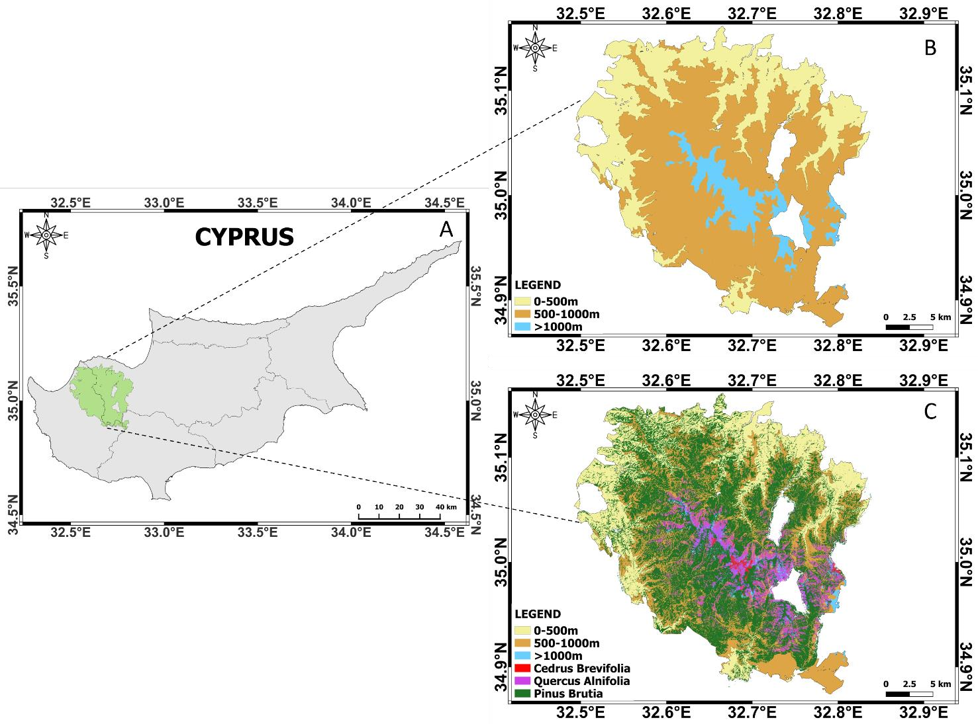
Figure 1. Cyprus island map indicating the Paphos forest boundaries with green colour (A). The elevation map of the Paphos forest derived from the Shuttle Radar Topography Mission (SRTM) is divided into three elevation zones (B). Dominant species distribution in the Paphos forest with the three elevation zones (C). Species shapefiles have been created through a random forest classification algorithm from in-situ data provided by the Forest Department. These data are collected in the framework of LIFE IP Physis – Managing the Natura 2000 network in Cyprus and shaping a sustainable future²².

Dominant species characteristics
These three dominant species play a decisive role in the smooth functioning of the Paphos forest, showing a remarkable interest. Their unique characteristics and conservation status, as outlined by the International Union for Conservation of Nature (IUCN), highlight their ecological importance and the need for their protection²³. The key characteristics and information about the dominant species are summarised in Table 1.
Table 1. Paphos forest dominant species characteristics.

Species | Altitudinal distribution (m) | Description | IUCN Red List Status
Pinus brutia | 0-1225m | A medium-sized tree reaching 2035 m in height with a trunk diameter of up to 1 m. It thrives in various soil types and is known for its thin, red-orange bark²⁴ | Red List Category: LC – Least Concern  Current Population Trend: Increasing  Population Severely Fragmented: No  Continuing decline of mature individuals: No
Quercus  Alnifolia | 600-1525m | An endemic species to Cyprus, it grows as a large shrub or small tree up to 10m high. It prefers rocky ground, and it is known for its golden-coloured leaves²⁵. | Red List Category: LC – Least Concern  Current Population Trend: Stable  Population Severely Fragmented: No  Continuing decline of mature individuals: No
Cedrus Brevifolia | 1075-1400m | Found in the cedar valley in the Paphos forest, this slow evergreen conifer tree can grow on a broader range of soils, reaching up to 20m tall²⁶. | Red List Category: VU - Vulnerable  Current Population Trend: Decreasing  Population Severely Fragmented: Yes  Continuing decline of mature individuals: Yes

DATA AND METHODOLOGY
Rainfall data from CHIRPS were assessed from 1987 to 2023 from the cloud-based platform GEE
(https://code.earthengine.google.com), calculating monthly and yearly precipitation. CHIRPS is a 40+ year quasi-global rainfall dataset from 1981 to the present incorporating approximately 5.5km spatial resolution satellite imagery with in-situ station data to create gridded rainfall time series for trend analysis and drought monitoring. Moreover, CHIRPS provides a long-term, high-resolution dataset showing a good correlation between CHIRPS and recorded precipitation in Cyprus²⁷. Moreover, Landsat 4,5, 7, 8, and 9 satellite images with 30m spatial resolution were utilised to create the NDVI (Equation 1) time series derived from GEE. The mean value of NDVI was computed for all pixels within the respective species’ shapefile (Figure 1C) for each month, providing a representative value of the vegetation index for each species distribution. Overall, 1046 images were pre-processed from 1987 to 2023, harmonised by applying a scaling factor to ensure consistency and comparability across the different Landsat missions. After the image pre-processing, the confidence interval was performed where images with less than 95% overlapping pixels over the study area were excluded to make the outcomes more reliable. After filtering out the images, the confidence interval revealed missing values in the time series, where the Kalman interpolation algorithm²⁸ was chosen to fill these values in the time series. Following the interpolation of missing values, the trend in the time series was analysed using Sen’s Slope estimator. This non-parametric method is robust against outliers, estimating the slope representing the rate of change in the time series data over time. Generally, it can give information about the statistical significance of the observed trend²⁹. After Sen’s slope estimator, a matrix correlation plot was created to compare the NDVI and precipitation data.

𝑵𝑰𝑹 −𝑹
𝑵𝑫𝑽𝑰: (1)
𝑵𝑰𝑹+𝑹
Where NIR = Near-Infrared band (0.7 to 1.1 μm) and R = Red band (0.6 to 0.7 μm).

RESULTS
The analysis of the monthly NDVI showed a positive trend for all the studied species, as indicated in Figure 2. More specifically, the NDVI dropped rapidly between 1991 and 1993, but there was a sharp increase in vegetation after this period. The overall percentage change for all the months for Pinus brutia was +28.68%, +26.12% for Cedrus Brevifolia, and +25.26% increase for Quercus alnifolia, indicating significant vegetation growth. On the other hand, despite the trend line not appearing to increase at first glance, the measurements showed a +10.13% positive change for all the months.

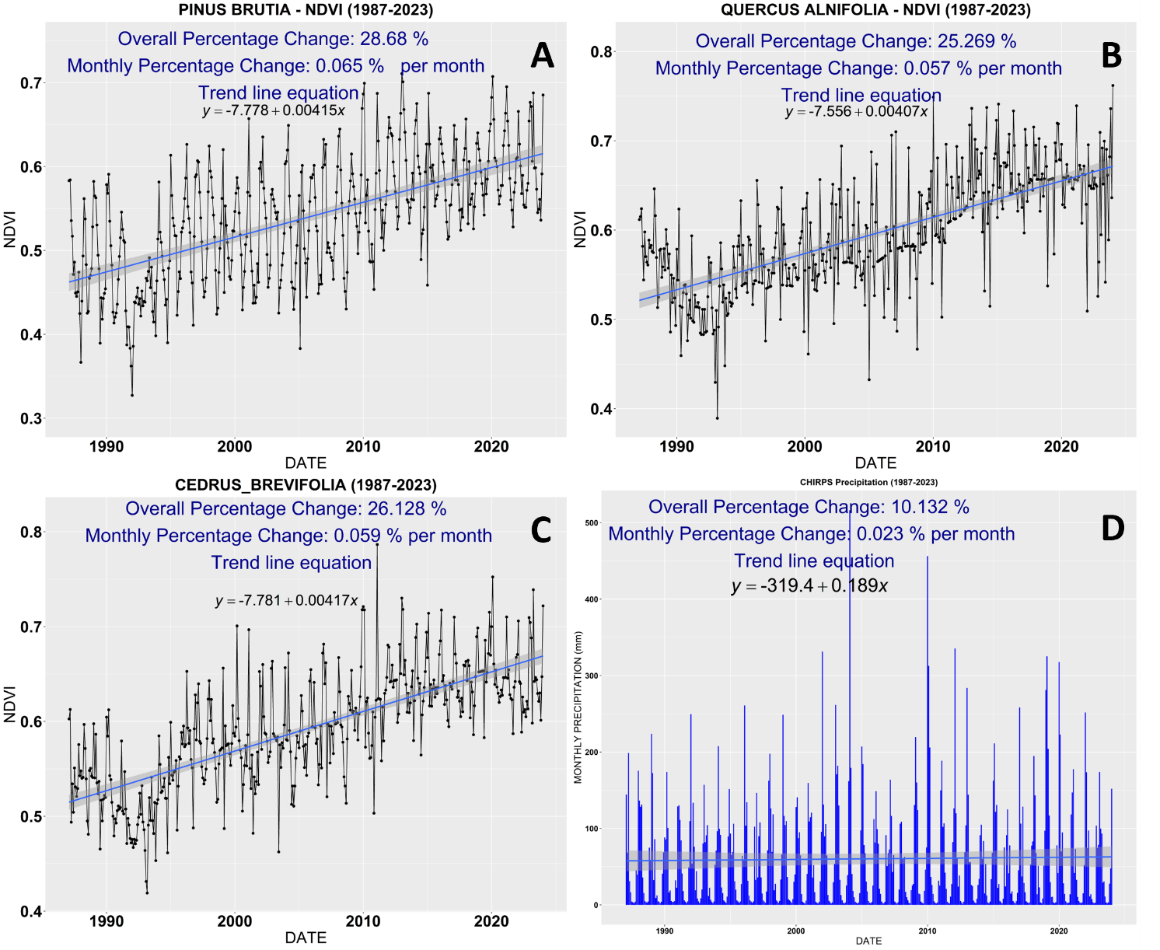
Figure 2. Monthly mean NDVI values for Pinus brutia (A), Quercus alnifolia (B), Cedrus brevifolia (C), and precipitation (D).

Similar to monthly NDVI, all three species exhibited nearly identical significant positive increases in mean annual NDVI with 28.69%, 26.13 and 25.27 for Pinus brutia, Cedrus brevifolia and Quercus alnifolia, respectively.
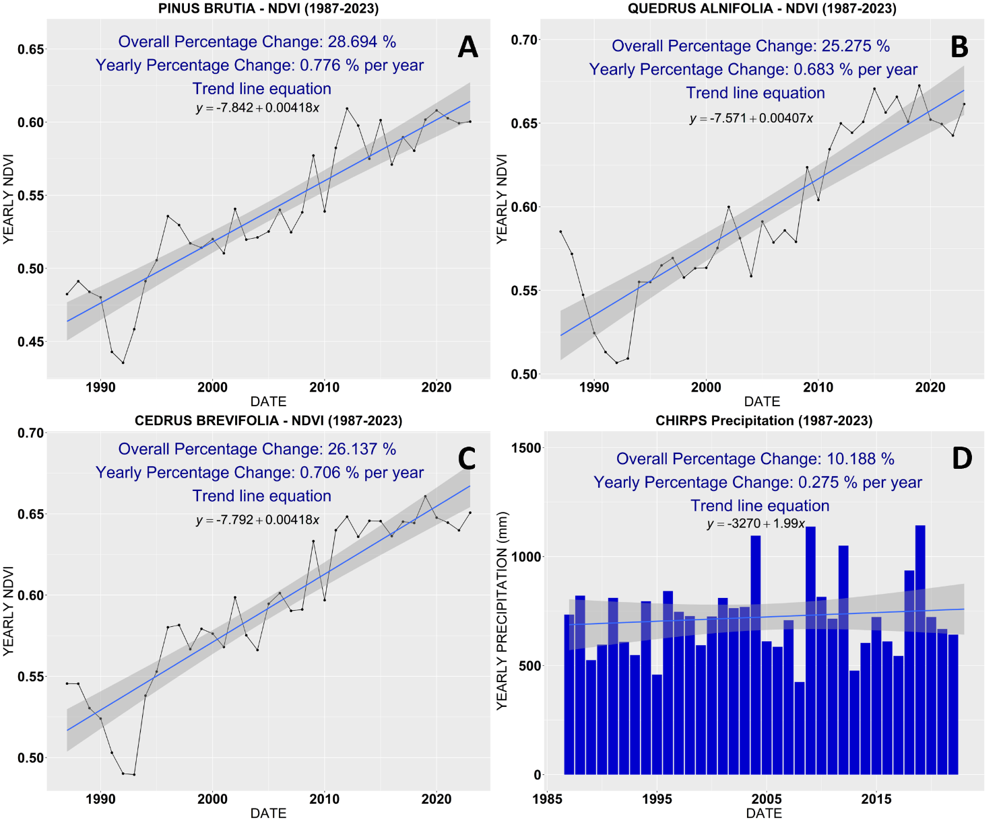
Figure 3. Yearly NDVI values for Pinus brutia (A), Quercus alnifolia (B), Cedrus brevifolia (C), and precipitation (D).

Analysing the yearly time series data further with Sen’s slope revealed crucial information about the trends, summarising them below in Table 2.

Table 2. Summary of Sen’s slope analysis results.

Variable | Sen’s slope | z-value | p-value
Pinus brutia | 0.0040 | 6.474 | 9.541e-11
Quercus alnifolia | 0.0043 | 6.160 | 7.267e-10
Cedrus brevifolia | 0.0039 | 6.317 | 2.665e-10
Precipitation | 0.2407 | 0.039 | 0.9687
The mean annual NDVI for Pinus brutia, Quercus alnifolia, and Cedrus brevifolia indicated a statistically significant trend since Sen’s slope values approached zero, indicating minimal deviation from the trend line over time; high z-values suggesting strong statistical significance, and p-values below 0.05, indicating a high level of confidence in the observed trends. However, in contrast, the precipitation data displayed no significant trend where the calculated Sen’s slope was 0.24; the z-value approached zero, and the p-value exceeded 0.05, signifying insufficient evidence to reject the null hypothesis of no trend. Moreover, the wide confidence interval of precipitation Sen’s slope (-4.221 – 5.912) suggests high uncertainty in this trend, as indicated in Figure 4.

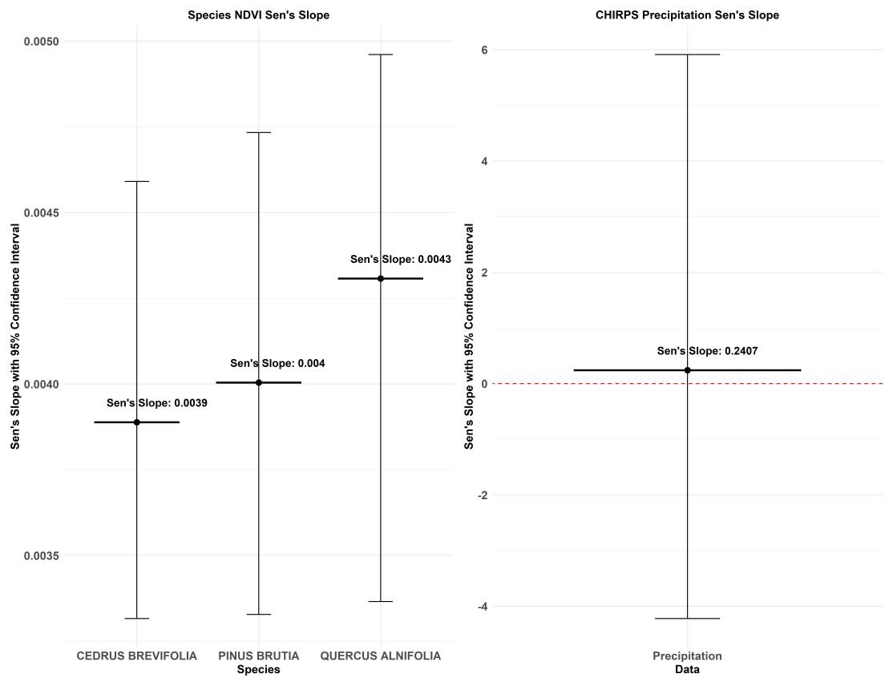
Figure 4. Sen’s slope of the NDVI yearly values for the species and precipitation data.

Delving further into the data analysis, the Pearson correlation matrix plot revealed a strong positive relationship between the NDVI values of Pinus brutia and Cedrus brevifolia, with a 0.89 correlation revealing similar growth rates. The next highest correlation was between Cedrus brevifolia and Quercus alnifolia, with a 0.69 and 0.57 correlation between Quercus alnifolia and Pinus brutia. Concerning the correlations between precipitation and the species, the results revealed low to very low correlations, whereas the precipitation versus Quercus alnifolia nearly reached zero correlations, implying that rainfall did not have a significant impact on the NDVI; therefore, other factors may affect (Figure 5).
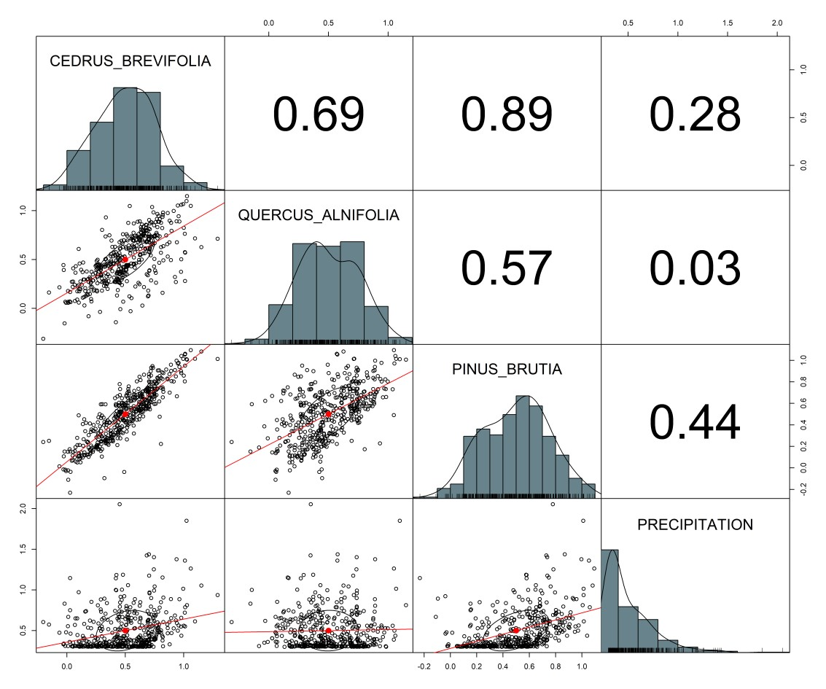
Figure 5. Pearson correlation matrix plot between NDVI of Pinus brutia, Quercus alnifolia, Cedrus brevifolia, and precipitation.

DISCUSSION AND CONCLUSION
The outcomes of this research provide a comprehensive analysis of precipitation and vegetation dynamics in the Paphos forest in Cyprus, focusing on three dominant species: Pinus brutia, Quercus alnifolia, and Cedrus brevifolia. The rapid drop in NDVI between 1991 and 1993 could be due to several factors, including natural disturbances such as pest outbreaks, drought, or low levels of rainfall during that period. Importantly, our investigation did not find evidence of wildfire in the Paphos forest during this time, excluding fire as a potential cause for the observed decline in vegetation health. In general, the NDVI values significantly increased over the past 37 years. This positive trend indicates an enhancement in the health and productivity of these species, and these findings are similar to other studies that have utilised NDVI to assess vegetation health and density^{30–32}. The Sen’s slope estimator results further justified these results, revealing statistically significant trends for all three species. Although the precipitation data showed a positive increase of 10.1%, it displayed no significant trend, suggesting that the increase in vegetation may be due to other environmental factors or anthropogenic actions such as reforestation or the forest was young and still was growing. Indeed, the Department of Forests conducted a large number of reforestations in the Paphos forest following the massive wildfire that occurred during the Turkish invasion of Cyprus in 1974³³. This wildfire resulted in extended destruction, with an estimated burned area of 136.36 square kilometers, as detected from a Landsat-1 image from 11 July 1975. As shown below in Figure 6A, an RGB Landsat-1 image created by the band combination of band 5 (Visible red – R), band 4 (Visible green – G) and band 6 (Near – Infrared – B), to show in bright green the extent of the forest fire. Moreover, Figure 6B presents in red the mapped polygon of the burned area generated by subtracting an NDVI image before and after the wildfire. It is evident that the wildfire did not manage to burn areas above 1000m hence, we assume that the distribution of Cedrus brevifolia was not affected that much which is a positive sign if someone considers the red list status from IUCN.
These significant findings justify completely the increase in vegetation over the past 37 years with the hypothesis that reforestation efforts played a pivotal role in enhancing the forest’s health and productivity. The strong positive correlations observed between the NDVI values of Pinus brutia and Cedrus brevifolia suggest quite similar ecological preferences, which is not surprising given their coexistence within the same forest ecosystem. On the other hand, the moderate correlation between Quercus alnifolia and Cedrus brevifolia indicates some degree of ecological divergence. The low correlation between precipitation and species showed that rainfall alone may not be the primary driver of vegetation dynamics in the Paphos forest. However, other environmental factors may also impact vegetation, such as temperature, soil moisture, soil properties, and human intervention, such as reforestation, as in our case.

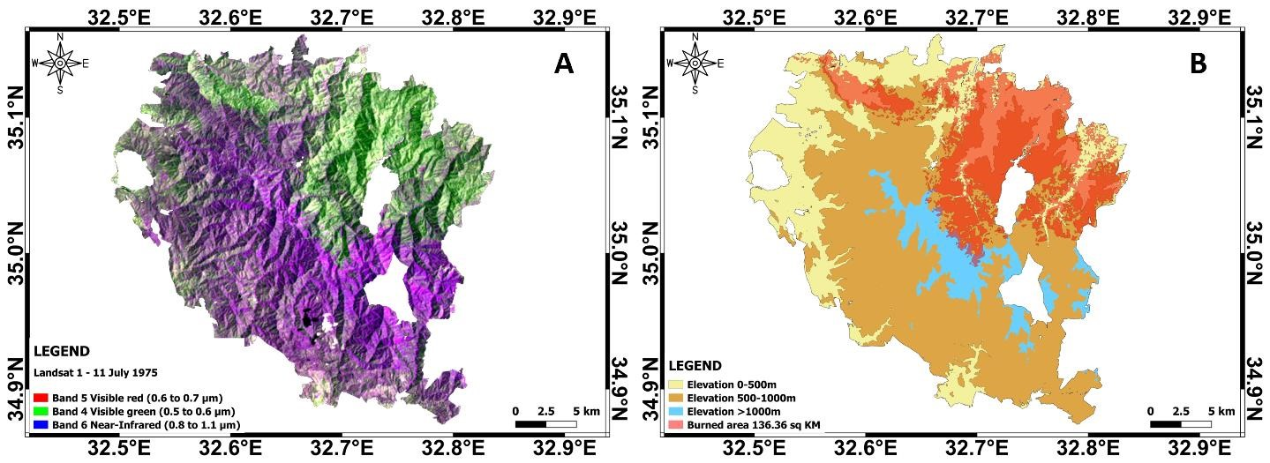
Figure 6. Landsat-1 image from 11 July 1975 over the Paphos forest (A). Elevation map from Paphos forest with the burnt area due to the wildfire which broke out due to the Turkish invasion of Cyprus in 1974 (B).

The results of this study can be used to evaluate biodiversity conservation and forest management in the Paphos forest and similar forest ecosystems. Understanding the various factors influencing forest dynamics at the species level is critical for developing effective conservation practices and enhancing ecosystem resilience and sustainability. Despite the upward trend in the NDVI values indicating the positive impact of reforestation efforts, these ecosystems need continuous monitoring to ensure their long-term viability due to ongoing environmental shifts and human disturbances.

ACKNOWLEDGEMENTS
The authors acknowledge the ‘EXCELSIOR’: ERATOSTHENES: Excellence Research Centre for Earth Surveillance and Space-Based Monitoring of the Environment H2020 Widespread Teaming project (www.excelsior2020.eu). The ‘EXCELSIOR’ project has received funding from the European Union’s Horizon 2020 research and innovation programme under Grant Agreement No 857510, from the Government of the Republic of Cyprus through the Directorate General for the European Programmes, Coordination and Development and the Cyprus University of Technology.

REFERENCES
- Theocharidis, C., Gitas, I., Danezis, C. and Hadjimitsis, D., “Satellite times-series analysis and assessment of the BFAST algorithm to detect possible abrupt changes in forest seasonality utilising Sentinel-1 and Sentinel-2 data. Case study: Paphos forest, Cyprus,” Copernicus Meetings (2023).
- Roy, P. S., Behera, M. D. and Srivastav, S. K., “Satellite Remote Sensing: Sensors, Applications and Techniques,” Proc. Natl. Acad. Sci. India Sect. A Phys. Sci. 87(4), 465–472 (2017).
- Reddy, C. S., Kurian, A., Srivastava, G., Singhal, J., Varghese, A. O., Padalia, H., Ayyappan, N.,
Rajashekar, G., Jha, C. S. and Rao, P. V. N., “Remote sensing enabled essential biodiversity variables for biodiversity assessment and monitoring: technological advancement and potentials,” Biodivers. Conserv. 30(1), 1–14 (2021).
- Pereira, H. M., Belnap, J., Böhm, M., Brummitt, N., Garcia-Moreno, J., Gregory, R., Martin, L., Peng, C., Proença, V. and Schmeller, D., “Monitoring essential biodiversity variables at the species level,” GEO Handb. Biodivers. Obs. networks, 79–105 (2017).
- Eliades, M., Michaelides, S., Evagorou, E., Fotiou, K., Fragkos, K., Leventis, G., Theocharidis, C., Panagiotou, C. F., Mavrovouniotis, M., Neophytides, S., Papoutsa, C., Neocleous, K., Themistocleous, K., Anayiotos, A., Komodromos, G., Schreier, G., Kontoes, C. and Hadjimitsis, D., “Earth Observation in the EMMENA Region: Scoping Review of Current Applications and Knowledge Gaps,” Remote Sens. 15(17), 4202 (2023).
- Chen, W., Li, A., Hu, Y., Li, L., Zhao, H., Han, X. and Yang, B., “Exploring the long-term vegetation dynamics of different ecological zones in the farming-pastoral ecotone in northern China,” Environ. Sci. Pollut. Res. 28(22), 27914–27932 (2021).
- Aquino, D. S., Gavier-Pizarro, G. and Quintana, R. D., “Disentangling the effects of hydro-climatic factors and land use intensification on wetland vegetation dynamics in the Lower Delta of the Paraná River,” Remote Sens. Appl. Soc. Environ. 21, 100466 (2021).
- Lyu, X., Li, X., Dang, D., Dou, H., Wang, K. and Lou, A., “Unmanned aerial vehicle (UAV) remote sensing in grassland ecosystem monitoring: A systematic review,” Remote Sens. 14(5), 1096 (2022).
- Papp, L., Van Leeuwen, B., Szilassi, P., Tobak, Z., Szatmári, J., Árvai, M., Mészáros, J. and Pásztor, L., “Monitoring invasive plant species using hyperspectral remote sensing data,” Land 10(1), 29 (2021).
- Gholizadeh, H., Friedman, M. S., McMillan, N. A., Hammond, W. M., Hassani, K., Sams, A. V, Charles, M. D., Garrett, D. R., Joshi, O. and Hamilton, R. G., “Mapping invasive alien species in grassland ecosystems using airborne imaging spectroscopy and remotely observable vegetation functional traits,” Remote Sens. Environ. 271, 112887 (2022).
- Kowe, P., Mutanga, O. and Dube, T., “Advancements in the remote sensing of landscape pattern of urban green spaces and vegetation fragmentation,” Int. J. Remote Sens. 42(10), 3797–3832 (2021).
- Bera, B., Saha, S. and Bhattacharjee, S., “Estimation of forest canopy cover and forest fragmentation mapping using landsat satellite data of Silabati River Basin (India),” KN-Journal Cartogr. Geogr. Inf. 70(4), 181–197 (2020).
- Ahmad, M. N., Shariff, A. R. M. and Moslim, R., “Monitoring insect pest infestation via different spectroscopic techniques,” Appl. Spectrosc. Rev. 53(10), 836–853 (2018).
- Zhang, J., Huang, Y., Pu, R., Gonzalez-Moreno, P., Yuan, L., Wu, K. and Huang, W., “Monitoring plant diseases and pests through remote sensing technology: A review,” Comput. Electron. Agric. 165, 104943 (2019).
- Wang, Y., Lu, Z., Sheng, Y. and Zhou, Y., “Remote sensing applications in monitoring of protected areas,” Remote Sens. 12(9), 1370 (2020).
- Zeng, L., Wardlow, B. D., Xiang, D., Hu, S. and Li, D., “A review of vegetation phenological metrics extraction using time-series, multispectral satellite data,” Remote Sens. Environ. 237, 111511 (2020).
- Ekundayo, O. Y., Okogbue, E. C., Akinluyi, F. O., Kalumba, A. M. and Orimoloye, I. R., “Spatiotemporal drought assessment using vegetation health index and standardized precipitation index over SudanoSahelian region of Nigeria,” African Geogr. Rev. 40(4), 412–424 (2021).
- Nanzad, L., Zhang, J., Tuvdendorj, B., Nabil, M., Zhang, S. and Bai, Y., “NDVI anomaly for drought monitoring and its correlation with climate factors over Mongolia from 2000 to 2016,” J. Arid Environ. 164, 69–77 (2019).
- Wang, H., He, L., Yin, J., Yu, Z., Liu, S. and Yan, D., “Effects of Effective Precipitation and Accumulated
Temperature on the Terrestrial EVI (Enhanced Vegetation Index) in the Yellow River Basin, China,” Atmosphere (Basel). 13(10), 1555 (2022).
- Li, C., Song, Y., Qin, T., Yan, D., Zhang, X., Zhu, L., Dorjsuren, B. and Khalid, H., “Spatiotemporal Variations of Global Terrestrial Typical Vegetation EVI and Their Responses to Climate Change from 2000 to 2021,” Remote Sens. 15(17), 4245 (2023).
- Arab, S. T. and Ahamed, T., “Near-real-time drought monitoring and assessment for vineyard production on a regional scale with standard precipitation and vegetation indices using Landsat and CHIRPS datasets,” Asia-Pacific J. Reg. Sci. 7(2), 591–614 (2023).
- Prodromou, M., Theocharidis, C., Gitas, I. Z., Eliades, F., Themistocleous, K., Papasavvas, K.,
Dimitrakopoulos, C., Danezis, C. and Hadjimitsis, D., “Forest Habitat Mapping in Natura2000 Regions in Cyprus Using Sentinel-1, Sentinel-2 and Topographical Features,” Remote Sens. 16(8), 1373 (2024).
- Rodrigues, A. S. L., Pilgrim, J. D., Lamoreux, J. F., Hoffmann, M. and Brooks, T. M., “The value of the IUCN Red List for conservation,” Trends Ecol. Evol. 21(2), 71–76 (2006).
- Boydak, M., “Silvicultural characteristics and natural regeneration of Pinus brutia Ten.—a review,” Plant Ecol. 171, 153–163 (2004).
- Anagiotos, G., Tsakaldimi, M. and Ganatsas, P., “Variation in acorn traits among natural populations of Quercus alnifolia, an endangered species in Cyprus,” Dendrobiology(68) (2012).
- Andreoua, M. and Papasavvasb, K., “Favourable Reference Range and Favourable Reference Area of Habitat Type Cedrus brevifolia Forests (9590*),” Handb. Sustain. Manag. long-term Conserv. a narrow Endem. habitat type a Ltd. area occupancy-The case habitat type 9590* Cedrus brevifolia For. (Cedrosetum brevifoliae). LIFE-KEDROS 9590, 997 (2021).
- Katsanos, D., Retalis, A. and Michaelides, S., “Validation of a high-resolution precipitation database (CHIRPS) over Cyprus for a 30-year period,” Atmos. Res. 169, 459–464 (2016).
- Welch, G. and Bishop, G., “An introduction to the Kalman filter” (1995).
- Sen, P. K., “Estimates of the Regression Coefficient Based on Kendall’s Tau,” J. Am. Stat. Assoc. 63(324), 1379–1389 (1968).
- Schultz, M., Clevers, J. G. P. W., Carter, S., Verbesselt, J., Avitabile, V., Quang, H. V. and Herold, M., “Performance of vegetation indices from Landsat time series in deforestation monitoring,” Int. J. Appl. earth Obs. Geoinf. 52, 318–327 (2016).
- Vogelmann, J. E., Gallant, A. L., Shi, H. and Zhu, Z., “Perspectives on monitoring gradual change across the continuity of Landsat sensors using time-series data,” Remote Sens. Environ. 185, 258–270 (2016).
- Mullapudi, A., Vibhute, A. D., Mali, S. and Patil, C. H., “Spatial and Seasonal Change Detection in Vegetation Cover Using Time-Series Landsat Satellite Images and Machine Learning Methods,” SN Comput. Sci. 4(3), 254 (2023).
- Hughes-Wilson, J., “The forgotten war: A brief history of the battle for Cyprus, 1974,” RUSI J. 156(5), 84–93 (2011).

